How to delete or remove a project manually
Problem:
There is a situation when some project couldn’t be neither deleted nor removed from the Site Admin, because buttons “Delete Project” and “Remove Project” are disabled. Usually these buttons are disabled when the system is performing some operations with this particular project. However, sometimes due to some unexpected problems the project could be in a “corrupted” state. In this case user is not able to delete or remove project as well. Follow instructions to delete or remove the project manually.
Instructions:
- Update project state of the project you are trying to remove/delete in “PROJECTS” table.
update projects set PR_IS_ACTIVE = 'N' where project_id = %PROJECT_ID%
- Refresh cache.
- Add new Site Admin parameter REGISTER_CACHE_TO_JMX with value Y.
- There are 2 options how to refresh the cache:
    - Starting from ALM 11.50 you can use following URI http://localhost:8080/qcbin/jmx-console/.
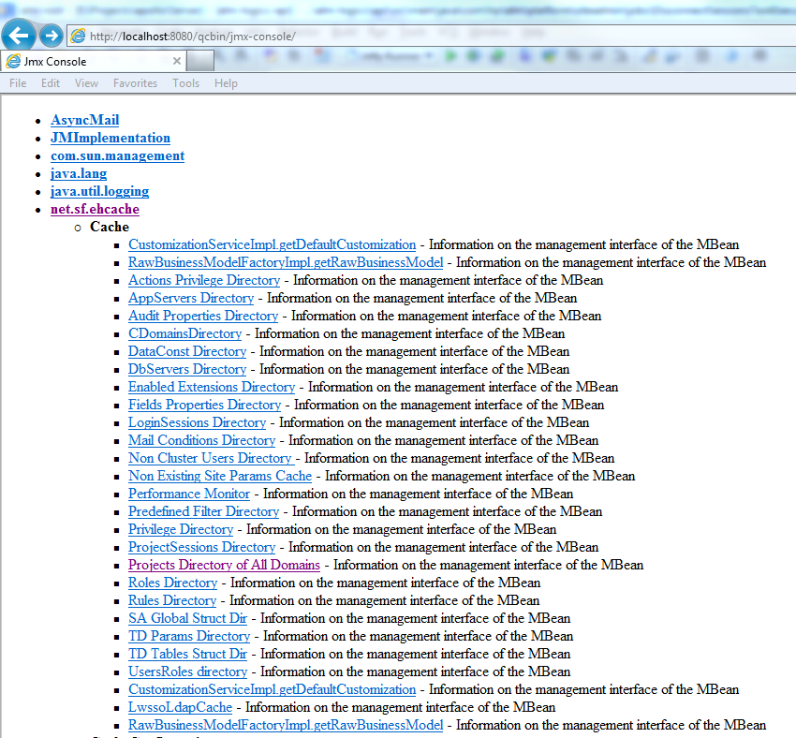
Go to the “Projects Directory of All Domains” and then press “invoke” button.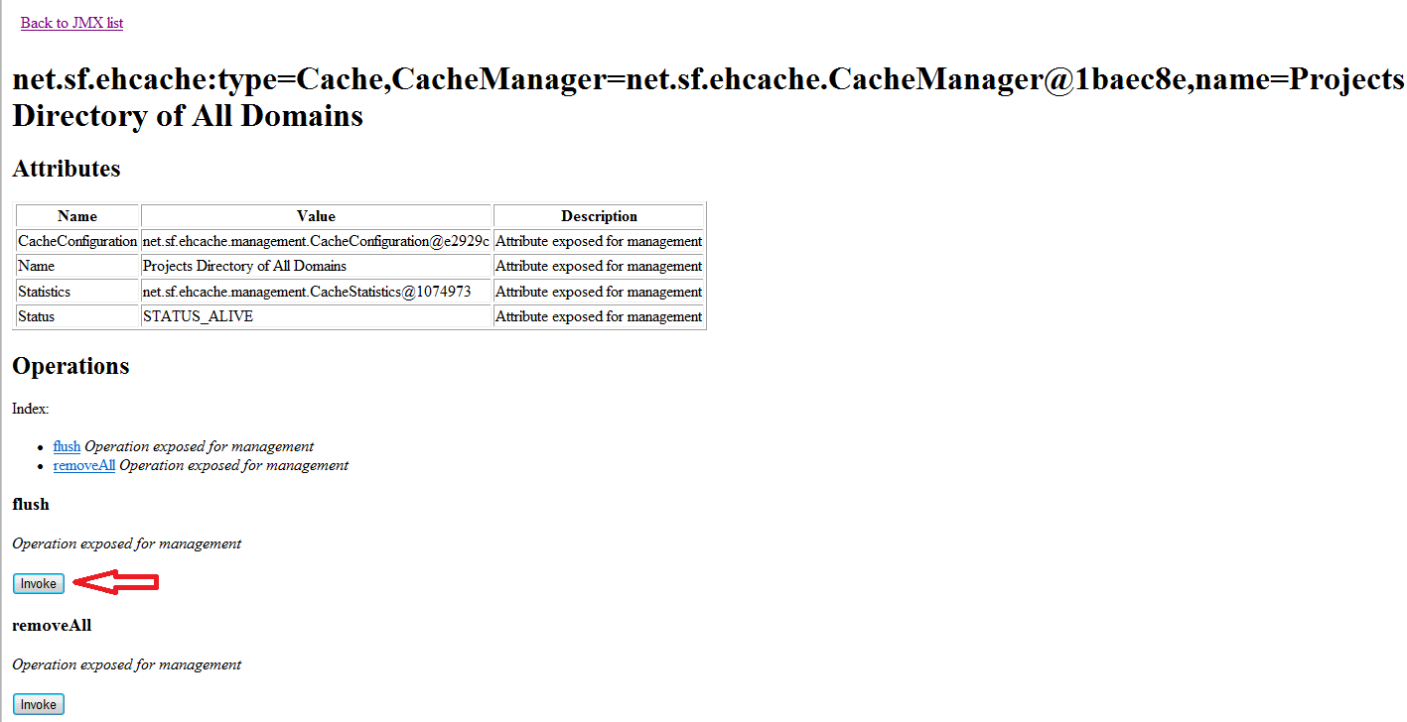
    - Run JConsole application located in bin folder in Java home directory. Connect to ALM process and go to the MBeans tab. Find “Projects Directory of All Domains” and press “flush”.
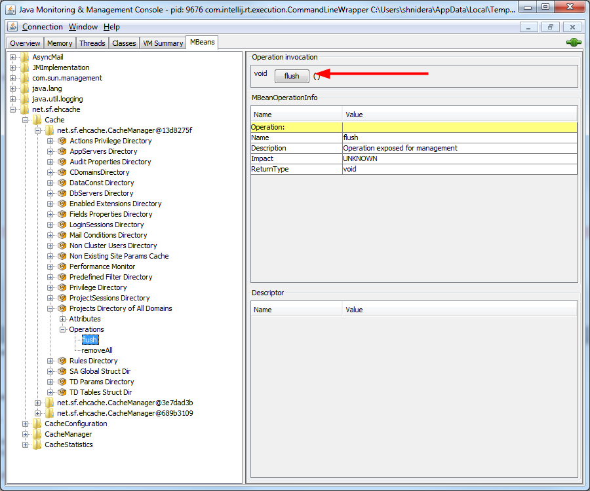
- For ALM 11 you should invoke next operation: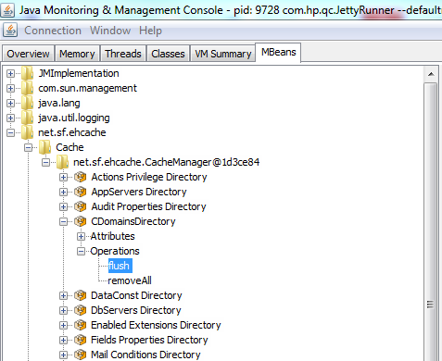

- Note that you can clear cache by restarting the ALM server as well.

- “Delete Project” and “Remove Project” buttons should be enabled and you can perform appropriate action.

