A capacity view of SySH 11.23

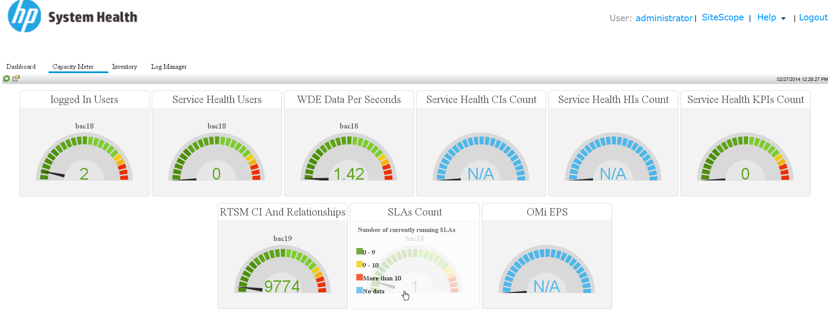

Those values are collected via a JMX method from the GW server, as you can see the max values are defined here

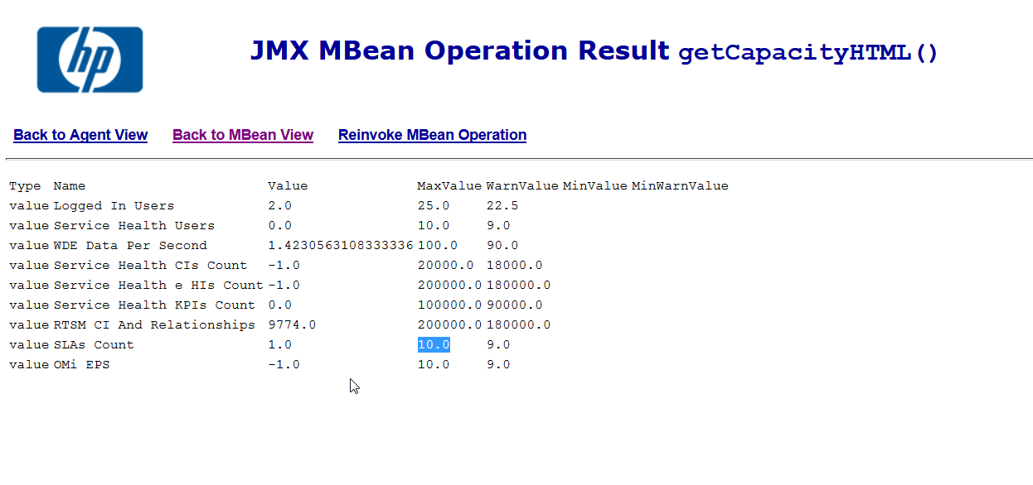

The maximum values are controlled by the properties of the platform administration page in BSM.

Let’s take the example with the SLA max count, if we look at the server deployment of my BSM now we can see that for SLA we have Small installation selected

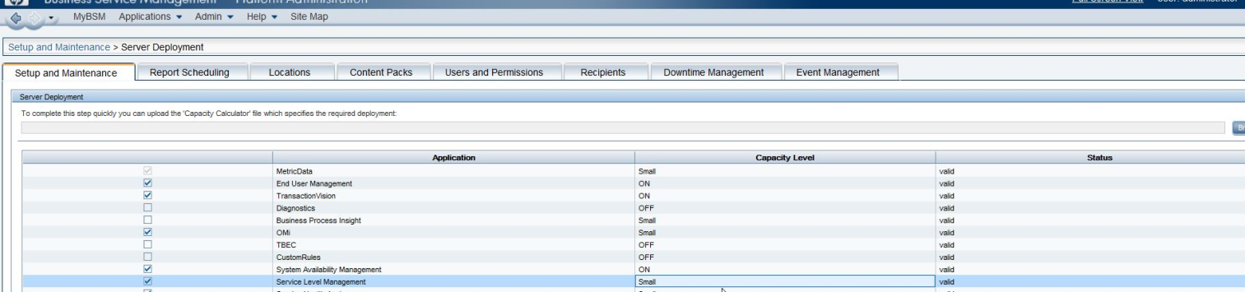

If we know that our server have enough resources and we are sure it can handle this we could set this to a Large installation:

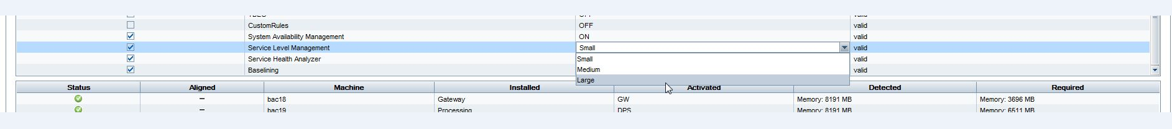

Now if we check the capacity JMX we can see that the max SLA count is 400 and not 10:

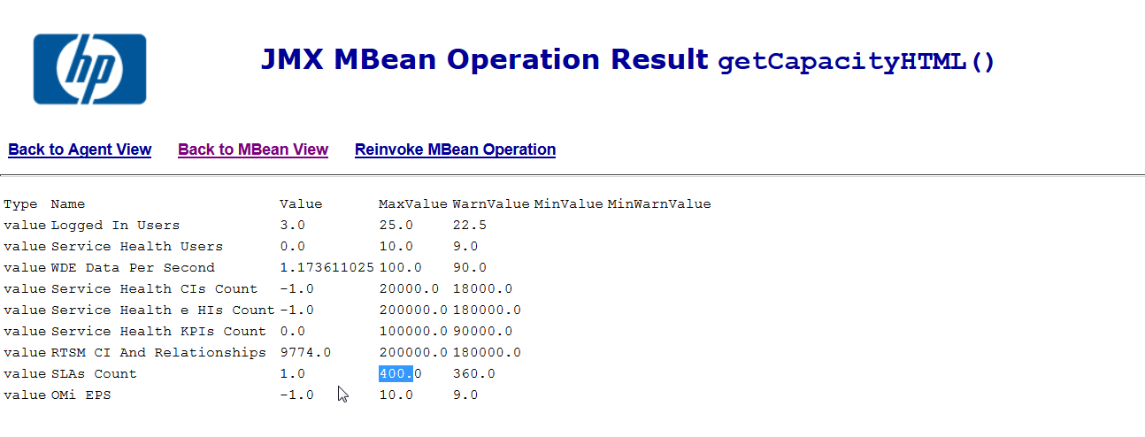

This is also reflected in the SySH


