UCMDB Self-Monitoring

UCMDB Server
- 1 Windows service involved (monitor to make sure it is running):
  - Service name: “UCMDB_Server”
- 1 Linux process – search for UCMDBServer (you'll see the path e.g. opt/hp/UCMDBServer/bin/wrapper)
- 1 'watchdog' process (wrapper.exe) running that monitors the UCMDB_Server process
  - Wrapper logs about UCMDB Server printed in C:\hp\UCMDB\UCMDBServer\runtime\log\wrapper.log:
  - Logs entries for starting UCMDB:
    - STATUS | wrapper | 2014/07/30 10:47:51.692 | Launching a JVM...
    - INFO | jvm 1 | 2014/07/30 10:47:52.896 | -XX:+CMSClassUnloadingEnabled -XX:+CMSIncrementalMode -XX:+HeapDumpOnOutOfMemoryError -XX:InitialHeapSize=1073741824 -XX:+ManagementServer -XX:MaxGCPauseMillis=250 -XX:MaxHeapSize=4294967296 -XX:MaxNewSize=1073741824 -XX:MaxPermSize=201326592 -XX:MaxTenuringThreshold=6 -XX:OldPLABSize=16 -XX:-OmitStackTraceInFastThrow -XX:+PrintCommandLineFlags -XX:+PrintGC -XX:+PrintGCDetails -XX:+UseAdaptiveGCBoundary -XX:+UseCompressedOops -XX:+UseConcMarkSweepGC -XX:-UseLargePagesIndividualAllocation -XX:+UseParNewGC
    - INFO | wrapper | 2014/07/30 10:48:06.658 | Waiting to start...
    - INFO | jvm 1 | 2014/07/30 10:48:09.629 | WrapperManager: Initializing...
    - INFO | jvm 1 | 2014/07/30 10:48:11.351 | 2014-07-30 10:48:11,336 [WrapperSimpleAppMain] INFO - Starting cmdb server
    - STATUS | wrapper | 2014/07/30 10:48:13.668 | UCMDB_Server started.
  - UCMDB process stopping:
    - STATUS | wrapper | 2014/07/25 20:53:30.517 | on_exit trigger matched. Restarting the JVM. (Exit code: 1)
    - INFO | wrapper | 2014/07/30 10:12:13.870 | Waiting to stop...
    - STATUS | wrapper | 2014/07/30 10:12:17.473 | <-- Wrapper Stopped
    - STATUS | wrapper | 2014/07/30 10:12:18.876 | UCMDB_Server stopped.
- UCMDB status (http://host:8080/status) shows the status of the server: Up/Starting/Down
- It is necessary to monitor the amount of free space available on the server. The server creates files/uses up the disk space in the directory tree of where the server is installed into (by default under C:\hp\UCMDB\ UCMDBServer). Full-text search indexes can occupy a significant amount of disk space and grow proportional to the data model size.
- Reconciliation.audit log for total time of discovery bulks
INFO - [ID=1612311824] [Customer ID=1] [Changer=UCMDBDiscovery: MZ_GDC Cyberjaya_Basic node_Host Connection by WMI] [total time=11.625
- Statistics from runtime folder(generated for the last 15 min)
  - api.request
  - dal
  - operation
- Slow logs for elapsed time and number of threads
- UI statistics from jmx getServicesStatisticsSortByAvgDuration
- Thread count from jvm_statistics.log
INFO - HEAP - [USAGE: 3989.8, FREE: 3.9, TOTAL: 3993.6, MAX: 3993.6]; NON-HEAP - [USAGE: 181.6, FREE: 50.9, MAX: 240.0]; CLASSES - [Loaded: 26658, Unloaded: 1651, Left: 25007]; THREADS - [Count: 259]
- System Health Services jmx for active TQL count
- Check cmdb.pattern.statistics.log which might show you TQLs/Views with statistics of how long it took, average, maximum and result size
- Check cmdb.dal.log(cmdb.dal.slow) to identify queries which took more than 120 sec
- Output from JMX runSupportHandlersForAllCategories. Contains a lot of useful statistics about UCMDB server

Universal Discovery

- On the Data Flow Probe server 3 Windows services are involved (one can monitor to make sure the services are running):
  - Service name: “UCMDB_Probe_XmlEnricher”, Display name: “HP Universal Discovery XML Enricher”
  - Service name: “UCMDB_Probe”, Display name: “UCMDB Probe”
  - Service name: “UCMDB_Probe_DB”, Display name: “UCMDB_Probe_DB”
- The Probe service monitors the XML Enricher service and should restart it automatically if it finds that it crashed
- It is necessary to monitor the amount of free space available on the probe. The probe creates files/uses up the disk space in the directory tree of where the probe is installed into (by default under C:\hp\UCMDB\DataFlowProbe). Scan files (especially if software scanning is enabled) can occupy a significant amount of disk space.
- When problems are encountered, one can take a look at the log files (by default: C:\hp\UCMDB\DataFlowProbe\runtime\log). Typical logs that can contain information about fatal errors: WrapperProbeGw.log, probe-error.log
- One can use the administrative UI (under Data Flow Management> Data Flow Probe Status module) to see if all probes are connected and what they are working on.
- JMX: JobsInformation-> viewJobsStatuses
  - Show you the number of stuck triggers in the probe
  - When number of stuck threads reach 8 probe will restart
  - Monitor this JMX to alert about probe restarts
  - See picture below (just drag to enlarge)
- JMX: GwTaskResultDistributer
  - See ‘NumberOfUnsentResults’ – this is the number of pending bulks waiting in the probe to be sent to the server
  - Drill down to JMX GwTaskResultDistributer -> viewUnsentResults :
    - See how much time each bulk is waiting in the probe queue to be sent to server
      - Bulks may wait too much time in the probe-queue because of a server-side problem
  - See picture bellow (just drag to enlarge)
- Monitor the probe JVM heap
- probeGW-taskResults.log:
  - Examples:
    - <2014-07-24 12:08:37,925> 145673 [INFO ] (TaskResultsSenderThread.java:166) - Process Result Time Statistics - Total Time:5651, Results size:6, Time To get Tasks:9, Time to send results: 78, Time until server gets the results:90132, Time to get results status:5016, Time to process Id Mapping:98, Time to update warnings:0, Time to activate automatic deletion:378, Time to inform the sent results is:4, Time to finish deleting results:25, Total time to handle Successful results:505
  - The above entry is printed for each group of discovery results bulks , here is the explanation for each measurement:
    - Log-message - Time until server gets the results: Select results from DB (in probe side)
    - Log-message - Time to get results status: Server side work - reconciliation\model update
    - Log-message - total time to handle Successful results: Update probe DB table
- result processing queue time from mam.autodiscovery.results.stat.log
Processing result of 'Unix-Daily' from probe: 'USPMVAPP557' took 3948msec. Waiting time (in result processing queue): 133349
- Queue size from mam.autodiscover.log :
- Adding dispatch task to queue. New queue size: 846. Task: Redispatch Trigger CIs

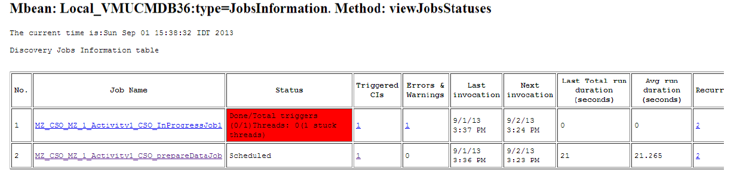

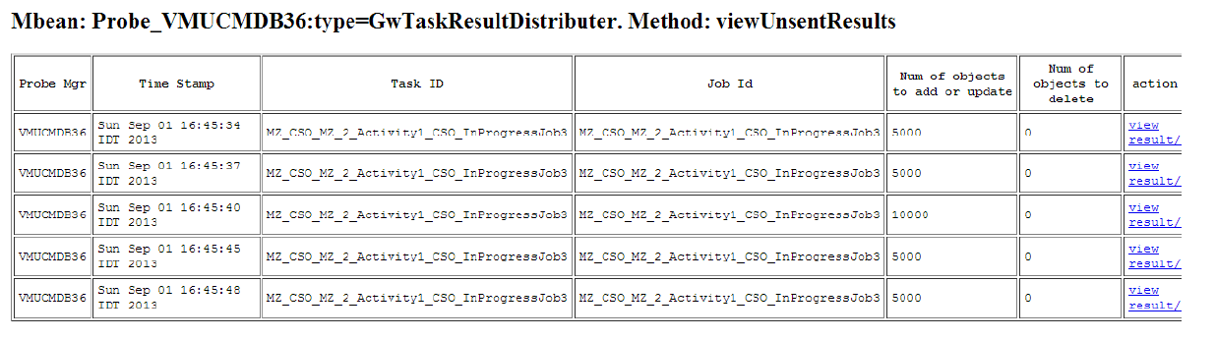

Store and Forward Server

  - Windows:
    - Uses two Windows services (one can monitor to make sure the services are running):
      - Service name: “hpudStoreAndForward”, Display name: “HP Universal Discovery Store and Forward Server”
      - Service name: “hpudApacheSF”, Display name: “HP Universal Discovery Store and Forward Web Server”
  - Linux:
    - The following processes belong to the Store and Forward server (one can monitor to make sure they are still running):
      - storeNforward
      - httpd (embedded Apache web server daemon)
  - The Store and Forward server also serves over HTTP (or HTTPS depending on how it is configured) the XML status document showing the current status of the server. It is available using the following URL:
http[s]://<StoreAndForwardServer>:<port>/server_status.xml
  - If the server status is opened in a browser, a user-friendly HTML page is displayed. But monitoring software can read the XML itself. Here is an example of it:
<?xml version="1.0" encoding="UTF-8"?>
<?xml-stylesheet type="text/xsl" href="server_status.xsl"?>
<StoreAndForwardStatus version="1.0">
<statusDirBytes>0</statusDirBytes>
<incomingDirBytes>0</incomingDirBytes>
<inProgressDirBytes>0</inProgressDirBytes>
<resumeDirBytes>0</resumeDirBytes>
<freeDiskSpaceBytes>50882215936</freeDiskSpaceBytes>
<numIncomingFiles>0</numIncomingFiles>
<numInProgressFiles>0</numInProgressFiles>
<numResumeFiles>0</numResumeFiles>
<modifiedTime>06/22/14 08:23:30</modifiedTime>
</StoreAndForwardStatus>
- It is important to monitor the amount of free disk space available on the disk that the store and forward server uses for its data. If there are network connectivity problems and the store and forward server is not able to send the files on a timely basis, they will start to accumulate and eat up disk storage. Directories to be used for storage are configured in config.ini file used by the store and forward server:
[BaseDirectories]
dataDir=xxx
incomingDir=yyy
More details can be found in the documentation.

