UCMDB 2020.08 regarding adding/managing licenses

Please note, there have been changes in UDMDB with the 2020.08 release, regarding how licenses are loaded into UCMDB. With 2020.08 it is now supported a SaaS-based UCMDB. Management of licenses in the SaaS world is different than in the on-premise world in that the SaaS administrator will manage the licenses (centrally) for all using that SaaS instance, whereas previously in the on-premise world the customers managed their licenses. This changed the licensing methodology for ALL of UCMDB.

The key difference is that in the SaaS -based world the user ID is now relevant and required. SaaS based licenses will actually be held in a pool and assigned to customers as they come on board. This pool is the “null” customer ID. When a customer is added to a SaaS-based instance, licenses will be moved out of the pool and assigned to a specific customer ID. As customers are added to a SaaS instance they will get unique IDs. Therefore, UCMDB instances with multiple customers will have multiple customer IDs.

Previously, one could leave this field blank in the license JMX entries and it the customer ID would default to “1”. Now, if one leaves it blank, the licenses will be assigned to a license pool for that UCMDB instance but not assigned to any customer. Licenses assigned to the license pool are not visible to the customer, even in a standalone installation with only a single customer.

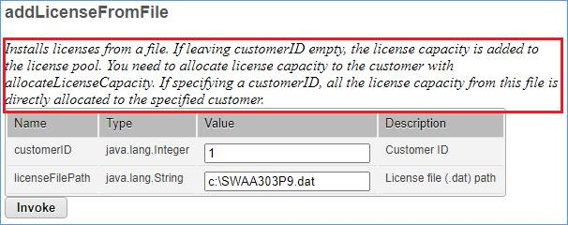

Therefore, starting with 2020.08, one MUST include the customer ID in the JMX methods to add the license to that UCMDB instance, or the licenses will be added successfully but to the license pool and not assigned to anyone. The license dialog box will show the license file is added, but there will be no licenses available for consumption.

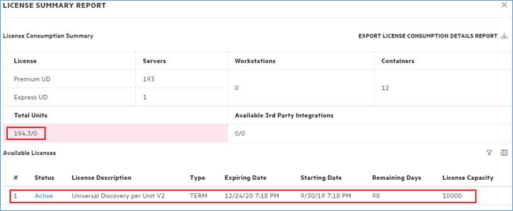

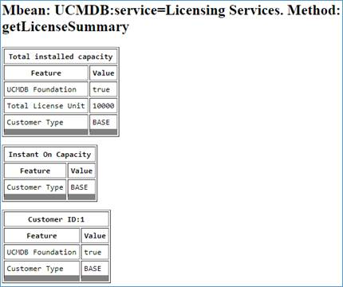

At least, it’s easy to fix. If one forgets to put a customer ID into the field, one can delete the licenses normally and start over. Or one can use the new allocateLicenseCapacity JMX method to move licenses form the pool to a specific customer. One might need to do this if the customer has licenses from a long time ago but no longer has the license file, and they don’t want to delete all their licenses. This is how it would work to assign 10,000 licenses form the pool to Customer ID #1



