Triplets
Online document page reference:
http://cmshelpcenter.saas.hp.com/CMS/10.22/ucmdb-docs/docs/eng/doc_lib/UCMDB_docs.htm#modeling/CitMan_ui_cit_wiz_4_triplets.htm?Highlight=triplets
The key for triplets is they are a “Calculated Relationship”. Triplets are used to determine what CI types are used in determining impact, based on their relationship to other CI types, and in which set of calculated links they are included (that is, in the Directly or Potentially impacted TQLs).
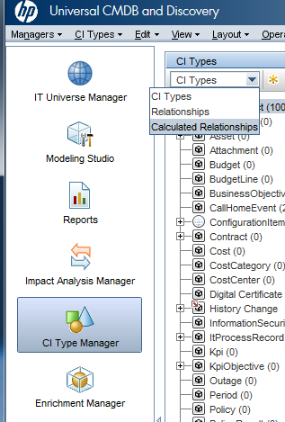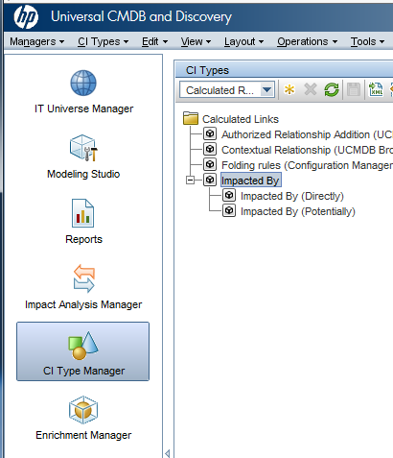

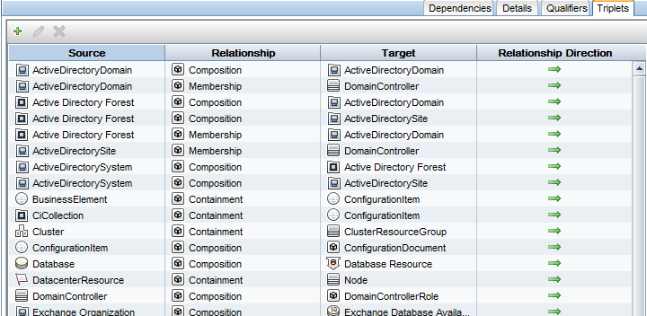

Navigate to the following:
- CI Type Manager
- Select “Calculated Relationships”
- Click on Impacted By (Directly) or Impacted By (Potentially)
- Click on the Triplets tab

For instance, if a node goes down, it makes logical sense that the CPU, file system and interfaces of that node would be directly impacted. One can see in the “Impacted By (Directly)” that this scenario is taken into account.

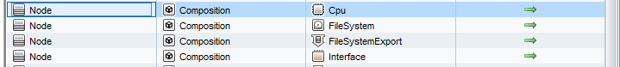

If used Impact Analysis, it is suggested to review that the OOTB relationships exist in both two scenarios, to make sure they represent how one’s business views impact are. A “triplet” that is in the Directly section will cause a bigger impact to the parent CI than a triplet in the Potentially section (this is part of the Impact Definition statements).

In the event there are many “impacts” that one business may care about that are not represented in the OOTB list – then, simply add them by clicking on the green + sign and filling in the form.

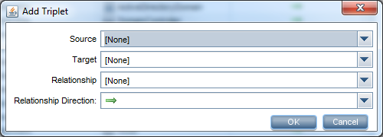

Something to be aware of
Keep in mind that the default list of triplets may include CI types that have MANY child CI types. For instance, in the screen shot below, “BusinessElement [Usage] BusinessElement” as one of the “Impacted By (Potentially)”. This actually means that ANY of the types within the Business Element will be viewed with any other type of CI in the Business Element space that have a Usage relationship.
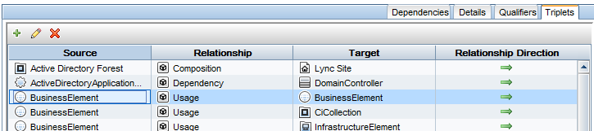

What this actually means is that the use case BusinessApplication [Uasge] BusinessService (or vice versa) is already included in the “Impacted By {Potentially)” impact rule and there is no need to add it.

Walk Through of Adding a Triplet
Here’s how to add a triplet, should decide the need of a new one. Knowing there is a Usage relationship between Business Application and Business Service, and would like to add this into the “Potentially” Impacted group, the following can be performed:

1. Navigate to CI Type Manager
2. Select Calculated Relationships
3. Click on Impacted By (Potentially)
4. Click on the Triplet Tab
5. Click on the green + sign
6. Provide the detail about the source, target and relationship information, and the direction (which is parent and which is child)
7. Click ok
8. Click Save icon to retain your changes

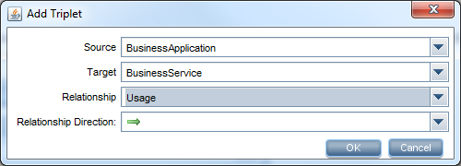
When selecting relationships, UCMDB only shows the relationship types that are supported between the two CI types (in either direction)
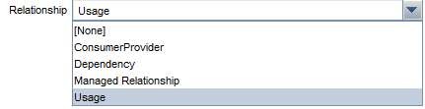
When one have clicked ok, this triplet now in the triplet tab, and this relationship will now be taken into account in the default Impact Analysis rules.

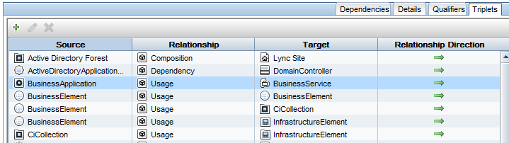

What if one do not know the OOTB relationships between CI Types?
To view existing relationships between CI Types, go into CI Type Manager and select CI Types. Then select the 2 CI types where would like to see what relationships exist, and right click, bringing up the “Add/Remove Relationship” window.
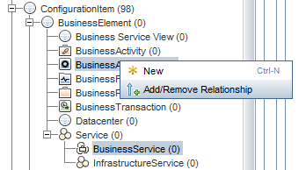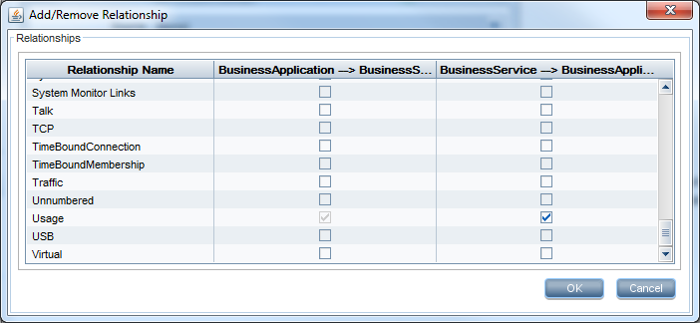

This will show all the existing relationships for the 2 CIs, from both directions (it can be different). Anything that is checked is OOTB (unless already modified).

If wanting to see relationships of a CI type to itself, then select just the one CI type, and then right click and select the “Add/Remove Relationship” choice



