Steps to check J2EE metric value collected/activated on the SAP NetWeaver Application Server
1. Enter: http://JAVAServer FQDN hostname>:5<Instancenumber>00/startPage
Example: http://hostname:50000/startPage
2. Then click on below option,
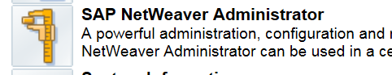

3. Then click on “Resource Monitoring” tab
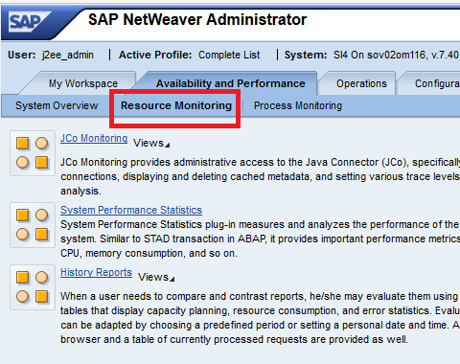

4. Click “History Reports”

5. Click on “Monitor Browser
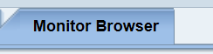

6. Enter the metric name (/Kernel/System Threads Pool/Active Threads Count) as shown below
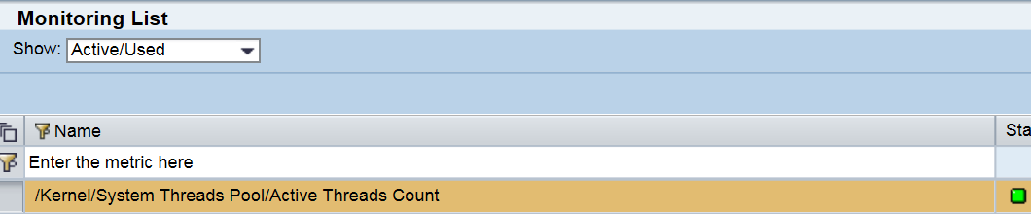
7. Scroll down to see the metric value
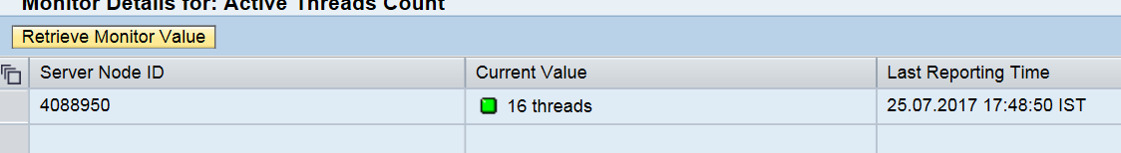

In order to get different J2EE Metric names, refer the “SAPJ2EE_MetricDefinition.xml”/
“SAPJ2EE_MetricDefinition_70.xml” file on the managed node and locate the Object Name defined for each SAP J2EE collection ID
For an instance,
"SAPJ2EE_C0201" collection ID, J2EE Metric name is ="/Kernel/Session Manager/Opened Security Sessions Count"
++Excerpt from “SAPJ2EE_MetricDefinition.xml”
<Collection application="SAPJ2EE" description="Opened Security sessions count" enabled="true" id="SAPJ2EE_C0201" name="Opened Security sessions count" source="jmx">
<Definition>
<JmxQuery>
<ObjectName>com.sap.default:name="/Kernel/Session Manager/Opened Security Sessions Count",j2eeType=SAP_MonitorPerNode,SAP_J2EEClusterNode="",SAP_J2EECluster=""</ObjectName>

