SMA-X How to sync users from LDAP to IDM

Background Knowledge:
The auto user sync from LDAP to IDM follows 2 rules which are controlled by 2 parameters in IDM. The 2 rules description are as below:
1. Sync every 10 minutes for new groups
2. Sync every 12 hours for all old groups
If a new user is added to an old group, it would take 12 hours automatically
There is a REST method to sync all users from LDAP to IDM manually.
NOTE: There is no REST method to sync a specific user from LDAP to IDM
Preparation:
1. Install the tool Postman, and go to File > Settings > Confirm "Variable autocomplete" is ON
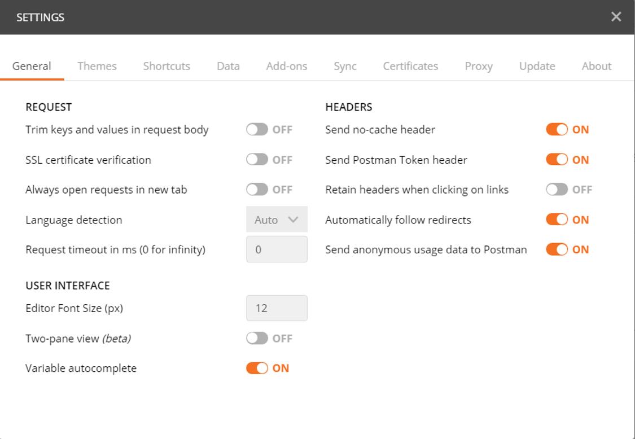
2. Install SMA-X and configure account and tenant records, the tenant should be in Active status and the tenant URL should be accessed successfully
https://[FQDN]:443/saw/ess?TENANTID=[ TENANTID]

3. Configure the External LDAP in SMA-X Accounts
3.1 Open the SMA-X BO link, for example https://[FQDN]/bo/
3.2 Click on Accounts, and select the account record which is going to configure the external LDAP
3.3 Click on Authentications in the left of the page, click on New and select type “LDAP configuration”
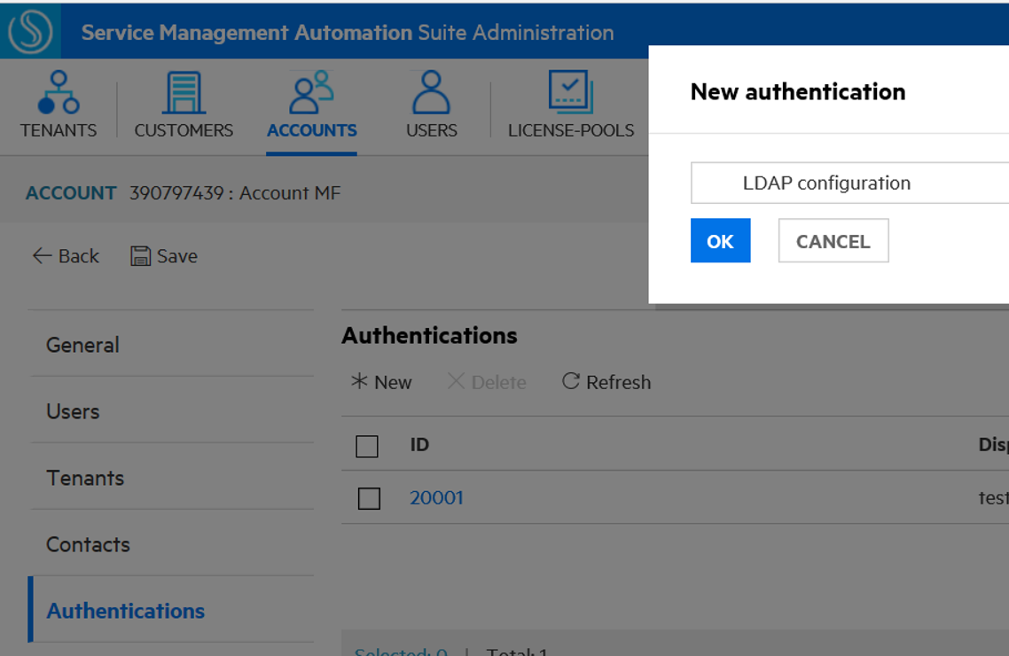
3.4 Configure the external LDAP information, for example
LDAP server settings
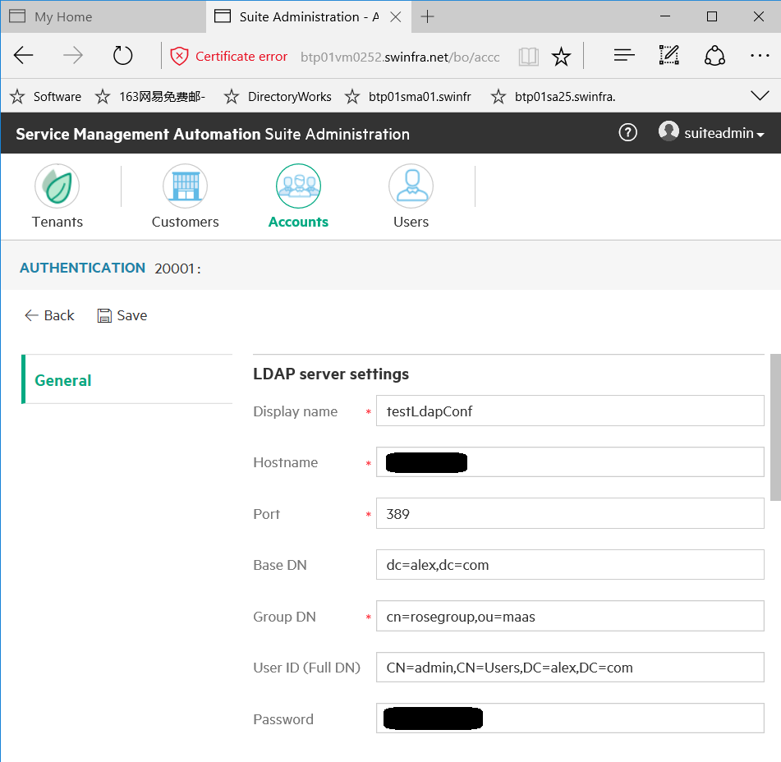
LDAP attributes
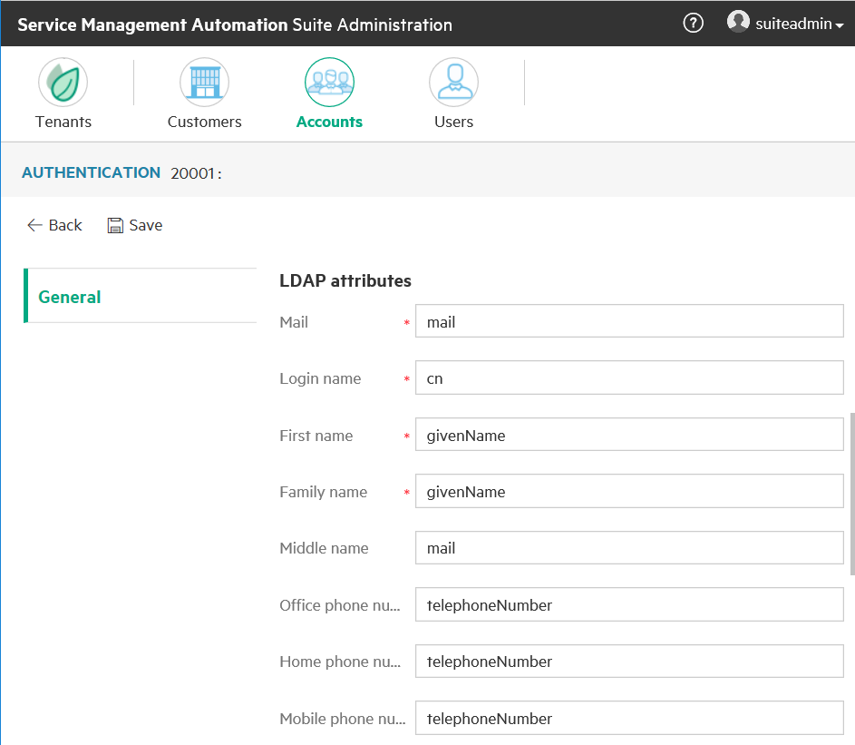
User login settings
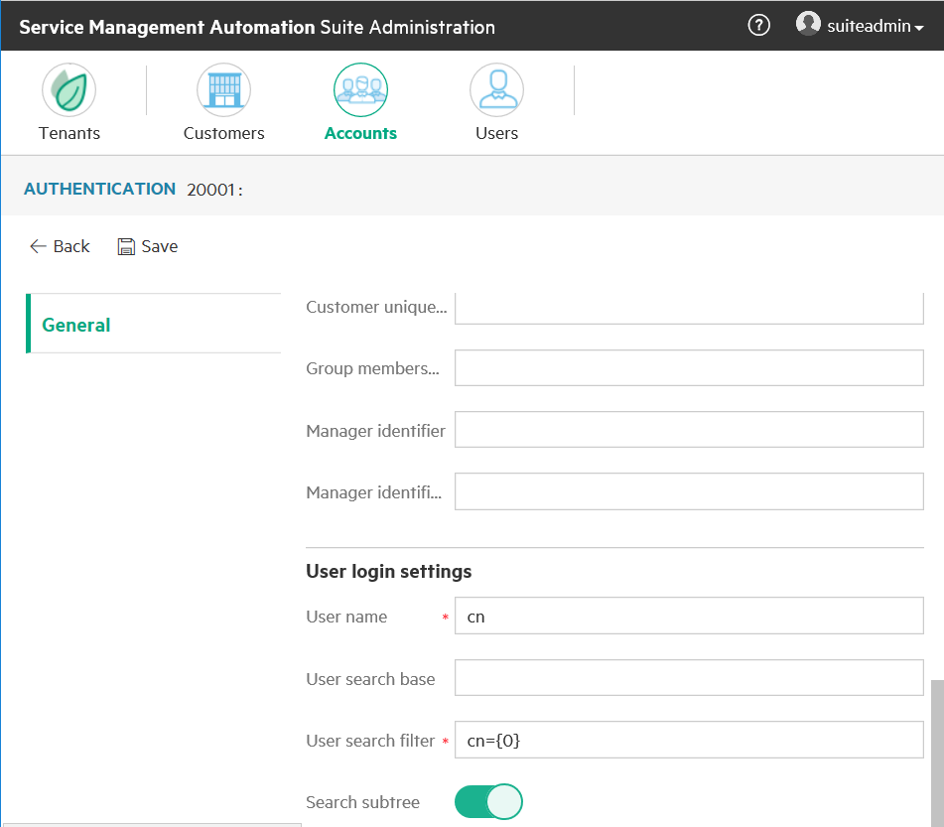

Click on Save
REST Method: Sync user from LDAP to IDM
- Open the tool Postman, and click on New to create a basic Request
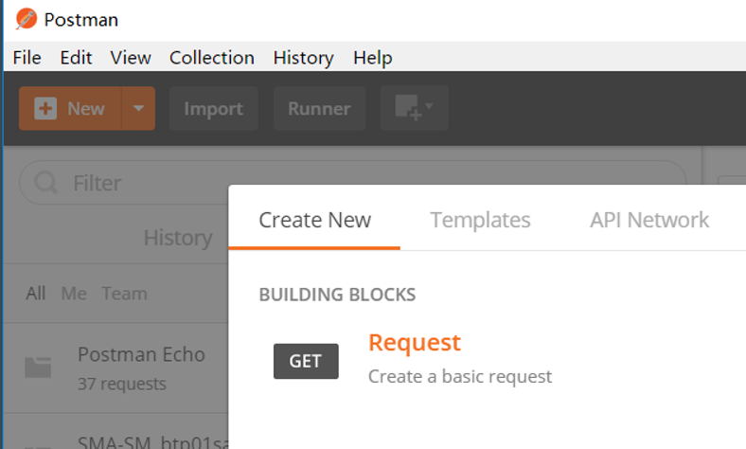

Set Request name and select a collection and click Save
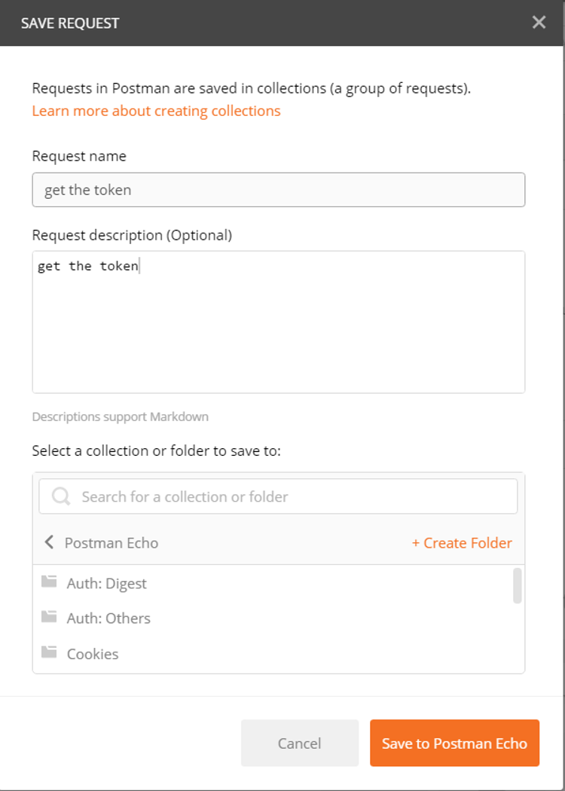

- Login with super admin, and get the token to be used next
Select the type POST, and enter request URL, for example
https://{{FQDN}}/idm_service/v2.0/tokens/
Click on tab Headers to add 3 parameters as below
Key | Value
Content-Type | application/json
Accept | application/json
Authorization | Basic aWRtVHJhbnNwb3J0VXNlcjppZG1UcmFuc3BvcnRVc2Vy

Click on tab Body and check raw to add codes as below
{
"passwordCredentials": {
"username" : "admin",
"password" : "propel"
},
"tenantName" : "Provider"
}
Note: The user admin is an integration user in Provider org with SUPER_IDM_ADMIN.
You could use the username / password / tenantName in SMA-X and SMA-SM in order to get the token
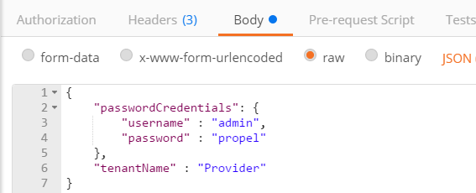

Then click on Send button. You would get the token marked in blue as below.
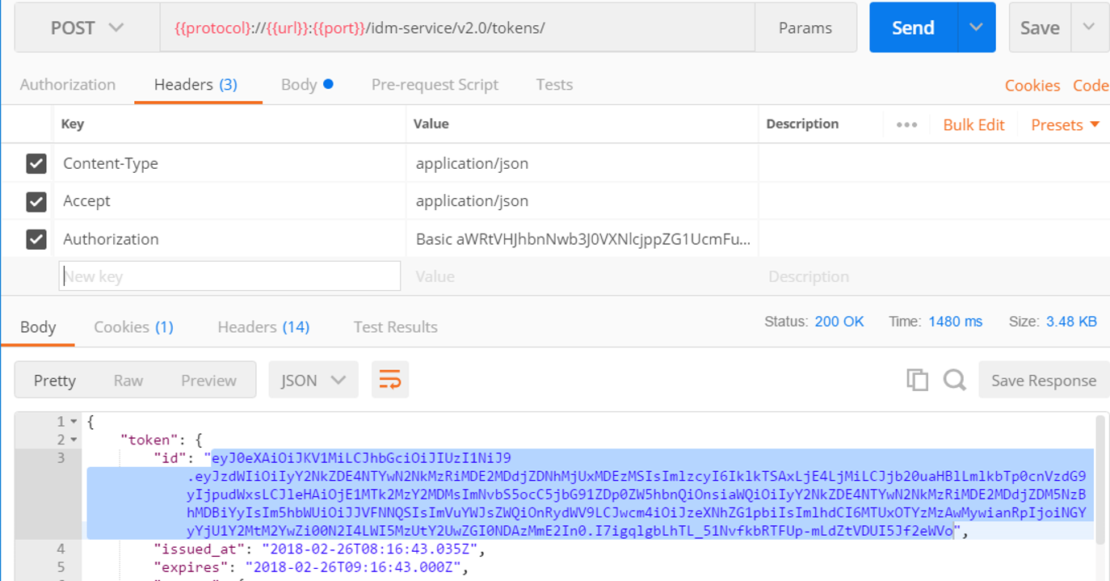

- Trigger a job to load user data from LDAP to IDM
Create another basic Request as step 1, select the type POST, enter request URL, for example
https://{{FQDN}}/idm-service/api/scim/tasks
Click on tab Headers to add 3 parameters as below, [X-Auth-Token] is the token copied from step 2
Key | Value
Content-Type | application/json
Accept | application/json
X-Auth-Token | [X-Auth-Token]

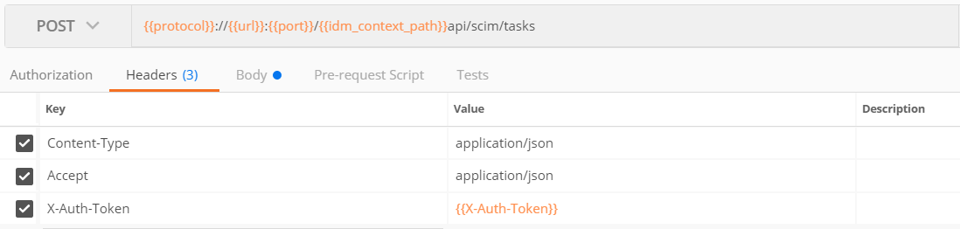

Click on tab Body and check raw to add codes as below
{
"taskName" : "LDAP_ROSTER_LOADER",
"operation" : "START"
}
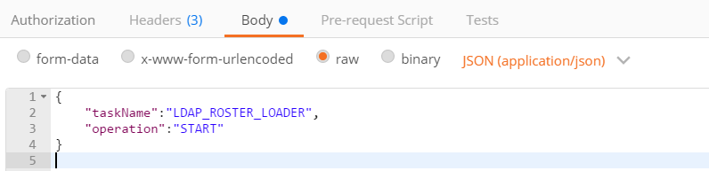
Then click on Send button.
The response code must be 200. The sync schedule job will run soon.
If not, go back to step 2 and check it again.
It may take some time, depending on the volume you are syncing.
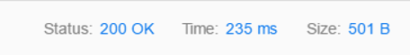
Verification: Check the user by below REST method, and login service portal (if you have user password)
- Postman: Check the user by REST method
Create another basic Request as step 1, select the type GET, enter request URL, for example

https://{{FQDN}}/idm-service/api/scim/organizations/{{accountid}}_ldap/users/{{username}}
Click on tab Headers to add 3 parameters as below, [X-Auth-Token] is the token copied from step 2 above.
Key | Value
Content-Type | application/json
Accept | application/json
X-Auth-Token | [X-Auth-Token]
Then click on Send button.
If the token is expired, you would get message below.
{
"code": "entity.accessDenied",
"detail": "Access is denied"
}
Please go to step 2 to renew the token, copy and paste to [X-Auth-Token]

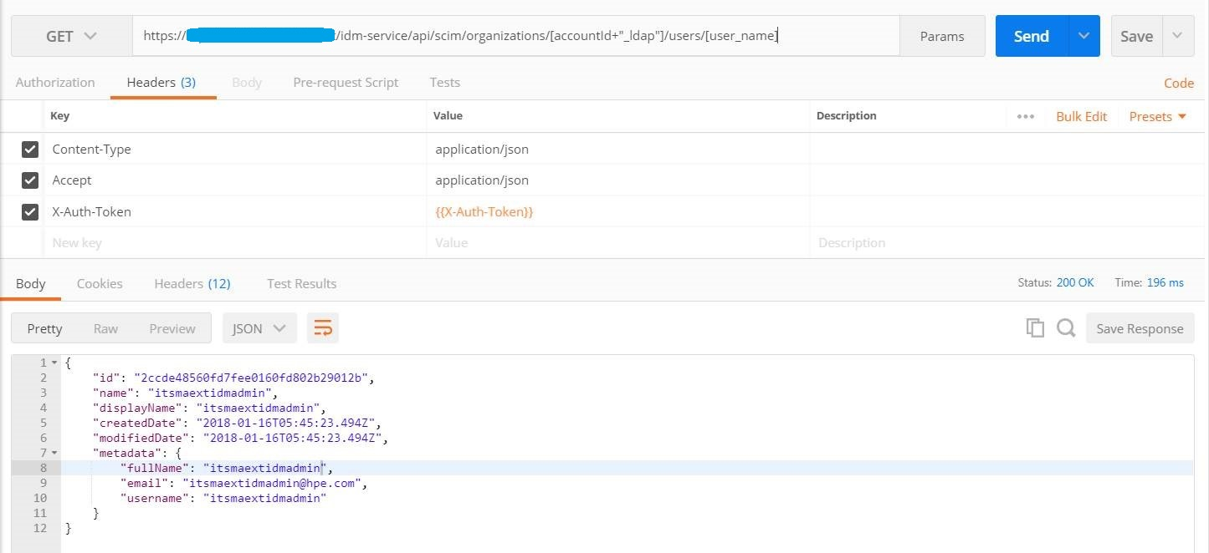

The result confirm the user is synced to IDM successfully
- Login Service Portal with the username / password with below URL
https://[FQDN]:443/saw/ess?TENANTID=[ TENANTID]

After login service portal, a specific user would sync to SMA-X persons table and BO users.
Before login service portal, the user is synced to IDM, not shown in SMA-X persons table nor BO users.

Note: If there are errors when login SMA-X Service Portal, please go to check Service Portal log
/var/vols/itom/itsma/itsma-itsma1-global/logs/xservices/serviceportal/itom-xservices-serviceportal-***-***-YYYY-MM-DD/maas/ess_error.log

