SMA-SM 201711_How to remove the Requested For field in Service Portal
Requirement:
Customer want to remove the Requested For field when request a service (for example Name Change) in SMA Service Portal.
Solution:
There is a new feature supported since SMA 2017.11 to meet the request.
STR in OOTB SMA-SM 2017.11
- Login Propel Admin UI as sysadmin
https://[FQDN]/propel/launchpad/dashboard
- Select Content Management, then find the Content Pack SM request to fulfilment, left click on the option button and click on Download to download the zip file.
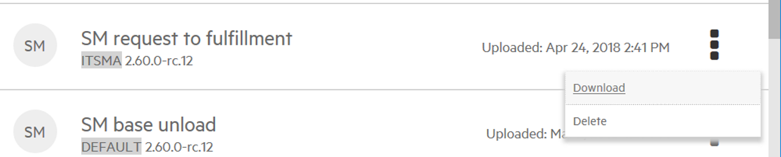
- Unzip the file, go to directory …\sm-r2f-2.60.0-rc.12\sx\templates and update 2 files as below
  - Open the file addItemToCart.ftl with notepad, and remove the line 30 and 31, save the change.

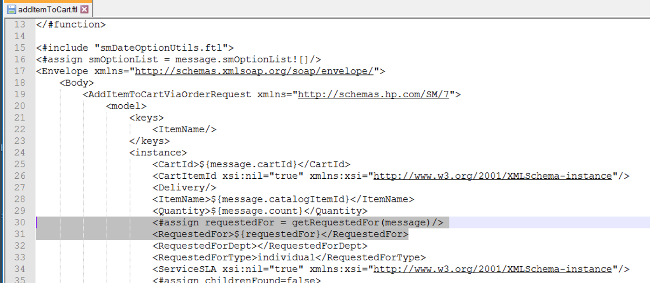
  - Open the file catalogFormUtils.ftl with notepad, and remove the line from 315 to 338, Save the change.

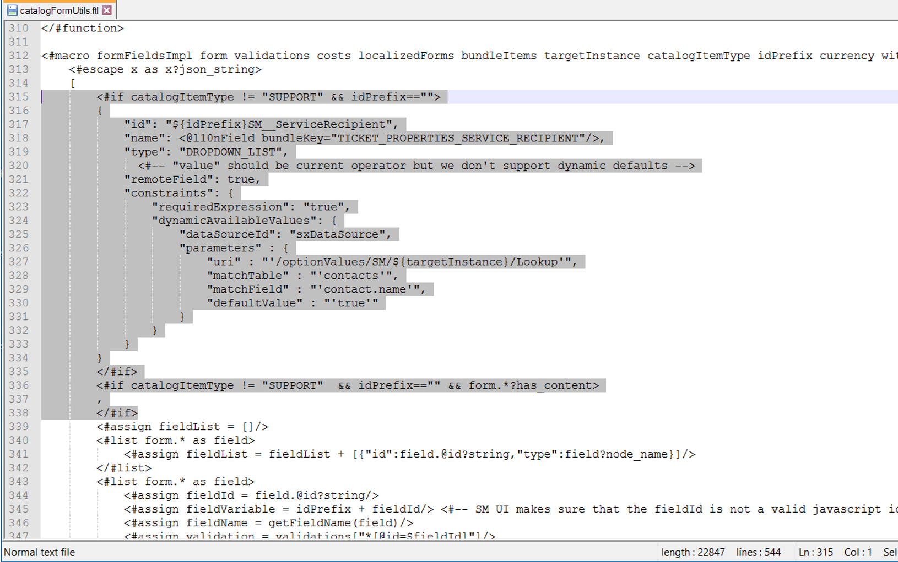
- Zip the updated folder to sm-r2f-2.60.0-rc.12.zip
- Go back to the Content Management page to Upload New Content Pack
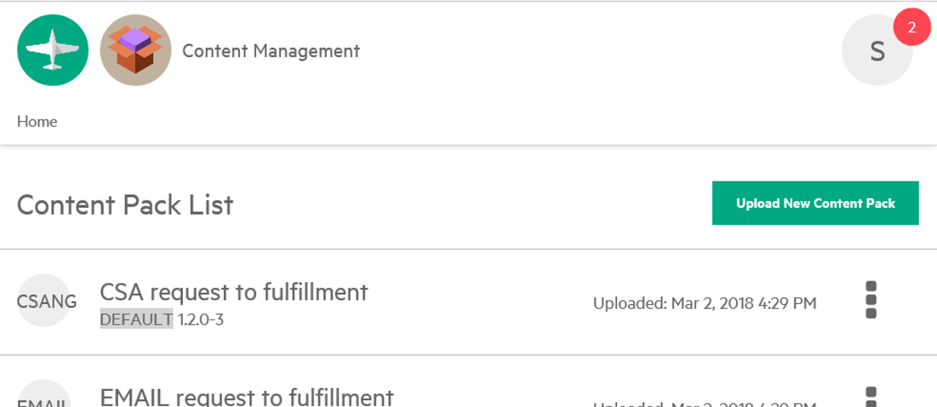

- After uploading successfully, click on the Launchpad icon left above the page, go to Catalog Connect, click on sm service from Aggregation List, left click on the option button and click on Restart Aggregation.
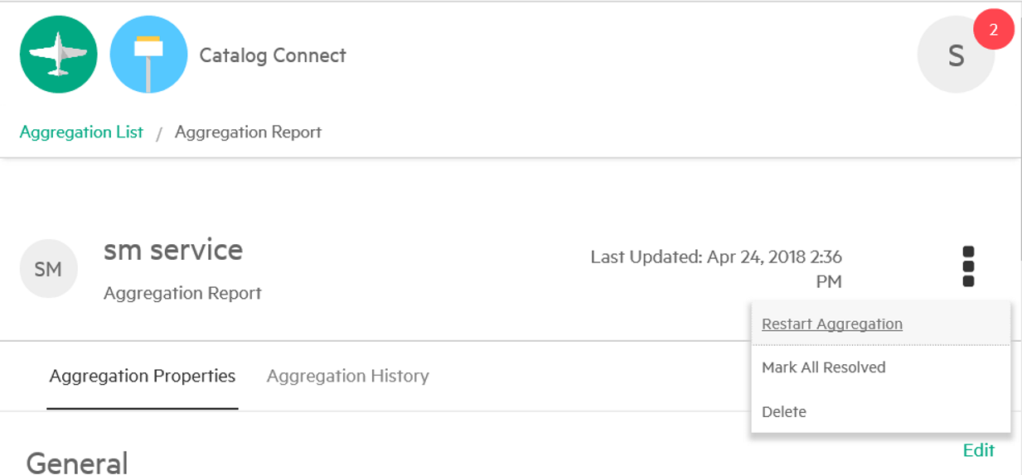
- Confirm the aggregation runs successfully
Verification:
- Login in SMA service portal with default user Aaron.Caffrey, password 123456
- Search Name Change, and click on REQUEST SERVICE button, there is no Requested For field. Go to submit the request. Refresh the page to get the interaction ID, for example SD10218.
- Login index.do as falcon / 123456, go to search the interaction ticket, and select the tab “Catalog Items”, the Requested For is set as the user Aaron.Caffrey who submit the request service.



