SMA-SM 2017.11_How to sync users from embedded OpenLDAP to IDM

Background Knowledge:
The auto user sync from LDAP to IDM follows 2 rules which are controlled by 2 parameters in IDM. The 2 rules description are as below:
1. Sync every 10 minutes for new groups
2. Sync every 12 hours for all old groups
If a new user is added to an old group, it would take 12 hours automatically
We could use REST API to sync all users from LDAP to IDM manually.
NOTE: There is no REST method to sync a specific user from LDAP to IDM
Scenario:
Add a new user whose uid is test1 in embedded OpenLDAP, add the user test1 in default group administrators;
Add a new group which cn is testgroup with a new user whose uid is test2, configure the new group in Propel Admin UI;
Use Postman to call REST API in order to sync user from OpenLDAP to IDM, then login Service Portal with the new user test1 / test 2 for verification.
Preparation:
1. Install the tool Postman, and go to File > Settings > Confirm "Variable autocomplete" is ON
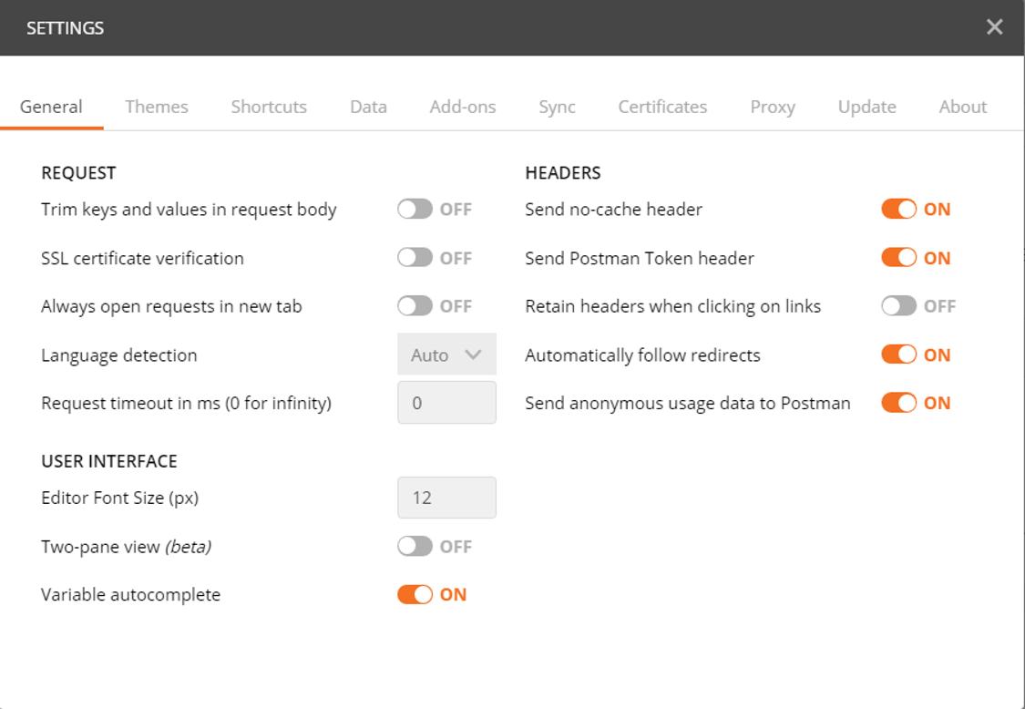
2. Install SMA-SM full containerized, the Service Portal URL should be accessed successfully
https://[FQDN]/saw/ess?TENANTID=100000002

3. Take the Embedded OpenLDAP for check. Open the Suite Configuration UI link
https:// [FQDN]/itsmaconfig/ldap
You could get the OpenLDAP configuration information as below
LDAP Server settings
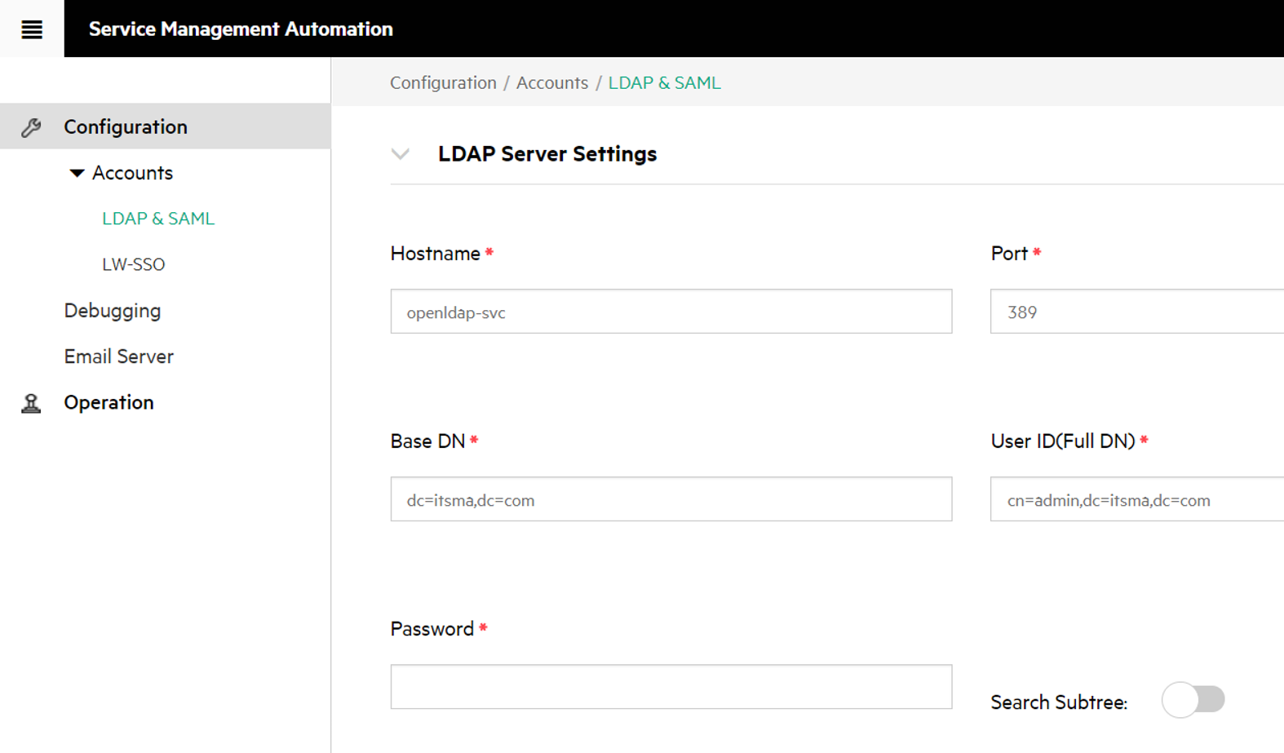
LDAP User Attributes
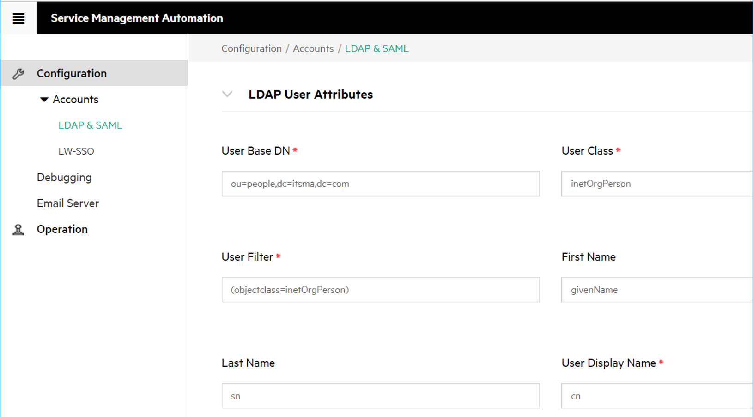

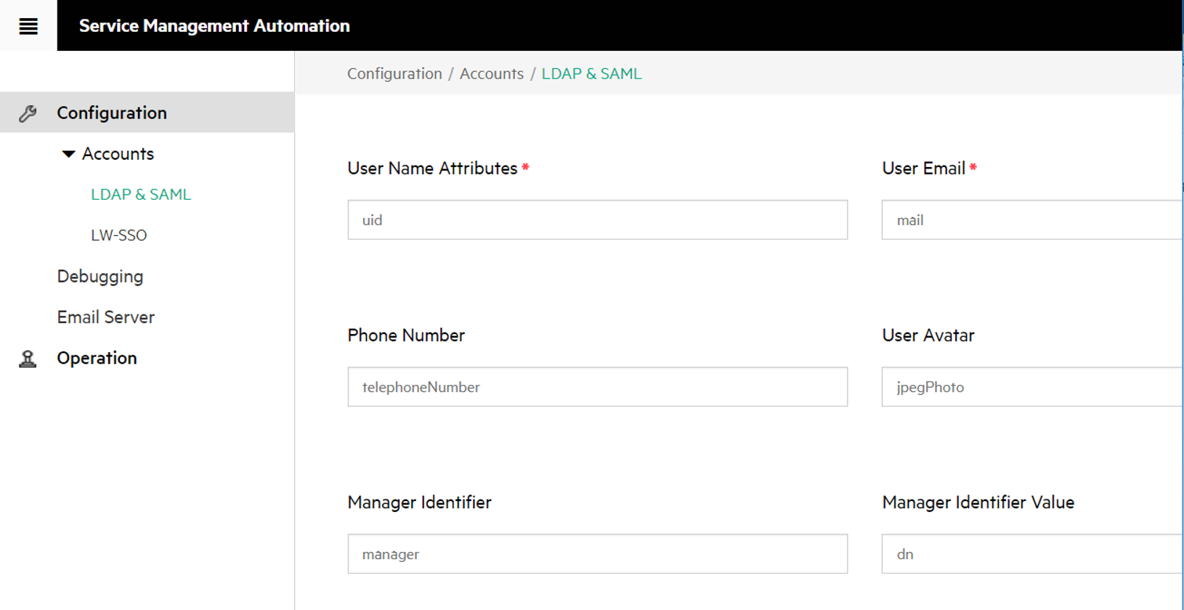

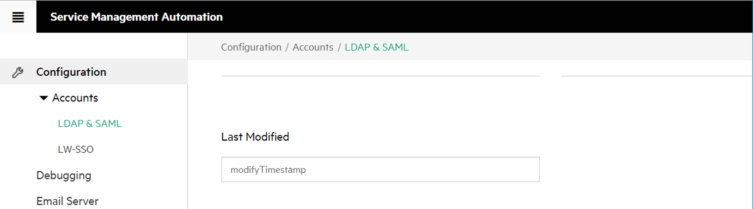
LDAP Group Attributes
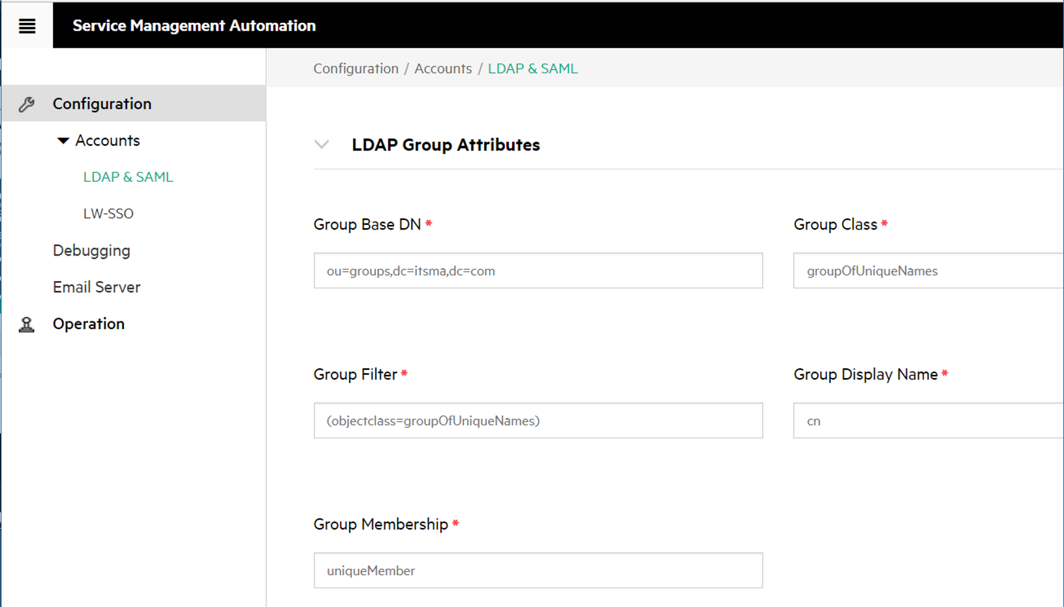

4. Use the LDAP connection tool Apache Directory Studio to connect to embedded OpenLDAP, please refer to below URL for detail
Configure users in the internal LDAP server
https://docs.microfocus.com/wiki/display/ITSMA201711H/Configure+users+in+the+internal+LDAP+server
5. Add 2 new users test1 and test 2 in OpenLDAP, add a new group testgroup. Add user test1 in default group administrators, add user test 2 in new group testgroup.
Select the cn FALCON, JENNIFER, right click of the mouse and select Copy Entry / DN
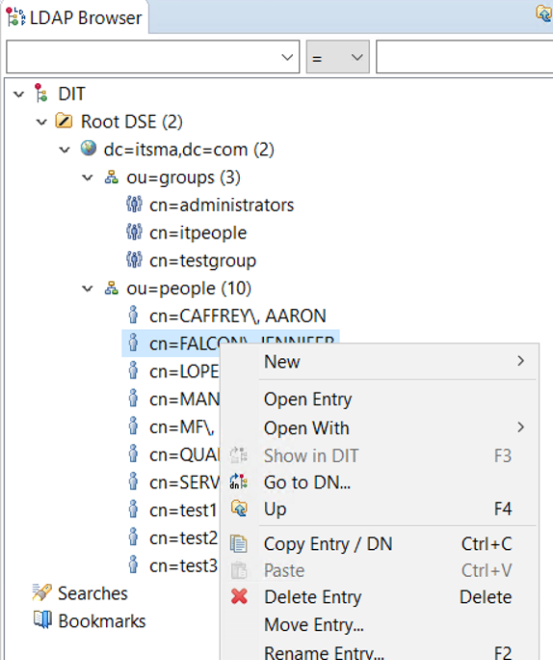
Select the ou people, right click of the mouse and select Paste Entry

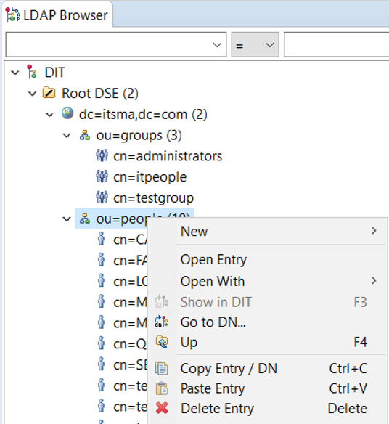

Select the option Rename entry and continue, update the cn to test1, click OK
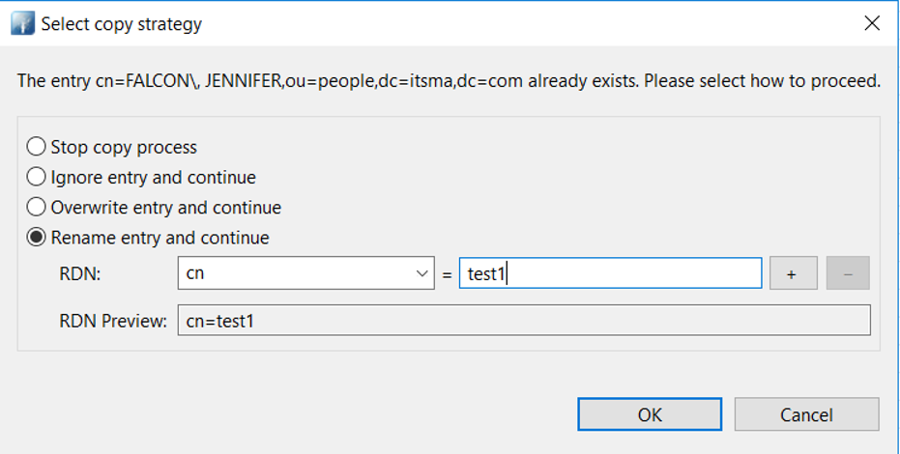
Select the cn test1, update the uid to test1 and other attributes as below
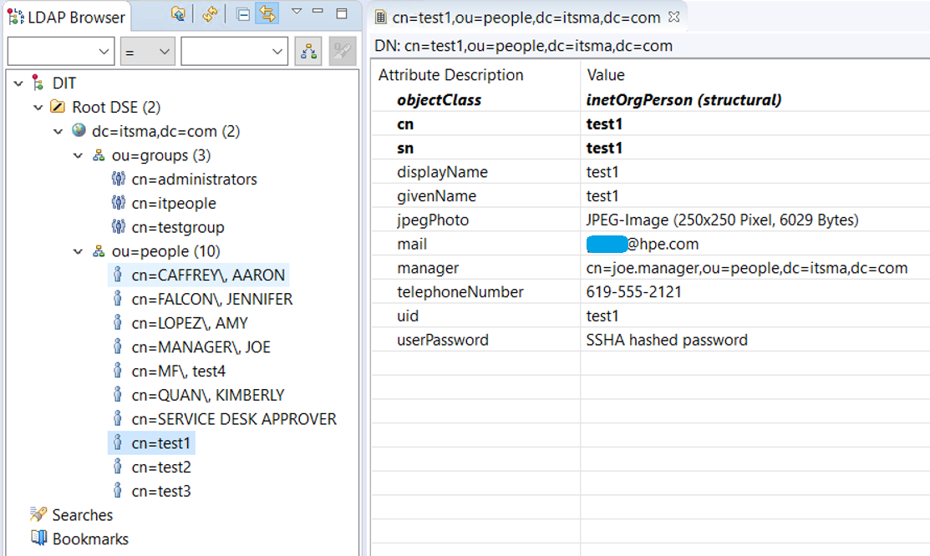
Select cn administrators, click on anywhere of the detail page, right click of the mouse, select New Attribute…
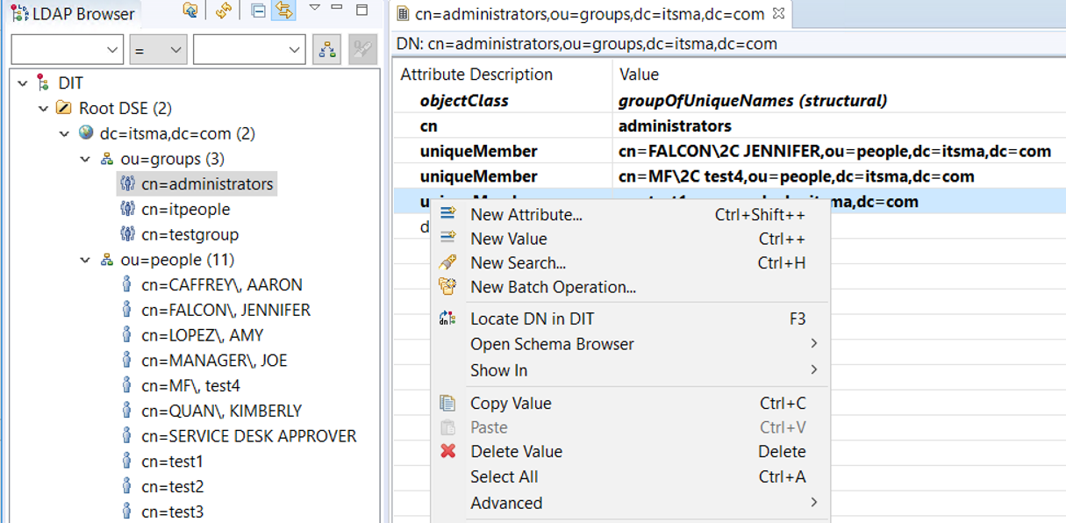

Attribute type select uniqueMember, click Finish
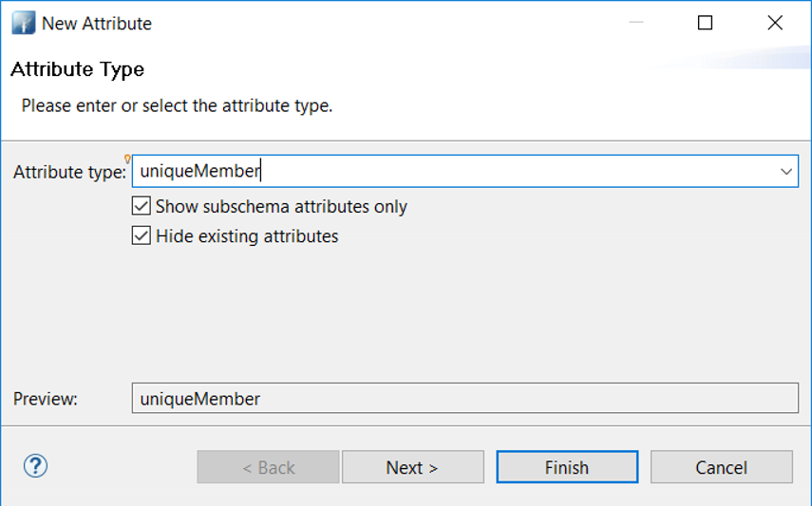

Set the value of the new uniqueMember to cn=test1,ou=people,dc=itsma,dc=com
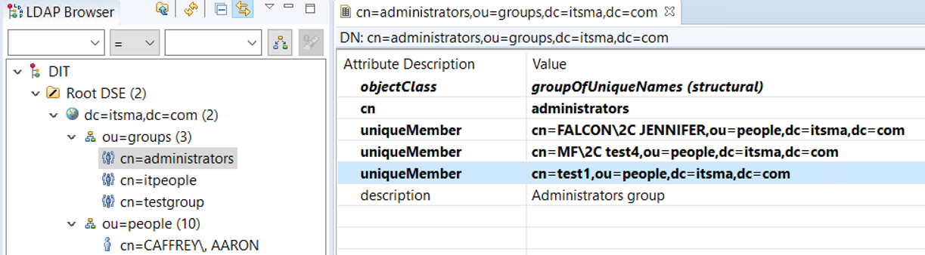
Use the same Copy / Paste Entry method to add a new user test2, a new group testgroup, and add the user test2 to the group testgroup
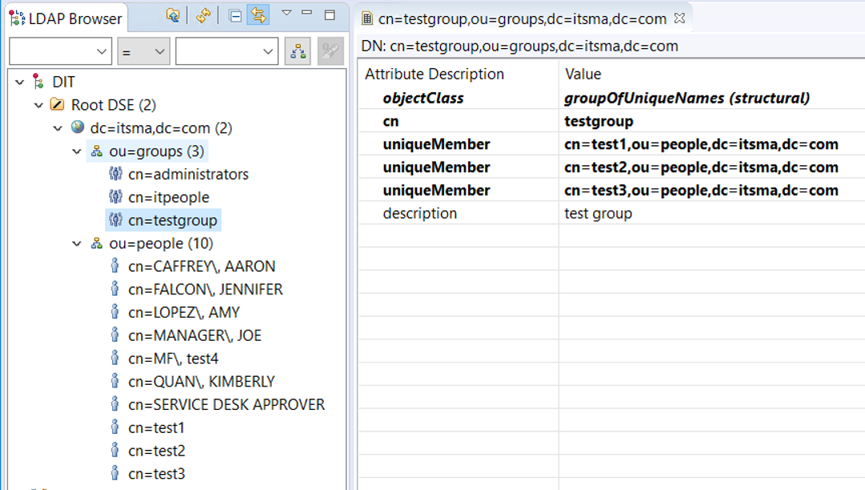
6. Configure Group DN for the group testgroup in Propel Admin UI
https://[FQDN]/propel/idm-admin/organization/ITSMA/group
Click on Add Group button
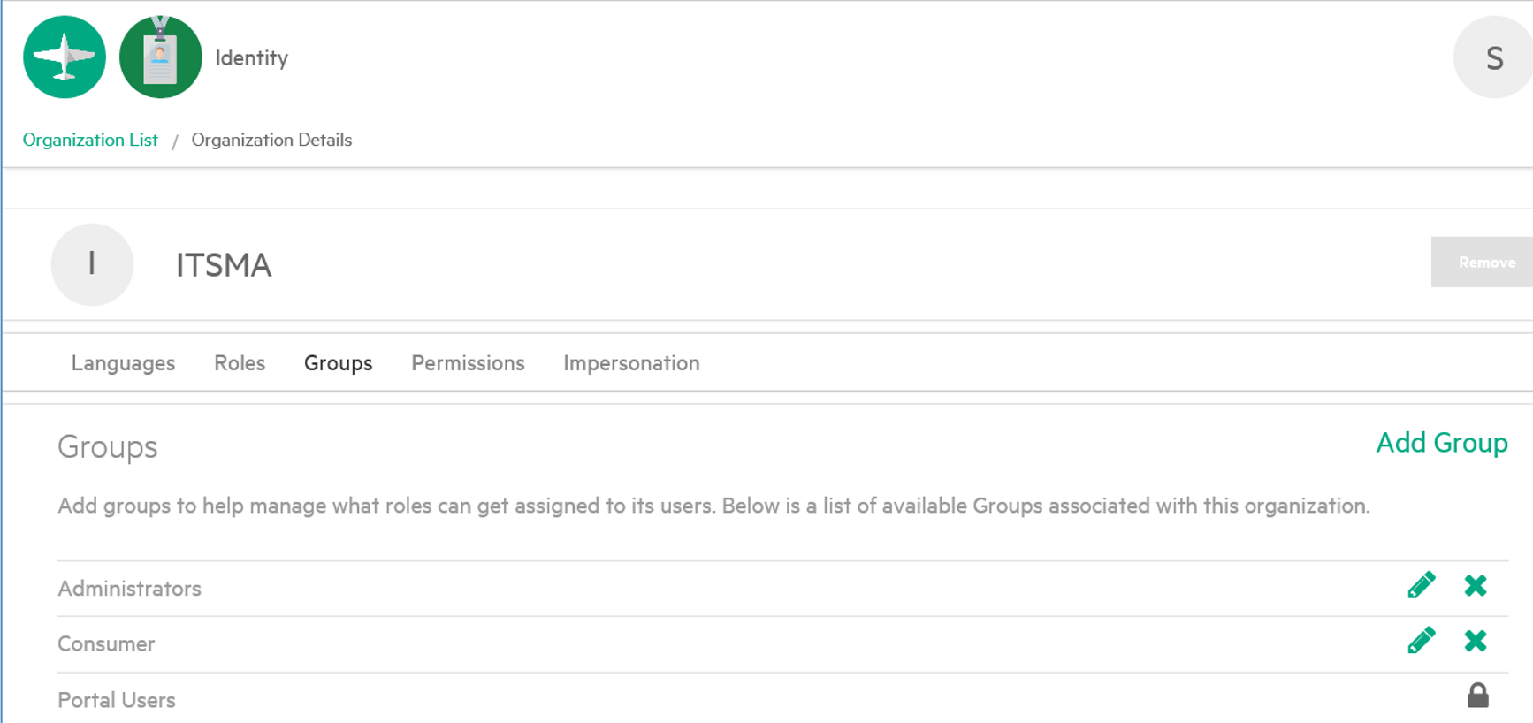
Fill Group Settings as below and click Save:
Group Name: testgroup
Distinguished Name: cn=testgroup,ou=groups,dc=itsma,dc=com
Authentication: ITSMA LDAP

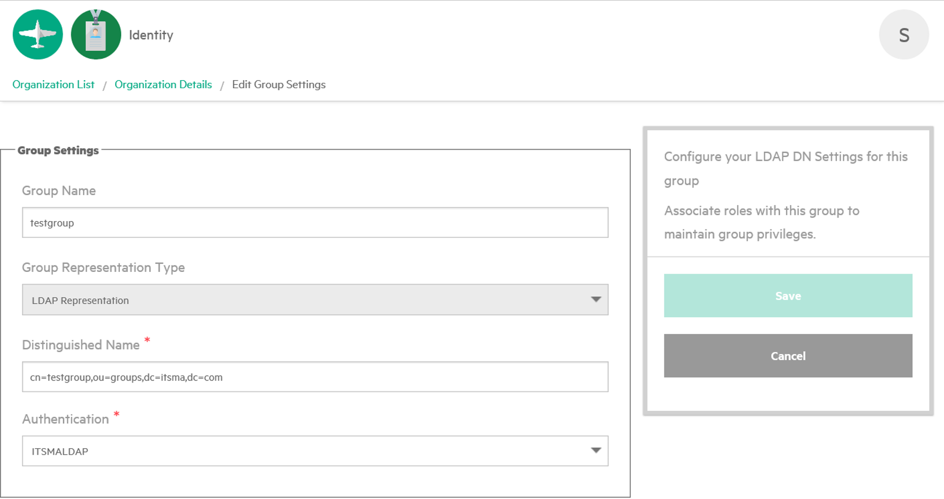
Call REST API: Sync user from embedded OpenLDAP to IDM
- Open the tool Postman, and click on New to create a basic Request
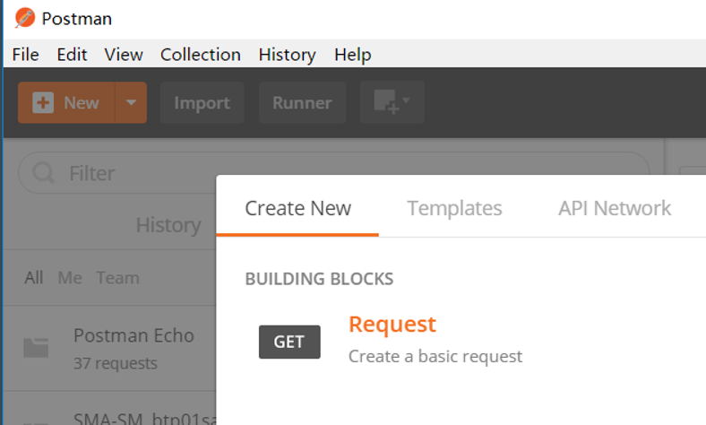

Set Request name and select a collection and click Save
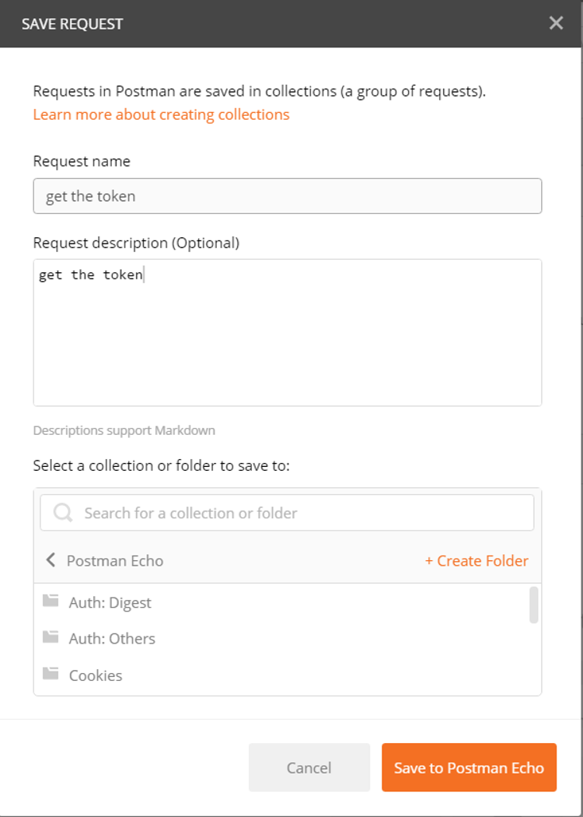

- Login with super admin, and get the token to be used next
Select the type POST, and enter request URL, for example
https://{{FQDN}}/idm_service/v2.0/tokens/
Click on tab Headers to add 3 parameters as below
Key | Value
Content-Type | application/json
Accept | application/json
Authorization | Basic aWRtVHJhbnNwb3J0VXNlcjppZG1UcmFuc3BvcnRVc2Vy

Click on tab Body and check raw to add codes as below
{
"passwordCredentials": {
"username" : "admin",
"password" : "propel"
},
"tenantName" : "Provider"
}
Note: The user admin is an integration user in Provider org with SUPER_IDM_ADMIN.
You could use the username / password / tenantName in SMA-X and SMA-SM in order to get the token
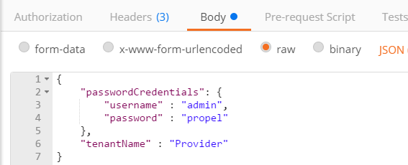

Then click on Send button. You would get the token marked in blue as below.
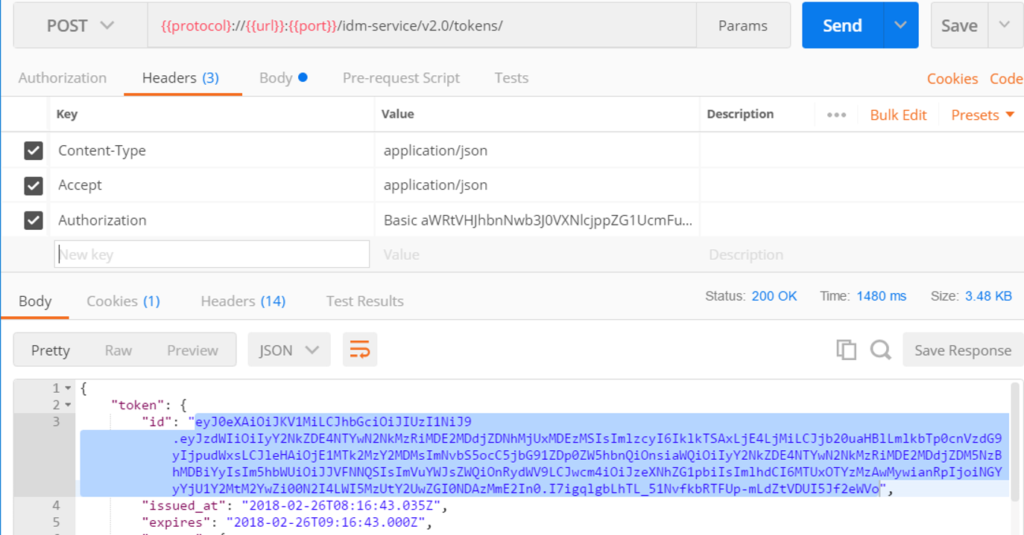

- Trigger a job to load user data from LDAP to IDM
Create another basic Request as step 1, select the type POST, enter request URL, for example
https://{{FQDN}}/idm-service/api/scim/tasks
Click on tab Headers to add 3 parameters as below, [X-Auth-Token] is the token copied from step 2
Key | Value
Content-Type | application/json
Accept | application/json
X-Auth-Token | [X-Auth-Token]

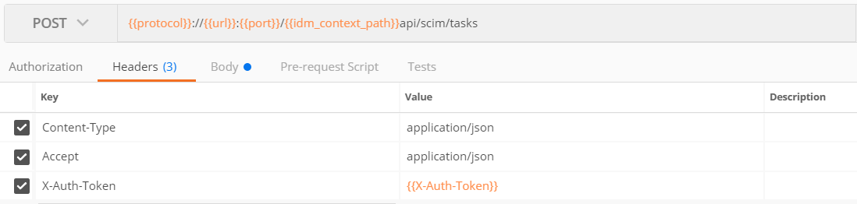

Click on tab Body and check raw to add codes as below
{
"taskName" : "LDAP_ROSTER_LOADER",
"operation" : "START"
}
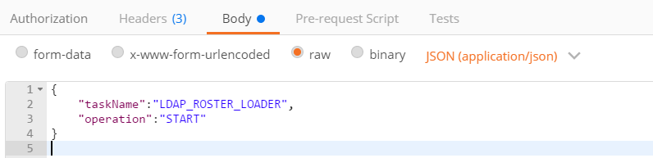
Then click on Send button.
The response code must be 200. The sync schedule job will run soon.
If not, go back to step 2 and check it again.
It may take some time, depending on the volume you are syncing.
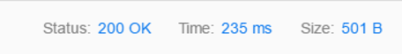
Verification: Login service portal. Check the user by calling REST API
- Login Service Portal with the username / password with below URL
https://[FQDN]/saw/ess?TENANTID=100000002

After login service portal, the specific user would be synced to SMA-SM operator table.
Before login service portal, the user is synced to IDM, not shown in SMA-SM operator table.
- Postman: Check the user by REST method
Create another basic Request as step 1, select the type GET, enter request URL, for example

https://{{FQDN}}/idm-service/api/scim/organizations/ITSMA/users/{{username}}
Click on tab Headers to add 3 parameters as below, [X-Auth-Token] is the token copied from step 2 above.
Key | Value
Content-Type | application/json
Accept | application/json
X-Auth-Token | [X-Auth-Token]
Then click on Send button.
If the token is expired, you would get message below.
{
"code": "entity.accessDenied",
"detail": "Access is denied"
}
Please go to step 2 to renew the token, copy and paste to [X-Auth-Token]
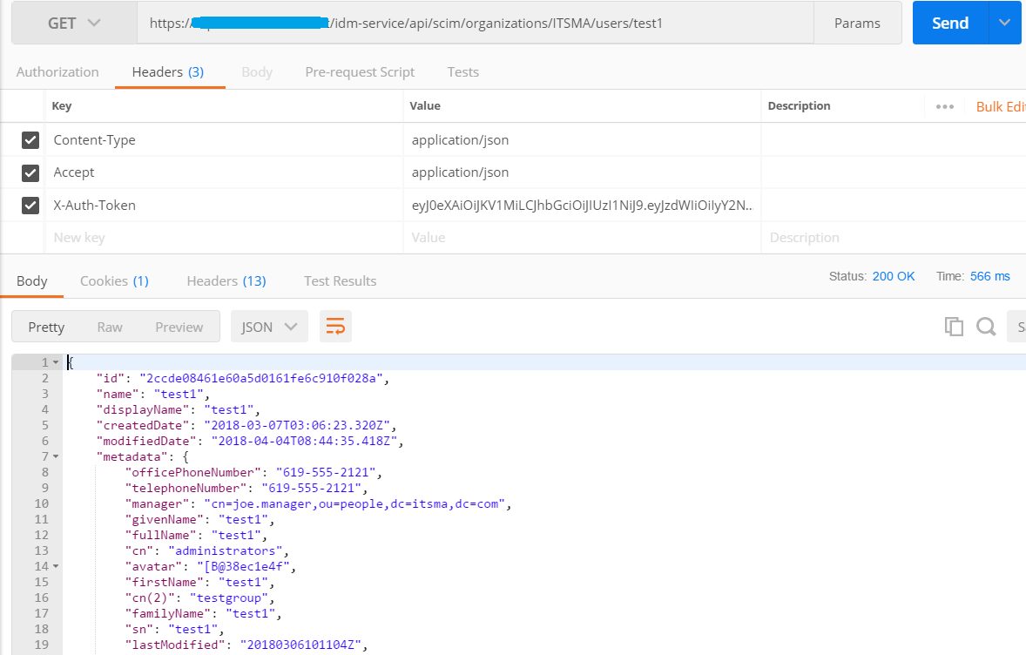
The result confirm the user is synced to IDM successfully
- Login SM index.do as falcon / 123456 to check the new user in operator table, check the new group in assignment table
https://[FQDN]/webtier/index.do
SM set a default User Role self service to the new operator, no group is assigned.

Note: After new login to Service Portal, above REST API could return the user information. But before new user login to Service Portal, above REST API could not return the user.
Note: If there are errors when login SMA-X Service Portal, please go to check Service Portal log
/var/vols/itom/itsma/itsma-itsma1-global/logs/xservices/serviceportal/itom-xservices-serviceportal-***-***-YYYY-MM-DD/maas/ess_error.log

