How to setup BSM 9.2x
with
Service Health Analyzer (SHA) Data Collector for Performance Agent (PA)

Table of Contents
Overview 2
Test Environment 3
Integrate SiteScope with BSM 4
Setup Operations Agent integration with BSM 5
Verification : does OA (embedded PA and/or Coda) collect data? 10
Verification : does BSM recognize the Operations Agent instance? 13
Verification : can BSM graph OA / PA metrics via PMi? 14
Install BSM SHA Data Collector for Performance Agent 15
JMX for SHA Data Collector 19
Enable / configure SHA to collect metrics from PA 20
What metrics does SHA DC for PA collect by default 24
TQL “Hosts with HP Operations Agents – Discovery” doesn’t work 25
Verify that SHA collects PA metrics 27
Running SHA DC for PA without installing it 30

Overview
This document gives an overview how to setup the BSM SHA Data Collector for PA,
including the steps required to integrate SiteScope with BSM, the Operations Agent with SiteScope,
and all other required setup steps plus some troubleshooting information.

Test Environment
- BSM 9.21 is installed on a Windows 2008 system,
system name is vm17094
- SHA is licensed and enabled via Server Deployment
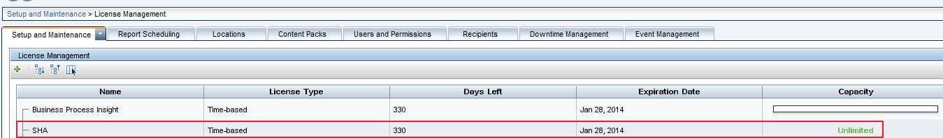
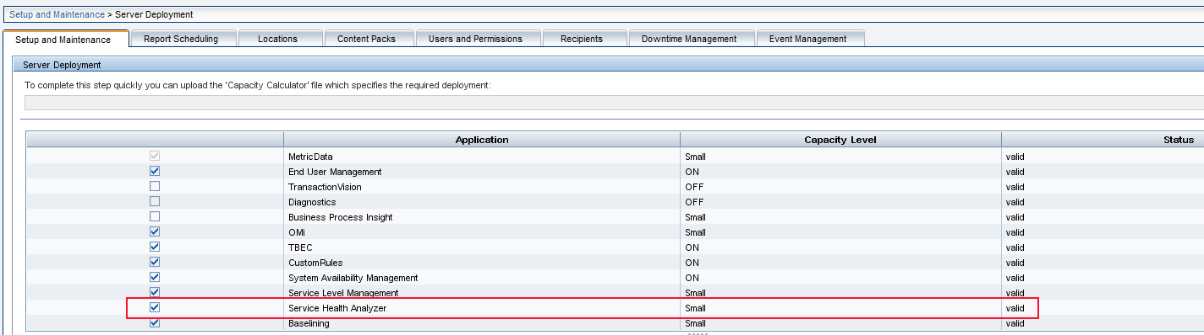
- SHA database has been defined
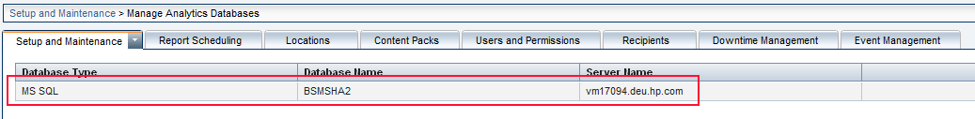
- SiteScope 11.20 with Operations Agent is installed on a Windows 2008 system,
system name is vm25174
SiteScope 11.20 carries Operations Agent 11.02.011
Operations Agent 11.x also includes the Performance Agent

Integrate SiteScope with BSM
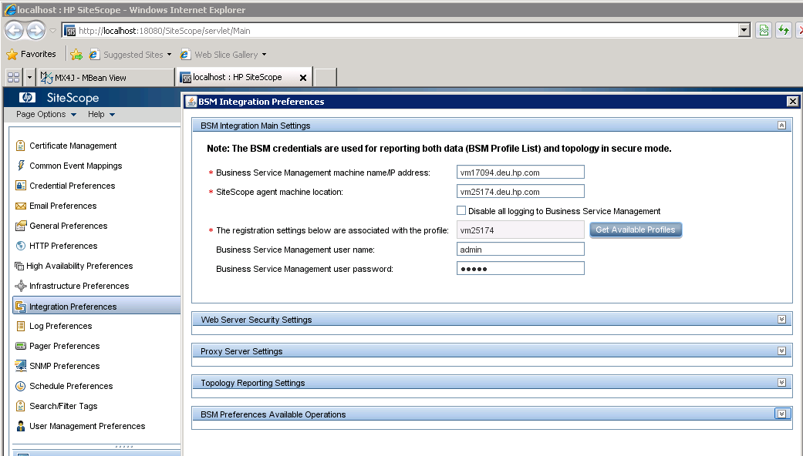

Setup Operations Agent integration with BSM
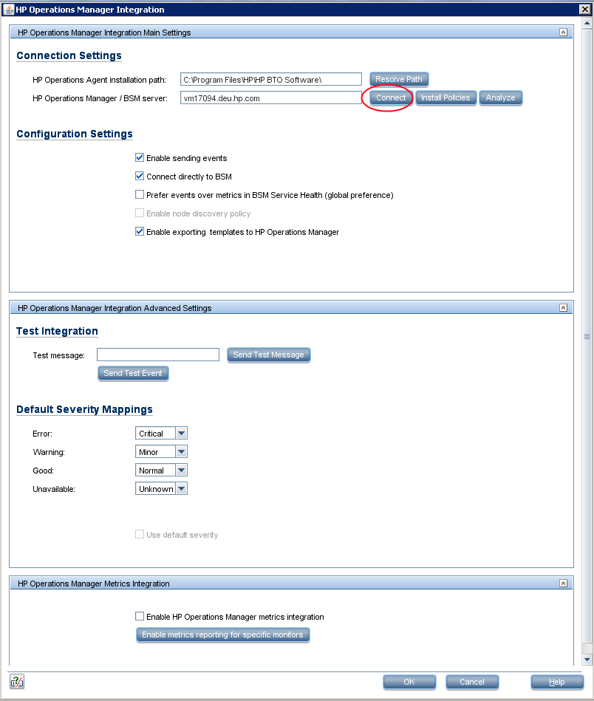
Clicking on “Connect” will run opcactivate, which does a lot of magic behind the scenes.
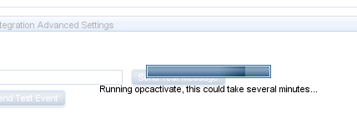
Please make sure to follow the comments in the output:
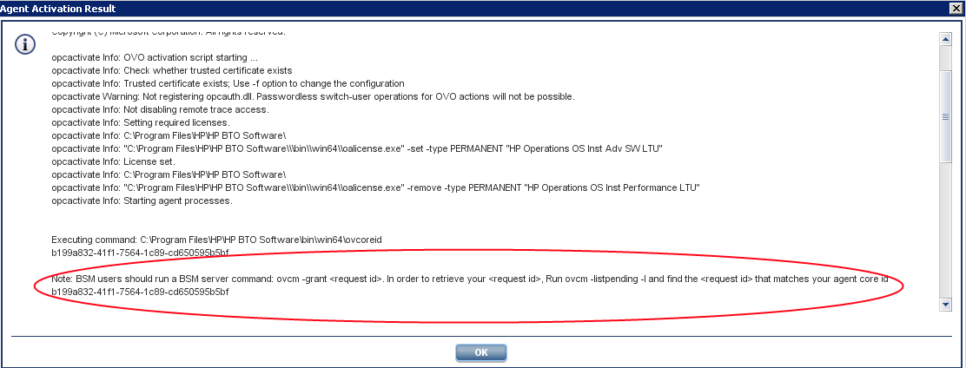
as one needs do execute (on the BSM server)
- ovcm –listpending –l
this will return the certificate request from the SiteScope server
take a note of the request_id and then execute
- ovcm –grant <request_id from above>
Next is to click on “Install Policies”
If all this worked as expected, click on “Analyze” and make sure you see this line:
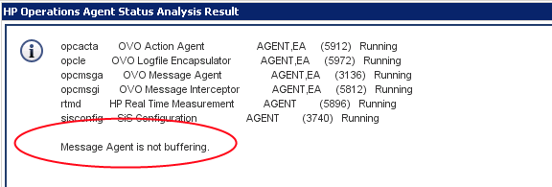
If the line says something like “Message Agent is buffering locally” or alike,
it means the agent cannot talk to the BSM server, for example the certificate request has not been granted yet.
To check whether or not the event integration to BSM / OMi works,
use these two tests:
“Sent Test Message” uses the OA’s tool opcmsg to send a message
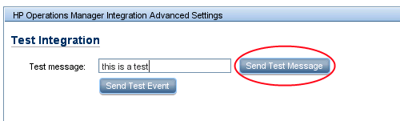
This should result in the following popup
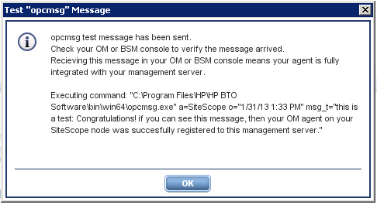
and this entry in BSM -> Applications -> Operations Management -> Event Perspective
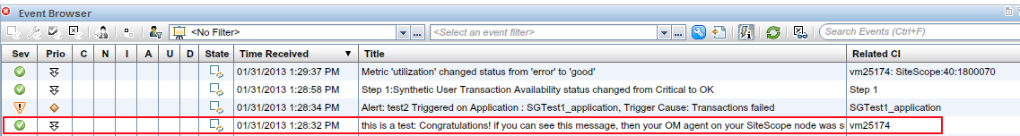
Similar test:
“Sent Test Event” writes a line into the integration log file which is then analyzed by the policies deployed before
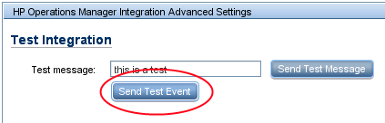
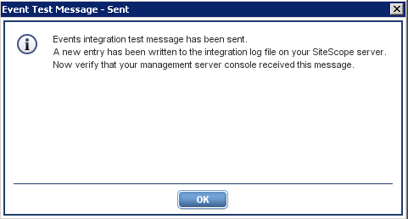
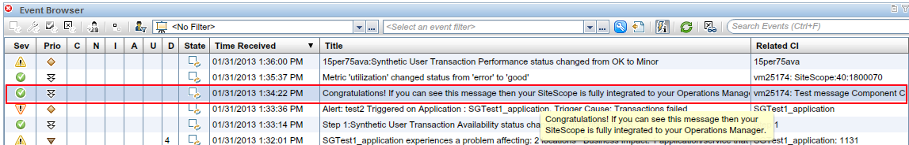

Note:
This type of automated integration displays all OA commands it uses,
so all this can be done manually as well, or commands can be copied and used if needed, for example
bbcutil.exe -ping <bsmserver>
opcagt.bat -status
ovcert -check
ovpolicy -list

Verification : does OA (embedded PA and/or Coda) collect data?

Are the processes up and running?
C:\Users\Administrator>perfstat
******************************************************
** perfstat for VM25174 Thu Jan 31 14:00:17 2013
** Microsoft Windows [ Version 6.1.7600 ]
******************************************************
List of Performance Tool Processes:
===================================
pid: 1100 dsisrv (DSI service)
pid: 1588 midaemon (measurement interface)
pid: 1544 misrv (measurement interface service)
pid: 2012 perfalarm (Alarm generator)
pid: 1980 perfalarmsrv (Alarm generator service)
pid: 2784 scopent (data collector)
pid: 2720 scopesrv (collector service)
pid: 352 perfd (Real Time Metric Access Daemon)
pid: 880 perfdsrv (Real Time Metric Access Service)
pid: 2420 ttd (transaction tracking)
pid: 2356 ttsrv (transaction tracking service)
pid: 1384 coda (CODA performance component)
Configured Datasources[1]
SCOPE
pid: 5896 rtmd (Real Time Measurement daemon)
pid: 5548 ovbbccb (BBC5 communication broker)
pid: 560 ovcd (OV control component)
All critical MeasureWare processes are executing
MeasureWare Extended Collection status
pid: 1756 Mwecsrv (extended collection service)
All critical MeasureWare Extended Collection processes are executing
============= (end of perfstat -p output) ===========

Data can be found in the collector logfiles. These are located at
%ovdatadir%datafiles
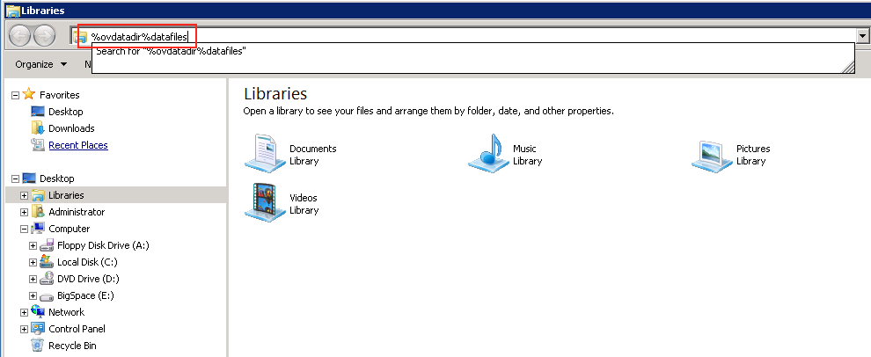
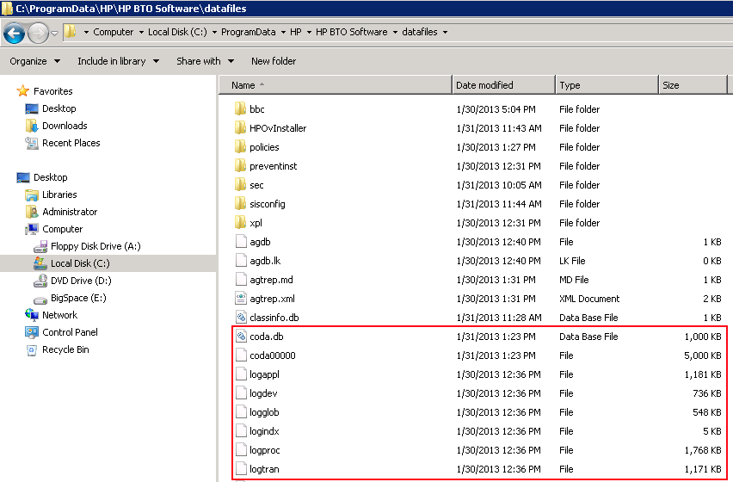

C:\Users\Administrator>ovcodautil –showds
NumDataSources = 2
SCOPE
CODA
C:\Users\Administrator>ovcodautil –dumpcoda
=== 01/31/13 2:00:00 PM
..
GBL_CPU_TOTAL_UTIL : 5.24
..

Verification : does BSM recognize the Operations Agent instance?

- Go to BSM -> Administration -> RTSM -> IT Universe Manager
select the view “System Software Monitoring”:
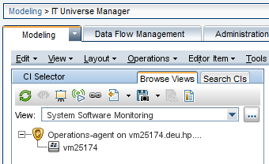
or
- Go to BSM -> Applications -> Service Health -> 360° View
select view “System Software Monitoring”:
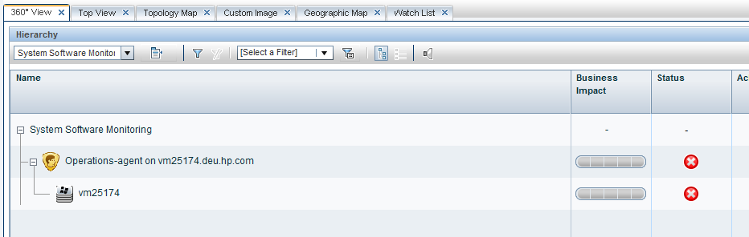
Note:
the view “Hosts with HP Operations Agents” ONLY shows system which have been setup via a HP OM system.
As in this example we integrated the Operations Agent with BSM directly, it doesn’t show up in this very view:
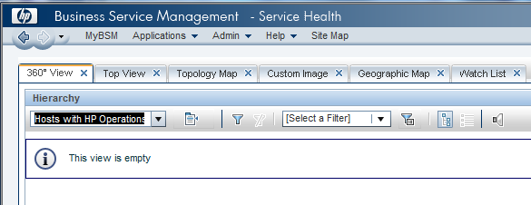

Verification : can BSM graph OA / PA metrics via PMi?

If all works as expected, one now can graph OA / PA metrics via the BSM Performance Perspective:
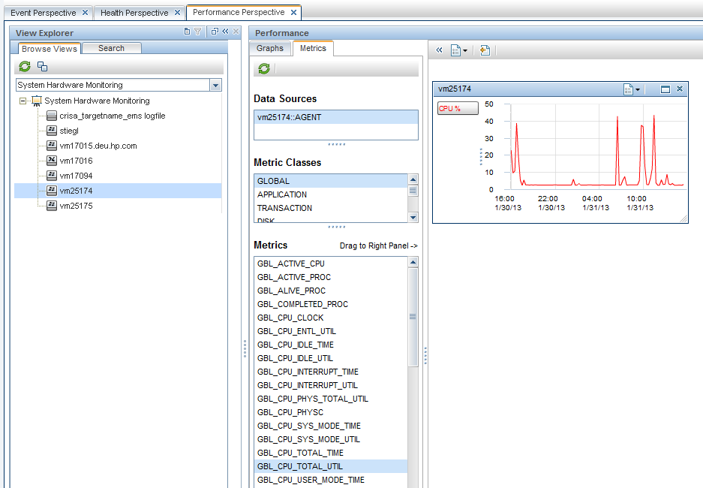

Install BSM SHA Data Collector for Performance Agent

Finally SHA DC for PA needs to be installed
Note:
if you plan to install the SHA DC for PA on the same system running the Operations Agent, you need to FIRST install the Operations Agent (here SiteScope with the Operations Agent),
otherwise the Operations Agent installation will fail due to version issues with multiple Ov packages.
Note:
SHA PA DataCollector is a strip-down version of BSM, and thus cannot be installed on a system where BSM has been installed already.
To install SHA PA Data Collector:
execute setup.exe
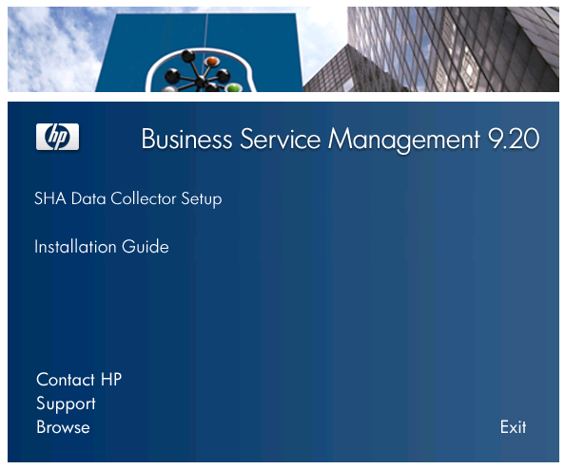
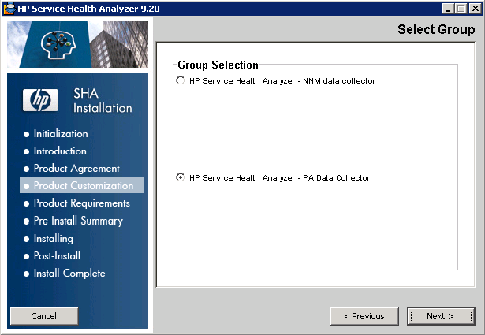
If you get this message
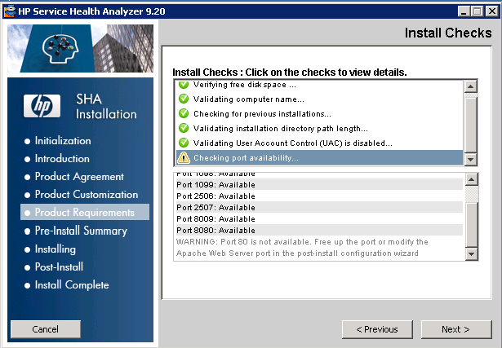

IIS or Apache might be active on the system, using port 80.
Other then with full BSM, SHA DC post-install configuration wizard does NOT allow the modification of the port, so better make sure that the port is free during installation.
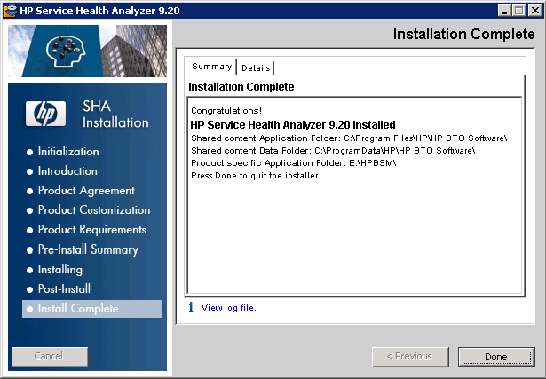

The remaining steps for the installation now are just to tell SHA DC what database to connect to (that’s the BSM Management database from the BSM installation running SHA) and the JMX password.
After the installation completed successfully, SHA DC needs to be started.
This is done the same way BSM is started:
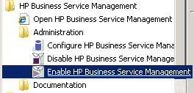
The progress and status of the startup can easily be checked by monitoring the logfile
<BSM>\log\supervisor\nannyStatus.all
…
2013-01-31 12:35:12,266 analytics_dc STOPPED
2013-01-31 12:35:12,267 analytics_dc LAUNCHED
2013-01-31 12:35:16,650 analytics_dc STARTING
2013-01-31 12:35:16,651 analytics_dc STARTED
2013-01-31 12:35:16,775 All services started in 4s
Now SHA DC for PA is ready to be used and can be configured.

JMX for SHA Data Collector

SHA DC offers a JMX Console via port 29931, as one can learn from the logfile
<BSM>\log\analytics_dc_boot.log
2013-01-31 12:35:22,852 - HttpAdaptor version 3.0.2 started on port 29931
http://<system with SHA DC for PA installed>:29931
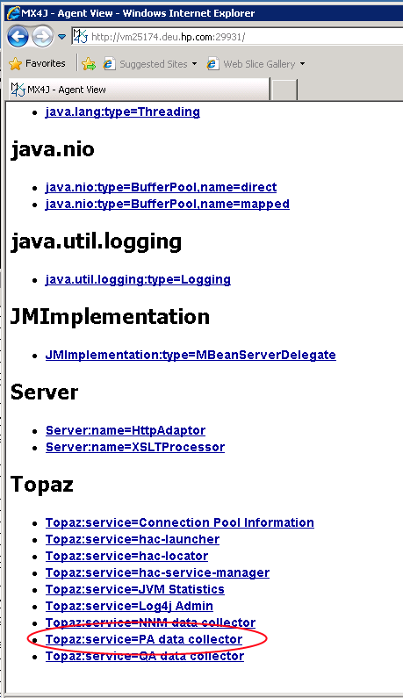

Enable / configure SHA to collect metrics from PA

To enable SHA to collect metrics from PA, a Business Service needs to be created and CIs assigned to it.
First create a Business Service via BSM -> Admin -> Service Level Management -> Services Manager and assign the system running OA to it:
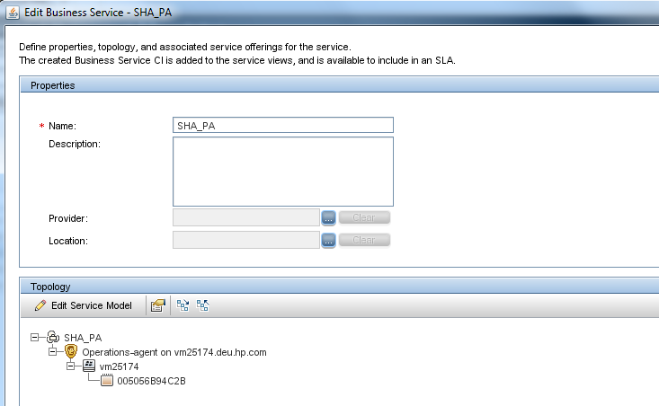
Then this Business Service is added to the SHA CI Selection:
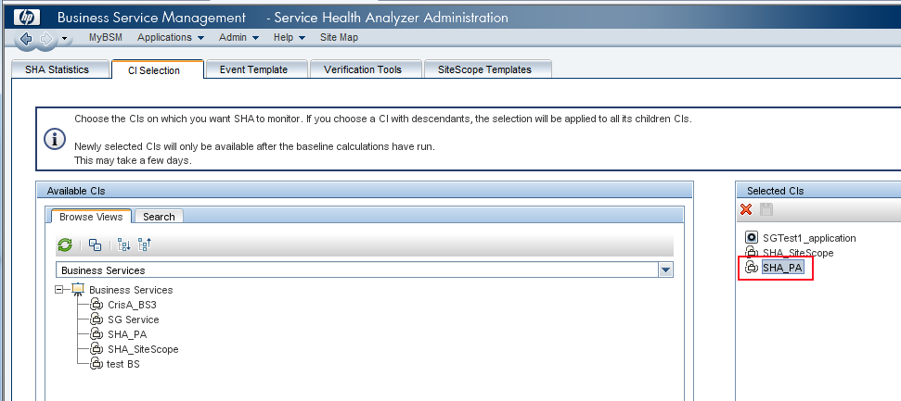

Important note:
The Data Collector collects data from the agents it finds via the view/TQL “Hosts with HP Operations Agents”. The agent’s node CI must be part of the CIs in the CI selection.
If the agent has not been registered via an OM server but to BSM directly (like in this example), the Infrastructure Settings need to be changed to use the TQL
“Hosts with HP Operations Agents – Discovery”.
This requires that Discovery reported the agent:
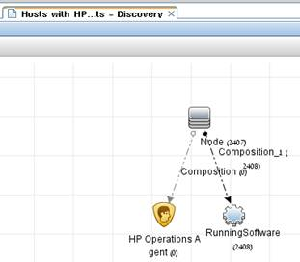
BSM -> Administration -> Platform -> Infrastructure Settings
select
Foundations : Analytics Data Collector
change
PA Agents view name from
“Hosts with HP Operations Agents”
to
“Hosts with HP Operations Agents – Discovery” (without quotes)
and save the change.
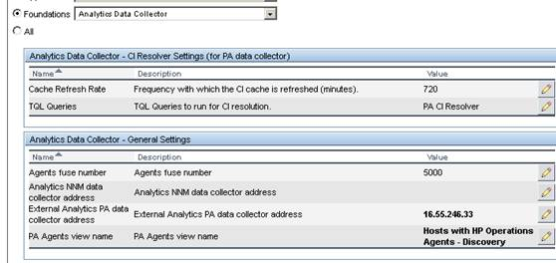

After this change, run the refreshPAAgents JMX:
for this access
http://<system with SHA DC for PA installed>:29931
Topaz:service=PA data collector
invoke java.lang.String refreshPAAgents
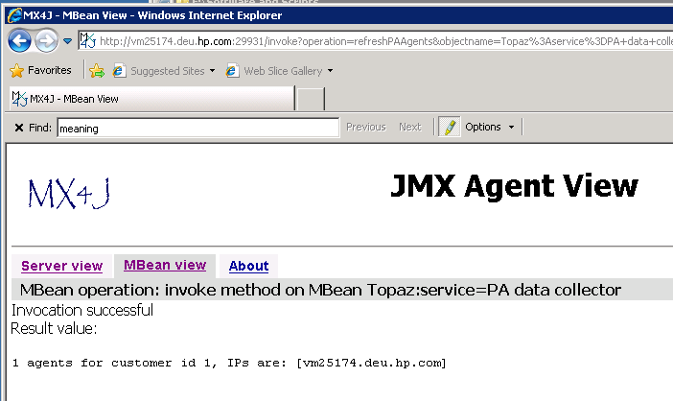
If everything is configured properly, one will see this message:
1 agents for customer id 1, IPs are: [vm25174.deu.hp.com]
If not, one will see:
0 agents for customer id 1, IPs are: []
Now check the PA Agent Status
for this access
http://<system with SHA DC for PA installed>:29931
Topaz:service=PA data collector
invoke java.lang.String agentsStatus
customerId : 1
Agent{ciId=a4bd48c386fe4ff54211c63b673e784d, agentAddress='vm25174.deu.hp.com', average samples per 5 minutes in the last hour=[SCOPE: 28 ], status=AgentStatus{lastBadConnectionTime=, lastGoodConnectionTime=Thu Mar 07 19:03:14 CET 2013, lastGoodDataAccessTime=Thu Mar 07 19:03:14 CET 2013, lastBadDataAccessTime=, dataAccessDurationTime=64, createConnectionDurationTime=61, numberOfFailedConnectionRetries=0, numberOfFailedDataRetries=0, numberOfSuccessConnectionRetries=2, numberOfSuccessDataRetries=2, poolingInterval=AgentPoolingInterval{timeUnit='MINUTES', interval=5}, lastTimeFrameTo=1362679394565, state=DATA_POSTED}, connection=AgentConnection{codaObjects={
{-1 SCOPE SCOPE C:\ProgramData\HP\HP BTO Software\\datafiles\logglob={Object name : NETIF 11=AgentCodaObject{metrics=[BYNETIF_IN_PACKET_RATE, BYNETIF_OUT_PACKET_RATE], instances={Instance: ID = 0Number of strobes: 0Number of Keys: 1Instance Key: BYNETIF_NAME 14 DATA:class java.lang.String=a4bd48c386fe4ff54211c63b673e784d, Instance: ID = 1Number of strobes: 0Number of Keys: 1Instance Key: BYNETIF_NAME 14 DATA:class java.lang.String=a4bd48c386fe4ff54211c63b673e784d, Instance: ID = 2Number of strobes: 0Number of Keys: 1Instance Key: BYNETIF_NAME 14 DATA:class java.lang.String=a4bd48c386fe4ff54211c63b673e784d, Instance: ID = 3Number of strobes: 0Number of Keys: 1Instance Key: BYNETIF_NAME 14 DATA:class java.lang.String=a4bd48c386fe4ff54211c63b673e784d}}
, Object name : GLOBAL 1=AgentCodaObject{metrics=[GBL_SYSCALL_RATE, GBL_ACTIVE_CPU, GBL_CPU_TOTAL_UTIL, GBL_CPU_TOTAL_TIME, GBL_CPU_SYS_MODE_UTIL, GBL_CPU_SYS_MODE_TIME, GBL_CPU_USER_MODE_UTIL, GBL_CPU_USER_MODE_TIME, GBL_CPU_IDLE_UTIL, GBL_CPU_IDLE_TIME, GBL_DISK_PHYS_IO_RATE, GBL_DISK_UTIL_PEAK, GBL_DISK_LOGL_READ_RATE, GBL_DISK_PHYS_READ_RATE, GBL_DISK_PHYS_WRITE_RATE, GBL_FS_SPACE_UTIL_PEAK, GBL_DISK_REQUEST_QUEUE, GBL_MEM_UTIL, GBL_SWAP_SPACE_UTIL, GBL_MEM_PAGEOUT_RATE, GBL_NET_OUTQUEUE, GBL_NET_IN_PACKET_RATE, GBL_NET_OUT_PACKET_RATE, GBL_NET_PACKET_RATE, GBL_ACTIVE_PROC, GBL_RUN_QUEUE, GBL_LOADAVG, GBL_NET_UTIL_PEAK], instances={Instance: ID = 0 Number of strobes: 0 Number of Keys: 0=a4bd48c386fe4ff54211c63b673e784d}}
}}, codaInfo= **** CODA INFO ACCESS
System Type + HostName + GMTOFFSET + STROBEINT + BUILDVER + BUILDATE + BBCVER
4 vm25174 -60 8 11.02.009 00/00/00 11.03.031
, connectionInfo= null vm25174.deu.hp.com vm25174.deu.hp.com /Hewlett-Packard/OpenView/Coda/ false null null null 0 60}}
]

What metrics does SHA DC for PA collect by default
SHA DC of PA collects a subset of the Performance Agent GLOBAL metrics, and predefined content for various SPIS.
This is controlled via Analytics Metadata, which is located at the DPS at
<BSM>\conf\analytics\metadata\default\PA.xml
..
<metric-type name="PA_Global_Metrics" mapped-to="pa_metric_t">
..
<match value="GBL_NET_IN_PACKET_RATE"/>
<match value="GBL_NET_OUT_PACKET_RATE"/>
..
<match value="GBL_ACTIVE_PROC"/>
<match value="GBL_SYSCALL_RATE"/>
..
<metric-type name="PA_SPI_Metrics" mapped-to="pa_metric_t">
..
<!-- webLogic -->
<match value="B005_JVMMEMUTILPCT"/>
<match value="B012_EXQUEWAITCNT"/>
..
<!-- webSphere -->
<match value="I005_JVMMEMUTILPCT"/>
<match value="I013_THRDPOOLPCTMAX"/>
..
<!-- mssql -->
..
<!-- oracle -->
..
<!-- exchange -->
..
<!-- domain controller [active directory] -->
..
<!-- Virtualization -->
..

TQL “Hosts with HP Operations Agents – Discovery” doesn’t work
It has been observed at least once that the TQL “Hosts with HP Operations Agents – Discovery” doesn’t work.
After changing the Infrastructure Settings and refreshing the agent as described, the logfile
<HPBSM>\log\odb\odb\cmdb.api.audit.detailed.log
shows
query: ExecutableQueryImpl{queryName='Hosts with HP Operations Agents – Discovery', queryDefinition=null, multiRefDef=null, parentQueryName='null', queryRestrictions={}, wholePatternPropertiesCarrierSupport={Properties carrier: {default: behavior: PROPERTIES_AND_QUALIFIERS named:
..
Error processing request:
Pattern [Hosts with HP Operations Agents – Discovery] doesn't exist
com.mercury.topaz.cmdb.shared.tql.exception.TqlException: [ErrorCode [55034] TQL doesn't exist]
Pattern [Hosts with HP Operations Agents – Discovery] doesn't exist
While the TQL works fine and can be used in RTSM Admin
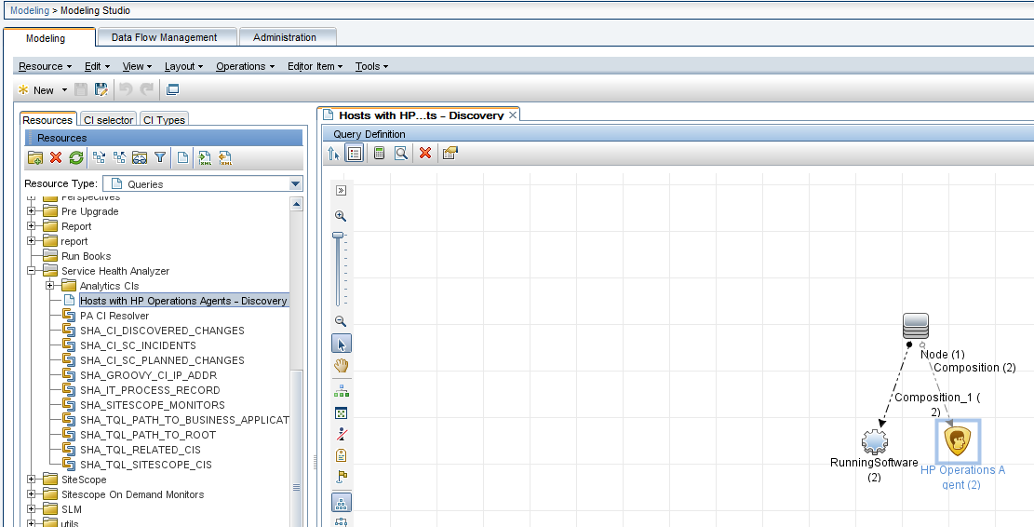
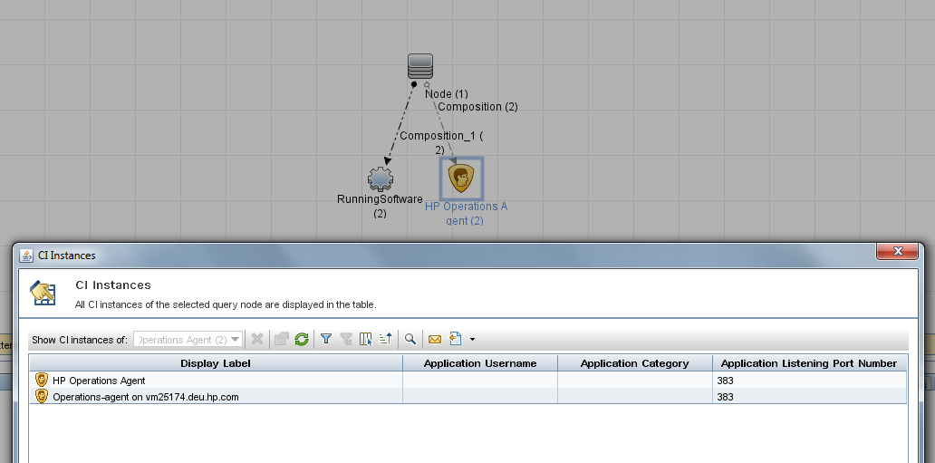
it doesn’t work when being used externally.
The workaround here is to save the TQL under a different name (for example “SG_PA_Hosts”) and then use this TQL in the Infrastructure Settings:
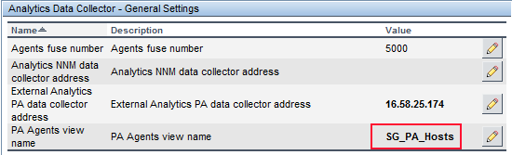

Verify that SHA collects PA metrics

Note:
for more details please see
KM00374312 - SHA - information around metrics and baselines
http://<DPS>:29926/mbean?objectname=Topaz%3Aservice%3DAnalytics+CIs
java.lang.String refresh
with
customerId : 1
and click Invoke:
customer id 1: 39 CIs;
1 CIs of type nt in samples [nnm_metric_t, ss_t, pa_metric_t, diag_metric_t]
{a4bd48c386fe4ff54211c63b673e784d=vm25174}
17 CIs of type business_transaction in samples [trans_t, rum_trans_t]
..
1 CIs of type hp_operations_agent in samples [rum_application_stats_t, rum_tcp_application_stats_t, ss_t, rum_trans_t, pa_metric_t, diag_metric_t]
{f1b486e3dc312e879ec5d908de7e511c=Operations-agent on vm25174.deu.hp.com}
18 CIs of type sitescope_monitor in samples [ss_t]
..
1 CIs of type interface in samples [pa_metric_t]
{995deaa5291c86eeccc8ad0fefc87809=005056B94C2B}
..
pa_metric_t is the data type for the Performance Agent metrics.
http://<DPS>:29924/mbean?objectname=Topaz%3Aservice%3DBaseline+Services
java.lang.String showDomainNames
enter
customerId : 1
and click Invoke
Domain names for 1:
SCOM
RUM
BPM
SiS
NNM
PA
DIAG
Again, PA is the domain name we are interested in.
http://<DPS>:29924/mbean?objectname=Topaz%3Aservice%3DBaseline+Services
java.lang.String showMetricTypeNames
enter
customerId : 1
domainName : PA
and click Invoke
Metric type names for customerID 1 domainName PA:
PA_SPI_Metrics
PA_Global_Metrics

So we can see that SHA is aware of the PA metrics, metric type "PA_SPI_Metrics" and "PA_Global_Metrics", using the next step we can see what PA metrics are collected:
http://<DPS>:29924/mbean?objectname=Topaz%3Aservice%3DBaseline+Services
java.lang.String showMetricsOfType
customerID : 1
domainName : PA
metricTypeName : PA_Global_Metrics
Metrics of customerID 1 domainName PA metricTypeName PA_Global_Metrics:
bulk/metric: 3/1022 type: 1/PA/PA_Global_Metrics Dimensions: [a4bd48c386fe4ff54211c63b673e784d, GBL_ACTIVE_CPU, SCOPE, GLOBAL, localhost [0]]
..
bulk/metric: 3/1005 type: 1/PA/PA_Global_Metrics Dimensions: [a4bd48c386fe4ff54211c63b673e784d, GBL_CPU_TOTAL_UTIL, SCOPE, GLOBAL, localhost [0]]
..
bulk/metric: 3/1028 type: 1/PA/PA_Global_Metrics Dimensions: [a4bd48c386fe4ff54211c63b673e784d, GBL_SYSCALL_RATE, SCOPE, GLOBAL, localhost [0]]
Note:
most of the data above can be retrieved more easily with running the agentStatus JMX
To verify that SHA collected and stored metric data in the SHA database for metric GBL_CPU_TOTAL_UTIL, execute the following query against the SHA database:
SELECT top 5 *
FROM AA_RAW
where metric_id = 1005 and bulk_id = 3
order by sampletime desc

Sampletime Metric_Id BULK_ID VAL …
1362730500 1005 3 3.070000
1362730200 1005 3 3.540000
1362729900 1005 3 3.150000
1362729600 1005 3 3.100000
1362729300 1005 3 3.420000

Sampletime is returned as Unix Epoch time (seconds since 1/1/1970) and can be converted by (for example) http://www.epochconverter.com/

1362730500 = Fri, 08 Mar 2013 08:15:00 GMT

Check whether a baseline exists for GBL_CPU_TOTAL_UTIL http://<DPS>:29924/mbean?objectname=Topaz%3Aservice%3DBaseline+Services
java.lang.String extractBaselineResult
metricID : 1005
bulkID : 3
Baseline:
Learning Time Frame: Sat Feb 02 00:00:00 CET 2013 - Mon Mar 04 00:00:00 CET 2013
Trend (change per day:) 0.0
Confidence Level: 96.948118
Buckets:
0: mean=2.5643, std-dev=0.219

Running SHA DC for PA without installing it
For a test, SHA DC for PA can also be enabled on the Gateway server, so there is no need for a separate installation. All what needs to be done is to enable it via
http://<<GW>>:11021/invoke?operation=enableService&objectname=Foundations%3Atype%3DNannyManager&value0=analytics_dc&type0=java.lang.String
When doing this one needs to make sure that the total amount of agents is small, to support a large number of agents you need the separate machine.

