Preserve Connector’s raw event on ArcMC

- These steps to enable preserve raw events on ArcMC WebUI.
- This document applies to both software and appliance ArcMC, on-board connectors as well remote-connectors.
- Go to Node Management
Select the connector by click to blank space next to the connector name.

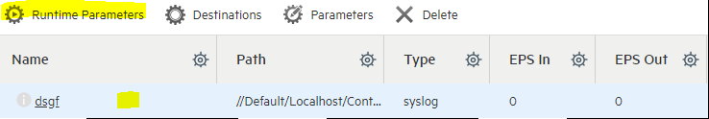

- Select Runtime Parameters

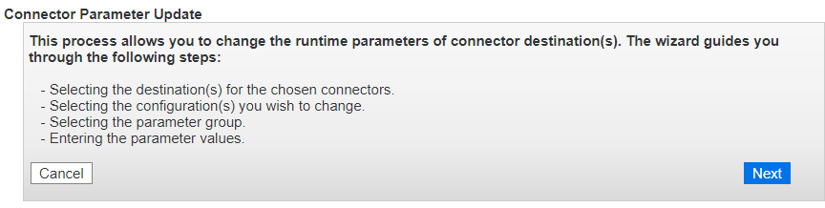
- Select the destination where you want to receive connector raw events

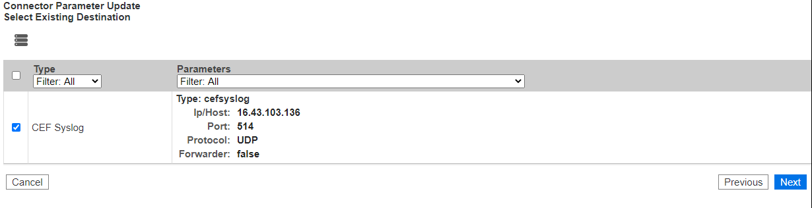
- Modify the destination settings

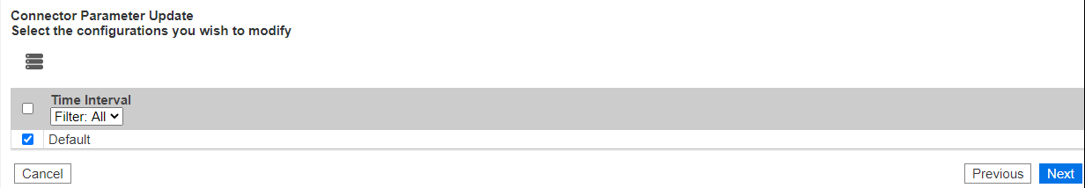
- Select Processing option to enable raw event

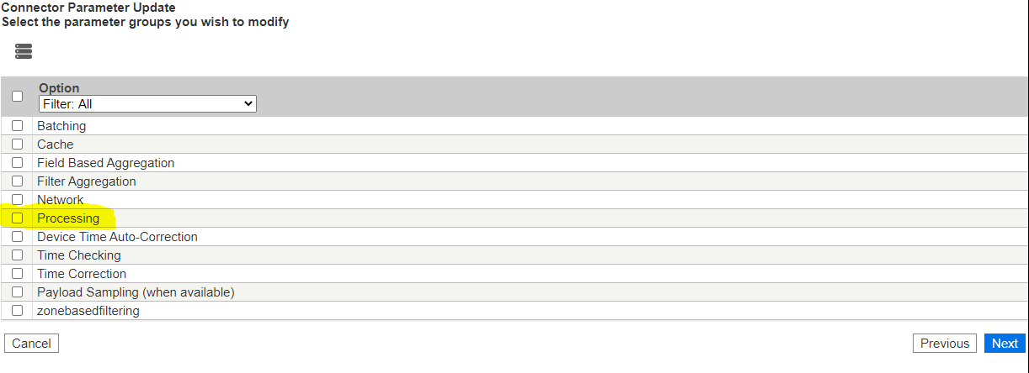
- Select “Yes” for Preserve Raw Event
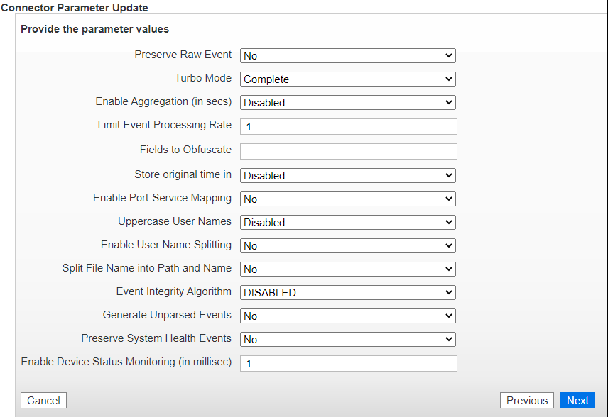
- Confirm the changes

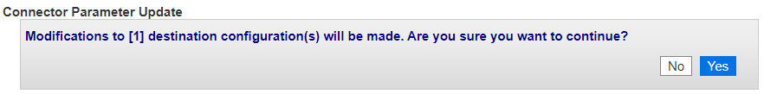
Notes:
The connector may need to restart, run for at least 10 mins to make sure we capture all connector raw events on destination.
Then we disable the Preserve Raw Event with the same steps as above.

