Problem when using the –e option of “backup.ovpl”.

This document describes a problem that may happen when the export ( -e ) option is used in the command backup.ovpl. A resolution to the problem is also documented.
After running backup.ovpl with the –e option, Report launching may fail with the following error.
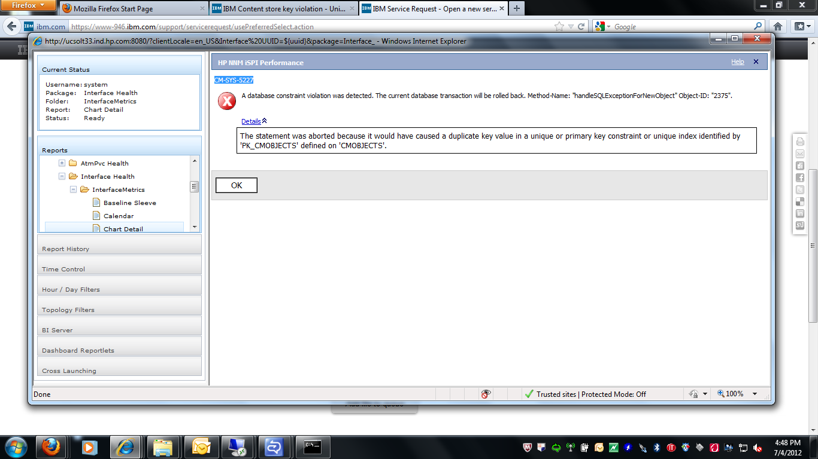

The problem occurs because the export function sometimes corrupts the content store.

Solution:

The following steps need to be performed to resolve this issue.
- Close all existing NPS browsers, Re-launch the report menu and click on the link “Log On as BI Server Administrator”.
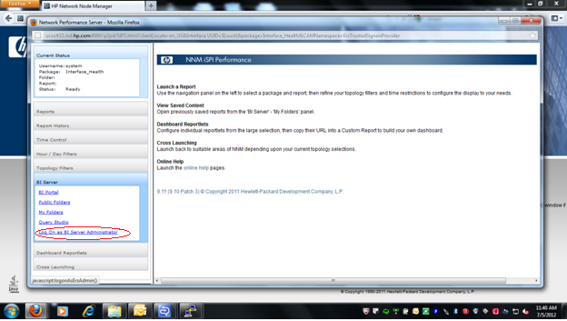
- Login with the BI Administrator credentials.
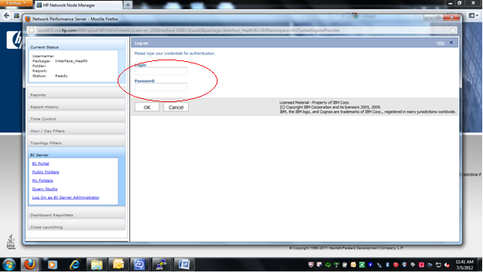
- Click on the “ Administrator HP NNM iSPI Performance content”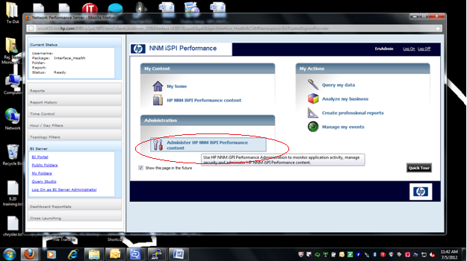
- Select the “Configuration” tab.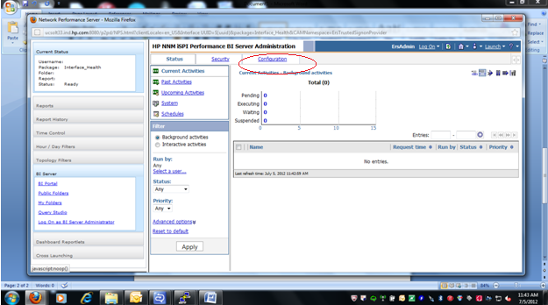

- Select “Content Administration”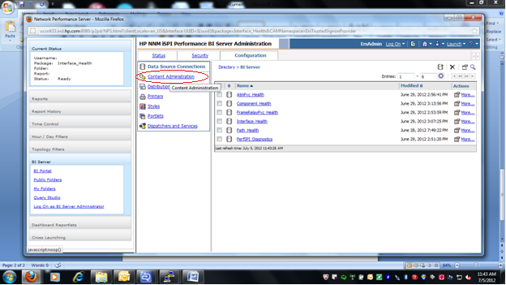
- Select “New Consistency Check” (5th icon from the left has an expandable option)
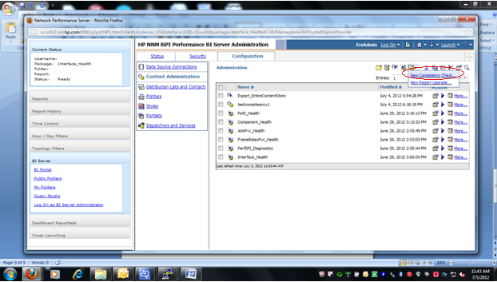
- This will open the following window. Give any name and click “Next”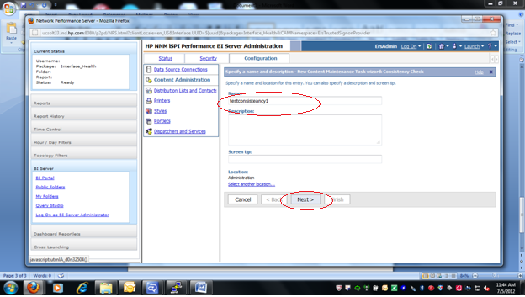
- Select “Internal References” and click “Next”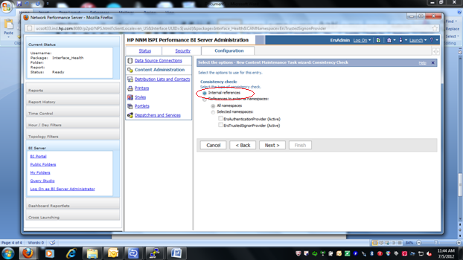
- Select “Save and Run Once” and click “Finish”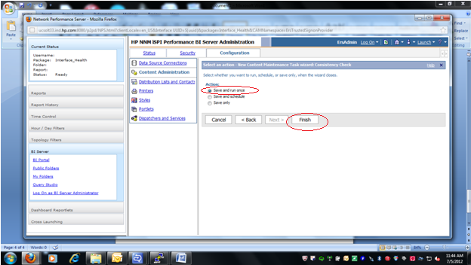
- Select “Find and Fix” and click “Run”.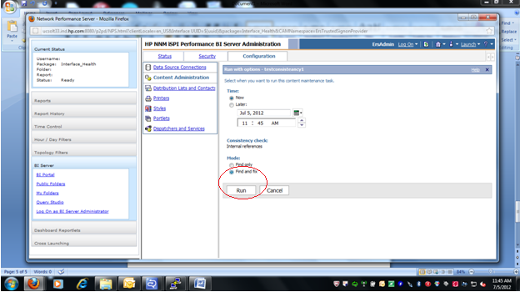
- And then click “Ok”. This will run the consistency check.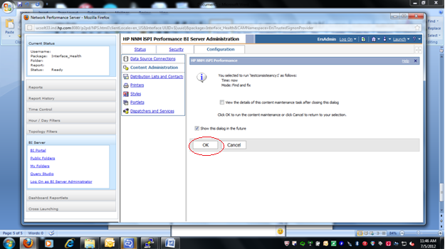
- Check whether the consistency check has succeeded by going to the “Status” tab and “Past Activities”
- Re-Run these steps if the status is “Failed”.
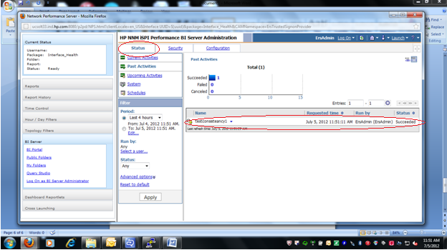
- After completing the above steps, go the NPS server and open the BI Configuration GUI by running runBIConfigGUI.ovpl.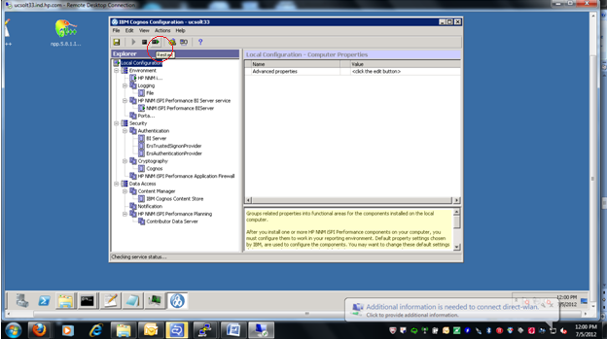

- Restart the services by clicking the highlighted option below. This will restart the services. Click the “Details” button to view the progress. The NNMi SPI Performance Server will fail. Ignore this failure and keep the window open till it completes. There will be some more steps performed and you can see them in the details section of the display window. 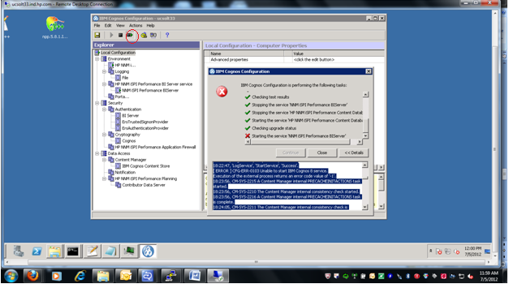
- The “Details” section is documented below. Highlighted in Red are the actions being performed due to the consistency check.
Successfully launched a test JVM with the memory setting of '1024'. Note that this does not guarantee that IBM Cognos 8 will start and run successfully.

To see which JVM options are based on this setting, view c8_location/bin/bootstrap_<OS>.xml and see your JVM documentation for an explanation of those options.

Since the value is empty, the feature is disabled. There is nothing to test.
[ ERROR ] The mail server cannot be reached.
18:21:55, 'CPS Producer Registration Service', 'StopService', 'Success'.
18:21:55, 'JobService', 'StopService', 'Success'.
18:21:57, 'DeliveryService', 'StopService', 'Success'.
18:21:57, 'PresentationService', 'StopService', 'Success'.
18:21:57, Send a stop request to the BIBusTKServerMain with pid 6856.
18:21:57, 'SystemService', 'StopService', 'Success'.
18:21:57, 'AgentService', 'StopService', 'Success'.
18:21:57, 'EventService', 'StopService', 'Success'.
18:21:57, 'ReportService', 'StopService', 'Success'.
18:21:57, 'ReportDataService', 'StopService', 'Success'.
18:21:57, 'MonitorService', 'StopService', 'Success'.
18:21:57, 'MetadataService', 'StopService', 'Success'.
18:21:57, 'BatchReportService', 'StopService', 'Success'.
18:21:58, 'ContentManagerService', 'StopService', 'Success'.
18:21:58, 'LogService', 'StopService', 'Success'.
18:22:47, 'LogService', 'StartService', 'Success'.
[ ERROR ] CFG-ERR-0103 Unable to start IBM Cognos 8 service.
Execution of the external process returns an error code value of '-1'.
18:23:56, CM-SYS-2215 A Content Manager internal PRECACHEINITACTIONS task started.
18:23:56, CM-SYS-2210 The Content Manager internal consistency check started.
18:23:56, CM-SYS-2216 A Content Manager internal PRECACHEINITACTIONS task is complete.
18:24:05, CM-SYS-2211 The Content Manager internal consistency check is complete.
18:24:05, CM-SYS-5203 Due to missing Content Manager IDs in the CMOBJECTS table, Content Manager deleted 5 invalid rows from table(s) (CMOBJPROPS25,CMOBJPROPS5,CMPOLICIES,CMREFNOORD2,CMSTOREIDS). CM-SYS-5194 Warning: Content Manager deleted 1 invalid row(s) in table 'CMOBJPROPS25'. CM-SYS-5194 Warning: Content Manager deleted 1 invalid row(s) in table 'CMOBJPROPS5'. CM-SYS-5194 Warning: Content Manager deleted 1 invalid row(s) in table 'CMSTOREIDS'. CM-SYS-5194 Warning: Content Manager deleted 1 invalid row(s) in table 'CMREFNOORD2'. CM-SYS-5194 Warning: Content Manager deleted 1 invalid row(s) in table 'CMPOLICIES'. Cause: CM-SYS-5194 Warning: Content Manager deleted 1 invalid row(s) in table 'CMOBJPROPS5'. Runtime Exception stack trace: CM-SYS-5194 Warning: Content Manager deleted 1 invalid row(s) in table 'CMOBJPROPS5'. at com.cognos.cm.dbstore.CMDbStoreConsistency.addDetails(CMDbStoreConsistency.java:1191) at com.cognos.cm.dbstore.CMDbStoreConsistency.addDetailForFixInTable(CMDbStoreConsistency.java:1092) at com.cognos.cm.dbstore.CMDbStoreConsistency.deleteJunkRowsForMissingCMIDs(CMDbStoreConsistency.java:731) at com.cognos.cm.dbstore.CMDbStoreConsistency.repairInternalInconsistencies(CMDbStoreConsistency.java:374) at com.cognos.cm.dbstore.CMDbStoreConsistency.performConsistencyCheck(CMDbStoreConsistency.java:246) at com.cognos.cm.dbstore.CMDbStoreConsistency.performConsistencyCheckAtStartup(CMDbStoreConsistency.java:196) at com.cognos.cm.dbstore.CMDbStore.initializeContentDependent(CMDbStore.java:4671) at com.cognos.cm.server.CMServlet.initializeContentStoreForActive(CMServlet.java:2398) at com.cognos.cm.server.CMServlet.init(CMServlet.java:2056) at com.cognos.cm.server.ContentManager.start(ContentManager.java:314) at com.cognos.cm.server.ContentManagerLifecycleHandler.start(ContentManagerLifecycleHandler.java:73) at com.cognos.pogo.services.DefaultHandlerService.start(DefaultHandlerService.java:111) at com.cognos.pogo.services.DispatcherServices.startInititalServices(DispatcherServices.java:426) at com.cognos.pogo.transport.PogoServlet$PogoStartup.run(PogoServlet.java:688) at java.lang.Thread.run(Thread.java:736) Caused by: CM-SYS-5194 Warning: Content Manager deleted 1 invalid row(s) in table 'CMSTOREIDS'. ... 15 more Caused by: CM-SYS-5194 Warning: Content Manager deleted 1 invalid row(s) in table 'CMREFNOORD2'. ... 15 more Caused by: CM-SYS-5194 Warning: Content Manager deleted 1 invalid row(s) in table 'CMPOLICIES'. at com.cognos.cm.dbstore.CMDbStoreConsistency.addDetails(CMDbStoreConsistency.java:1188) ... 14 more
18:24:05, CM-SYS-2212 Warning: The content store database contains inconsistencies. Review your IPF logs for more information.
18:24:08, CM-SYS-2216 A Content Manager internal POSTINITACTIONS task is complete.
18:24:08, CM-SYS-2215 A Content Manager internal POSTINITACTIONS task started.
18:24:10, CM-SYS-5159 Content Manager is running in active mode.
18:24:10, DPR-DPR-1002 Successfully registered the dispatcher http://ucsolt33.ind.hp.com:8080/p2pd in Content Manager.
18:24:10, 'ContentManagerService', 'StartService', 'Success'.
18:24:14, 'BatchReportService', 'StartService', 'Success'.
18:24:14, 'SystemService', 'StartService', 'Success'.
18:24:18, 'PresentationService', 'StartService', 'Success'.
18:24:18, Start a BmtMDProviderMain because the start count 1 is larger than 0.
18:24:18, 'AgentService', 'StartService', 'Success'.
18:24:18, Start a BIBusTKServerMain because the start count 1 is larger than 0.
18:24:18, 'MonitorService', 'StartService', 'Success'.
18:24:18, 'JobService', 'StartService', 'Success'.
18:24:18, 'MetadataService', 'StartService', 'Success'.
18:24:18, 'EventService', 'StartService', 'Success'.
18:24:18, 'ReportDataService', 'StartService', 'Success'.
18:24:18, 'DeliveryService', 'StartService', 'Success'.
18:24:18, 'ReportService', 'StartService', 'Success'.
18:24:20, Start the BIBusTKServerMain with pid 7916.
18:24:20, Start the BmtMDProviderMain with pid 4988.
18:24:21, 'CPS Producer Registration Service', 'StartService', 'Success'.
- Ignore the other errors mentioned in the above run. Run statusALL.ovpl and make sure all the processes are running.
- After this, re-launch the report menu, and the reports will be launched successfully.

