Mobile server proxy Settings

- Your organization or Internet service provider may offer or require you to use a proxy. A proxy acts as an intermediary between your computer and the Mobile Server. Proxies are used to improve performance, filter requests, and hide your computer from the Internet to improve security. Proxies are often part of corporate firewalls.
- Proxy type which we are supported from Sprinter side:
  - Sprinter could connect to HP MC only via forward proxy without proxies authentication

- You can define the mobile server proxy settings via this region at Sprinter’s UI:
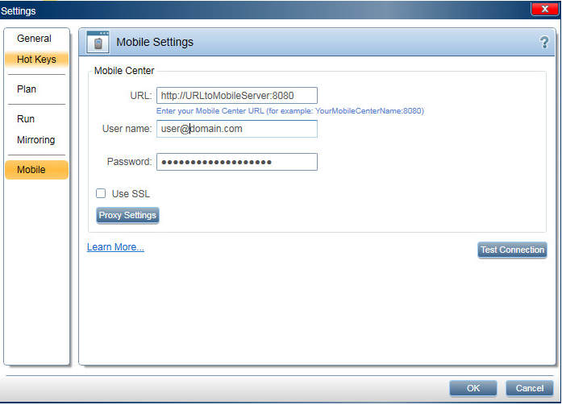

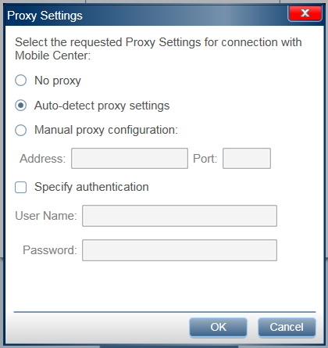
- Proxy settings options:
  - Proxy mode:
    - No proxy: Choose this option if you don't want to use a proxy.
    - Auto-detect proxy settings: Choose this option if you want Sprinter to automatically detect the proxy settings for your network (this is the default setting).
    - Manual proxy configuration: Choose this option if proxy settings required, and Sprinter unable/shouldn’t detect its settings automatically. Ask your system administrator for the configuration information. In this option you should insert the following values:
      - Address: this value should be in one of those formats:
        - IPv4 address (dotted-quad notation), e.g. ‘100.100.100.100’.
        - IPv6 address (colon-hexadecimal notation), e.g. ‘2001:db8::ff00:42:8329’.
        - Host name (free string), e.g. ‘aaa.bbb.ccc.com’.
      - Port: this value should be positive number, e.g. ‘8080’.
  - Proxy authentication:
    - Specify authentication: Use this option if you use a proxy that require authentication.

- If user define wrong proxy settings, he will receives an error messages (during testing of mobile server connection, or during startup of mobile test). This list shows the possible messages (and the required user actions):
  - Message “Mobile server proxy configuration required”:
    - You should use option ‘Auto-detect proxy settings', or option 'Manual proxy configuration' (with valid values).
  - Message “Mobile server proxy configuration is not valid”:
    - If option 'Manual proxy configuration' currently selected - change the ‘Address’ value within this option.
  - Message “Mobile server proxy configuration is redundant”:
    - You should use option ‘Auto-detect proxy settings', or option 'No proxy’.
  - Message “Mobile server proxy-authentication configuration required”:
    - You should use option ‘Specify authentication' (with valid values).
  - Message “Mobile server proxy-authentication configuration is not valid”:
    - You should change values within option 'Specify authentication'.
  - Message “Mobile server proxy-authentication configuration is redundant”:
    - Unselect option 'Specify authentication'.
  - Message “The mobile server is not available”:
    - If option 'No proxy' currently selected - try to use option 'Auto-detect proxy settings'.
    - If option 'Auto-detect proxy settings' already selected (i.e. Sprinter failed to automatically detect the proxy settings) - try to use option 'Manual proxy configuration'.
    - If option 'Manual proxy configuration' already selected - try to change values within this option, or try to use option 'Auto-detect proxy settings' (if this option was not tested yet).
    - This error message can be result of other communication issues (that not related to proxy), e.g. address of mobile server is incorrect, or mobile server is currently down.
  - Message “Timeout occurred, unable to complete an operation ('checking connection to HP Mobile Center') within the allotted time”:
    - Same as message “The mobile server is not available”.
  - Message “Mobile server proxy refused the connection”:
    - Ask your system administrator for the configuration information. This message indicate that your mobile server proxy refused the connection, possible cases (info about the actual case will appear in file '%appdata%\HP\Sprinter\Log\Sprinter.exe.log'):
      - Sprinter received HTTP error '403 - Forbidden' (the request was a valid request, but the server is refusing to respond to it. This error semantically means "unauthorized", i.e. the user does not have the necessary permissions for the resource).
      - Sprinter received HTTP error '407 - Proxy Authentication Required' (the client must first authenticate itself with the proxy).

