Prerequisite:
1. Have a working SM 9.30 environment
2. Install LDAP by executing “DCPROMO” from the start menu or through the “Add Role” functionality of the server
3. Configure the LDAP profile
4. Test the connection to LDAP.

LDAP SSL:

Install Active Directory Certificate Service:

1. Open Server Manager.
2. Select Roles, then click Add Roles in the center pane.

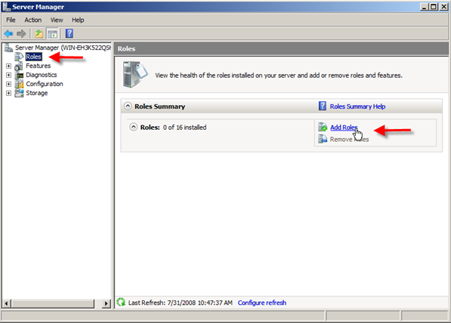

3. The Before You Begin page may show up if you haven’t turned it off already. If you see it just click Next.
4. In the Select Server Roles window go ahead and select Active Directory Certificate Services by placing a checkmark next to it, then go ahead and click Next.
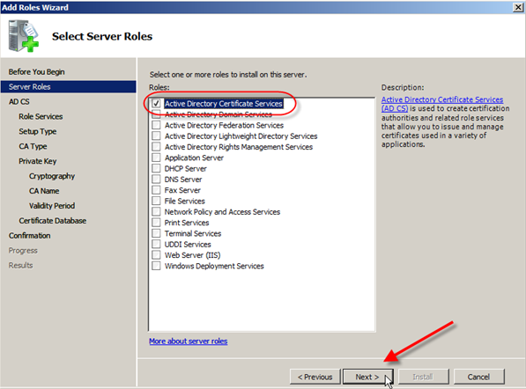
5. Now you will see an Introduction to Active Directory Certificate Services, where you can read about the good things you can do with AD CS.
The biggest thing to note here is the following:
Name & Domain settings of this computer cannot be changed after a CA has been installed. If you want to change the computer name, join a domain, or promote this server to a domain controller do so BEFORE install thing the CA.
Now with that warning out of the way, go ahead and click on Next.
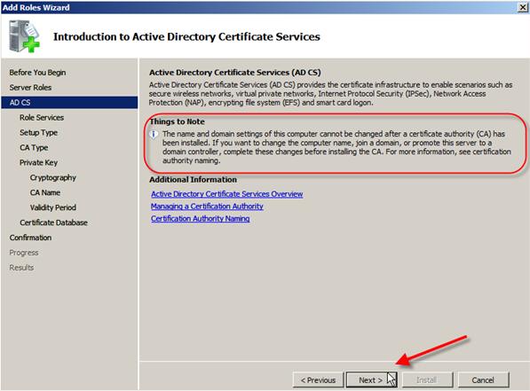
6. Next you get to Select Role Services, which can include any of the following depending on what version of Windows Server 2008 you are installing this on — refer to the table above for specifics.
For this install I am going to choose the Certification Authority only.
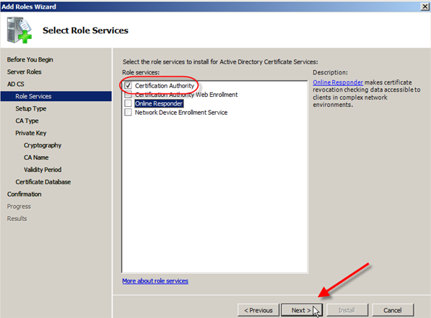
7. Now comes the Specify Setup Type, and for this I am going to select theEnterprise radio button.
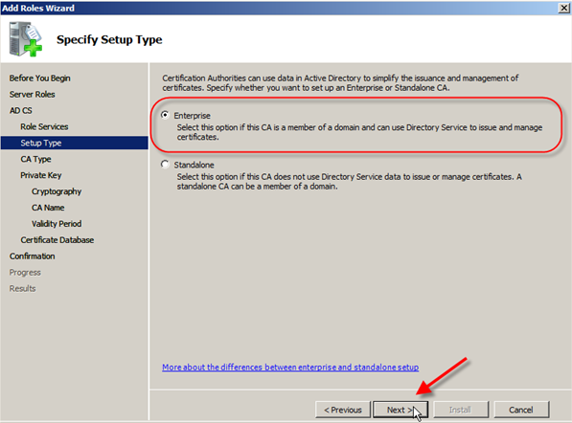
8. For the Specify CA Type, I am going to choose the Root CA radio button and then click Next.
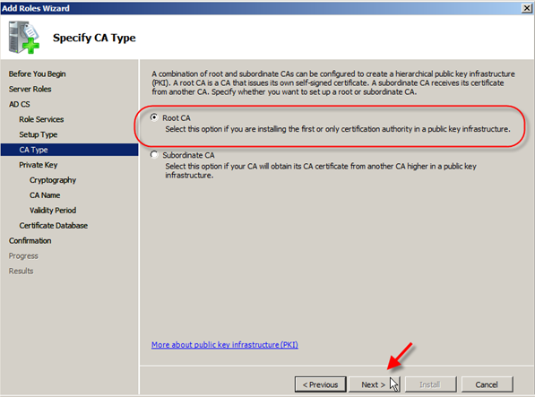
9. In Set Up Private Key, I am going to choose Create a new private keyradio button and then select Next.
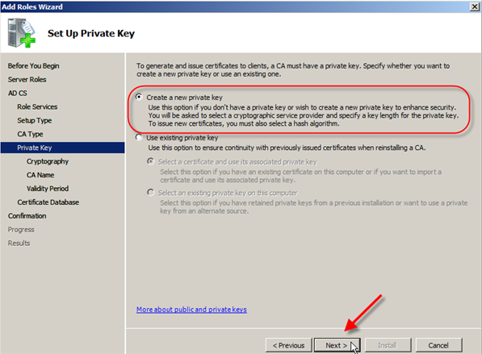
10. Now you have to Configure Cryptography for CA in this window and there are quite a few to choose from.
Now I am no expert on cryptography, but some basic rules do apply … the longer the key the harder it is to crack. For our purposes I am going to use the following settings:
RSA#Microsoft Software Key Storage Provider
4096 Key Character length
md5 Hash algorithm
Now I am going to click Next.
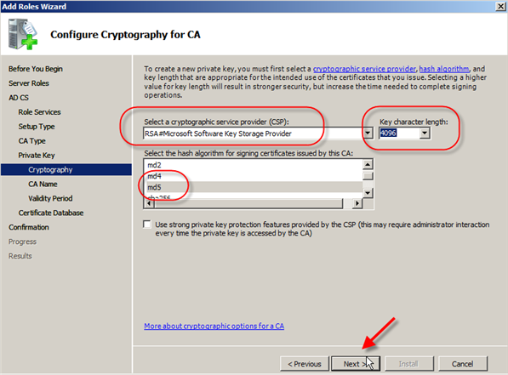
11. In Configure CA Name you can choose to overwrite the default common name for this CA and also the Distinguished name suffix if you so choose.
I am going to overwrite the default common name with Test-Enterprise-CA, but I will leave the rest alone.
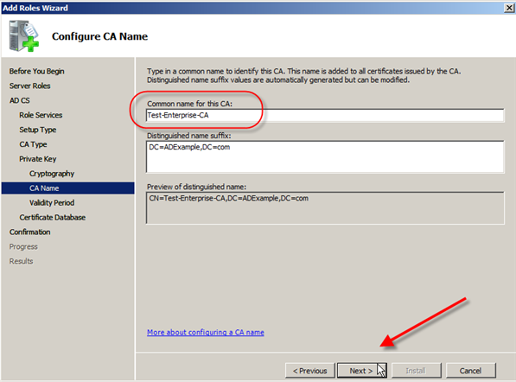
12. Next we will Set Validity Period for this CAs certificate.
Remember a root CA issues itself a certificate. The default is 5 Years so I will just leave it at that. You can change this based on any need you might have in your environment. Click Next.
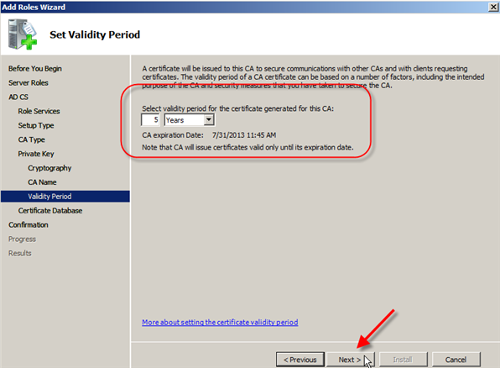
13. Configure Certificate Database will let you specify where you want to put the database and log files for the CA.
I am going to leave the default in place. Click Next.
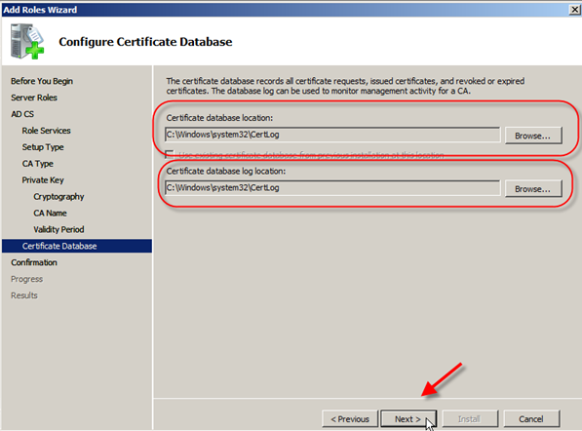
14. On the Confirm Installation Selections you can see the answers you have chosen and you will again see a warning that you cannot change the computer name or domain settings for this server after installing the CA.
Go ahead and click Install… you know you want to!
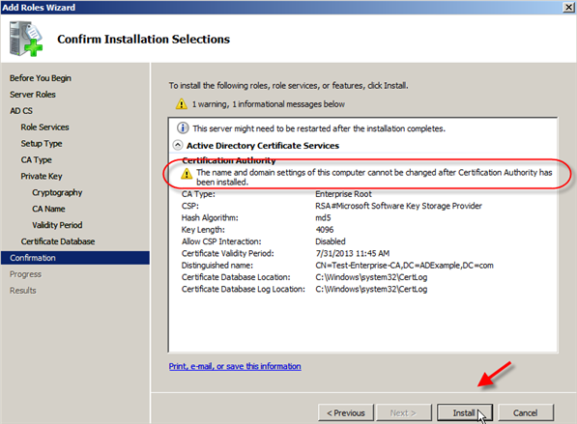
15. After a few minutes you will see the Installation Results, and with any luck you will have the message: Installation succeeded.
After your glow of certificate happiness fades go ahead and click Close.
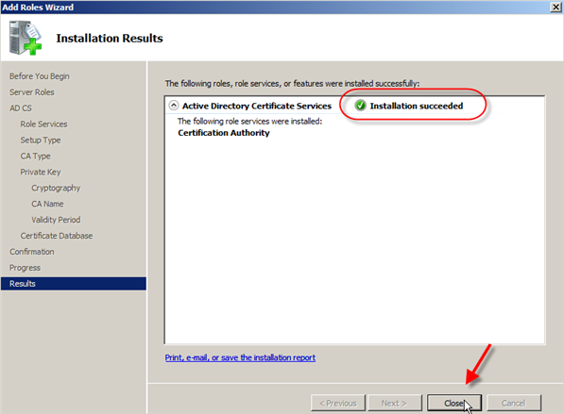

Steps to export the certificates:

1. Type in “mmc” in the Start Menu
2. A windows will be opened – click on File -> Add a snap-in
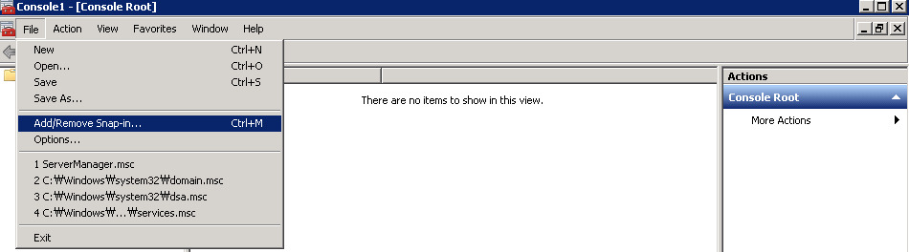
3. Select Certificates and Press Add
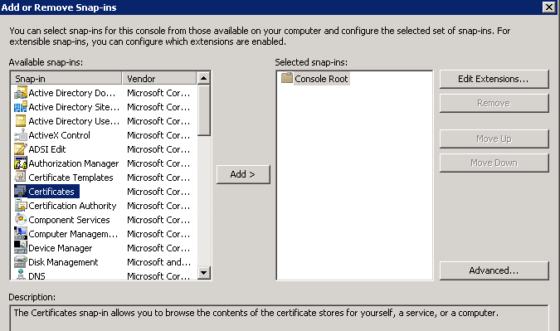
Select Computer Account
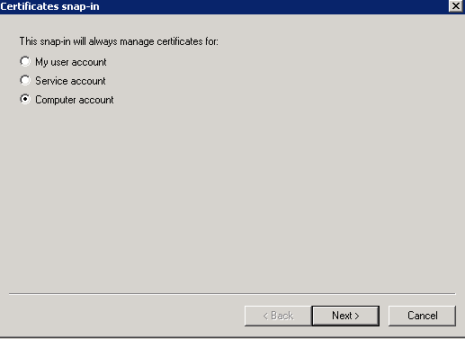
Click Next.
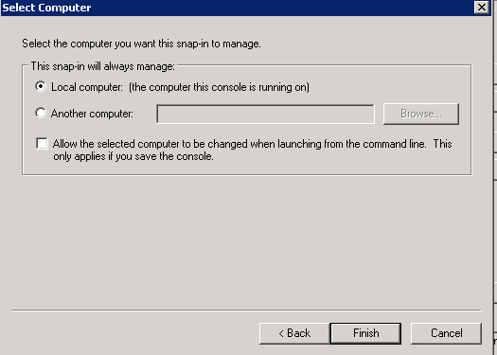
Click finish
Click Ok
4. Expand Certificates -> Personal -> Certificates
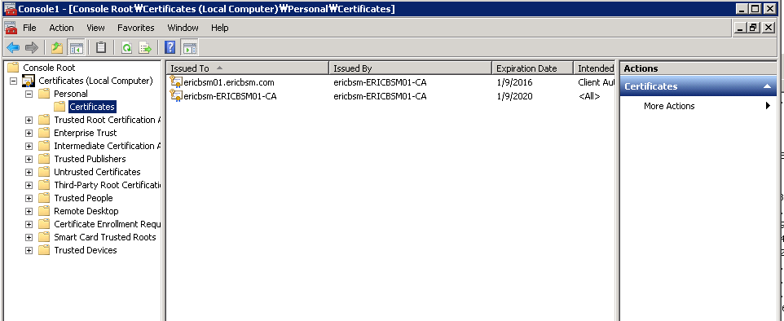

5. One or two certificate should be present there
5.1 If there are already two certificates, proceed to step 6
5.2 if there is only one:
5.2.1 Right Click on an empty space near the certificates and go to All Tasks -> Request New certificate
5.2.2 Next, Next, select the Domain Controller and Domain Controller Authentication, Enroll
5.2.3 You should have one or two more certificate added in there
6. Right click on the certificate that under Intended Purposes has a value of <All>, go to All Tasks -> Export
In this example, export the second certificate as in the above snapshot.

VERY IMPORTANT!
1. Do not extract the private key and on the next screen DO NOT select “DER encoded binary X.501 (.CER) – DO select “Base-64 encoded X.509 (.CER)”
2. Click on Next, select a file name and save.

Test the SSL connection via LDAP browser(Jxplorer):

  - Open Jxplorer Security->Select "Trusted Servers and CAs"-> Click on "Add certificate"-> Select the location of the certificate( certificate that was exported in above step). Select the file type as "All Files" to be able to see the certificated exported in above step.
  - The certificate details will be displayed. Click ok.
  - It will ask to give a certificate name, provide a unique name.
  - It will prompt for a keystore password, provide password as "changeit". Click Ok.
  - Make a SSL connection in the ldap browser as highlighted in the below snapshot:
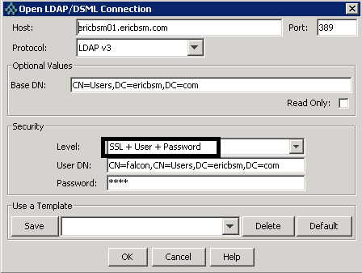

Verify LDAP ssl from SM using the below steps:
1. Go back to SM -> open “scldapconfig” through “db”
2. Click on the checkbox SSL? Ensure the LDAP server: <FQDN of LDAP server> and not IP address of LDAP server.
3. On the “LDAP SSL DB Path” field enter the path to the certificate you just exported and Save
4. Click on “Set File/Field Level Mapping” and search for “operator”
5. Here you should already have specified the “sAMAccountName” field for the “name” field in SM
6. Click on the checkbox LDAP SSL?
7. On the “LDAP SSL DB Path” field enter the path to the certificate you just exported and Save – we are done with the settings in SM!
8. Open the LDAP profile with LDAP Browser
9 .Go to the properties of the LDAP profile
10. Click on “Enable SSL” checkbox and save
11. Now try to connect to SM – no restart is needed
You should be able to log in with LDAP over SSL in SM, but in my testing connection fails when providing path to the certificate On the “LDAP SSL DB Path” field and Checking the checkbox "LDAP SSL". When only Checking the checkbox "LDAP SSL" and removing the path to certificate On the “LDAP SSL DB Path” field the connection succeeds.

Copy of sm.ini of my testing:

# (c) Copyright 2008 Hewlett-Packard Development Company, L.P.
# Configuration Modified Date:1/8/15 4:37 PM
shared_memory:32000000
log:../logs/sm.log
system:13080
httpPort:13080
sslConnector:0
httpsPort:13443
sqldictionary:sqlserver
[sqlserver]
sqldb:SM
sqllogin:sm_user/sm_user
plugin0:kmplugin.dll
#ldapauthenticateonly
ldapbinddn:CN=falcon,CN=Users,DC=ericbsm,DC=com
ldapbindpass:test
ldapnostrictlogin:0
ldapstats:1
ldapdisable:1

Contents of Help server as per sm 9.34 regarding LDAP SSL:
Enable LDAP over SSL
Applies to User Roles:
System Administrator
You must have the SysAdmin capability word to use the procedures below.
By default, when you enable LDAP over SSL, you need to set the root certificate of the CA that issued the LDAP server’s certificate on the Service Manager server, and then specify the location of the certificate file in the LDAP SSL DB Path field.
If you do not want to set the CA's root certificate on the Service Manager server, follow these steps:
  - Set the ldapsslallownocert parameter to 1.
  - Log in to Service Manager, and then click System Administration > Ongoing Maintenance > System > LDAP Mapping.
  - Set the LDAP Server and LDAP Base Directory fields, select the LDAP SSL check box. Leave the LDAP SSL DB Path field blank.
  - Click Set File/Field level mapping, enter operator in the Name field, and then map the name field of operator to sAMAccountName (for Active Directory server).
  - Restart the Service Manager server.
If you wish to authenticate Service Manager users that belong to different domains or subdomains, you can deploy multiple LDAP servers that belong to the corresponding domains, and then set up a horizontal scaled (HS) cluster. By the following configuration, users belong to different domains can share the same database while at the same time be authenticated by different domain’s LDAP server over SSL.
  - Set the ldapsslallownocert parameter to 1.
  - Log in to Service Manager, and then click System Administration > Ongoing Maintenance > System > LDAP Mapping. Leave everything on this page empty.
  - Click Set File/Field Level Mapping, enter operator in the Name field, and then map the name field of operator tosAMAccountName.
  - Add the ldapserver parameter in the sm.ini file as the following example:
ldapserver1:16.183.93.217%636%cn=users,dc=swsm,dc=ind,dc=lab
You can add this parameter multiple times if you have more than one LDAP server.
  - Restart the Service Manager server.
Note: In both cases above, you still need to set the ldapbinddn and ldapbindpass parameters in sm.ini.

Snapshot of scldapconfig record in my testing:
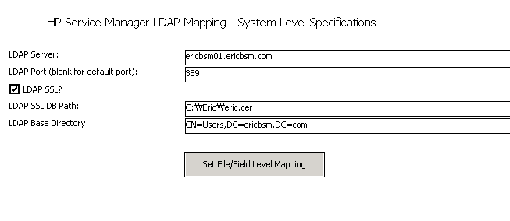

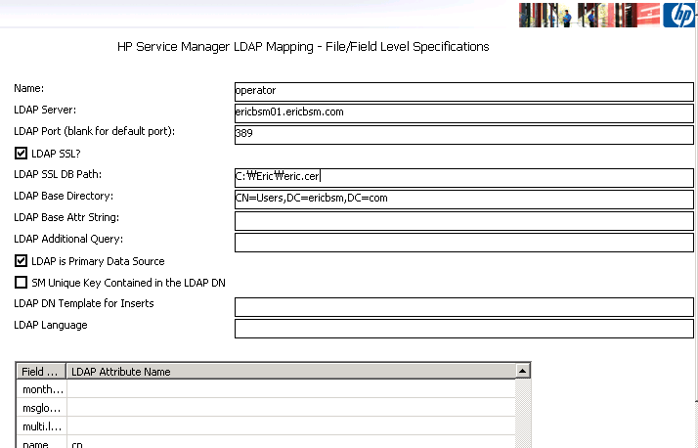

Reference KM:
KM1416868
https://softwaresupport.hp.com/group/softwaresupport/search-result/-/facetsearch/document/KM1416868

