Upgrading Elasticsearch from Version 5.x to 6.x (Windows)

Summary
Elasticsearch is a required component of ALM Octane. This document is provided as a service and provides instructions on upgrading Elasticsearch on Windows.

Topic
This article provides the steps for upgrading the Elasticsearch database from version 5.x to 6.x. Elasticsearch is a required database component for ALM Octane. Elasticsearch version 6.x is required for ALM Octane 12.60.47 and later.

Overview
The upgrade is divided into the following stages:
- Before upgrading
Delete multi-type indices.
Delete indices of version older than 5.x.
- Upgrade
Perform the upgrade.
- This procedure for Windows uses the ElasticSearch(ES) Snapshot tool which is available here…
https://github.com/philzippy/Elasticsearch_Snapshot_Tool

Before upgrading
- Running the ES snapshot tool
- Stop ALM Octane servers

Windows installations:
Stop the ALM Octane service
- Back up configuration files – Use DOS command here
robocopy <source> <target /mir
Example…
robocopy D:\Elastic\elasticsearch-5.6.10 D:\Elastic\elasticsearch-5.6.10_backup /mir
- Check the installed Java version
Elasticsearch requires Java 8
java -version
- Create a Snapshot Repository – Use the ES Snapshot tool
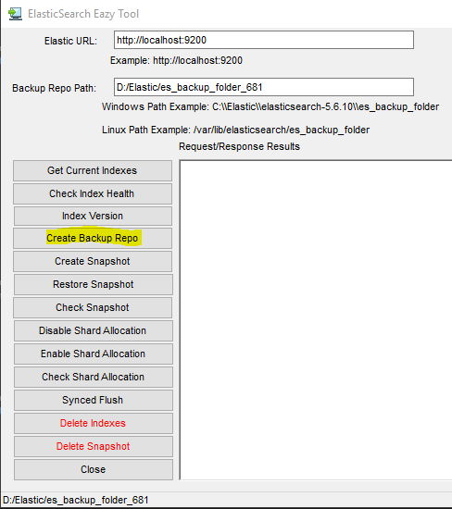
- Perform a synced flush and stop indexing – Use the ES Snapshot tool
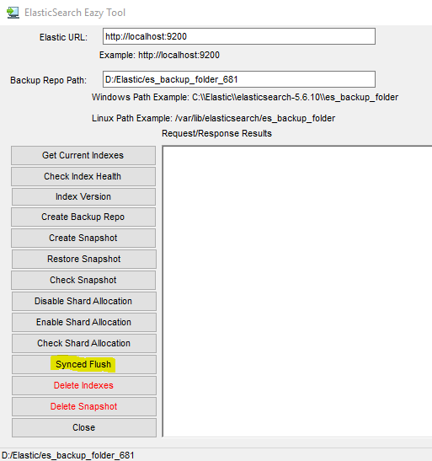
A synced flush request is a “best effort” operation. It will fail if there are any pending indexing operations, but it is safe to click the ‘Synced Flush’ button multiple times if necessary.

- Back up ELS indices – Use ES Snapshot tool
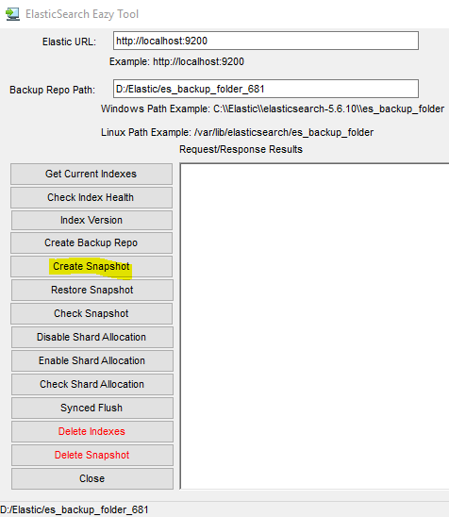
- Install Elastic the contents of the folder containing the snapshot. This is the path in the “Backup Repo Path” and paste them into the “Backup Repo Path” defined for ES 6.x
Note: For Steps 8 and 9 know that these repository locations should be different and defined in the ‘elasticsearch.yml’ for each respective ES version (5.6.x and 6.x)
- Shut down all cluster nodes – Stop the Elasticsearch service on all nodes
- Download ELS v6.8.1 for Windows installation
https://artifacts.elastic.co/downloads/elasticsearch/elasticsearch-6.8.1.zip
- Remove the service for ES 5.6.x – perform on all nodes
cd <drive>\<path>\elasticsearch-5.6.x\bin
elasticsearch-service.bat remove
- Install the service for ES 6.8.1 – perform on all nodes
cd <drive>\<path>\elasticsearch-6.8.1\bin
elasticsearch-service.bat install
- Start the Elasticsearch 6.8 service on all nodes
- Restore the snapshot taken from ES 5.6.x to ES 6.x - Use the ES Snapshot tool
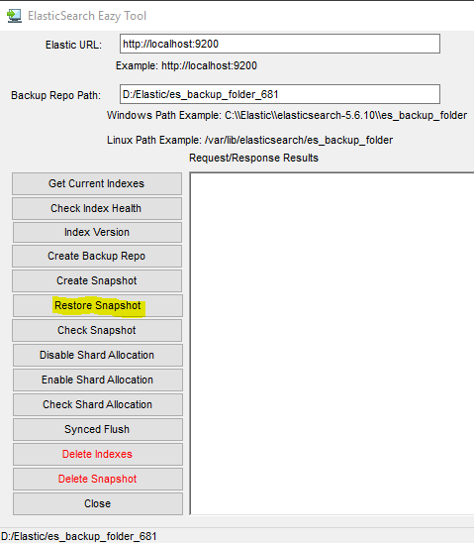
Note: make sure the “Backup Repo Path” value reflects that defined for ES 6.x which is also in the ‘repo.path’ in the elasticsearch.yml

Upgrade

- Uninstall plugins
cd <drive>\<path>\elasticsearch-<version>\config /bin
elasticsearch-plugin list
elasticsearch-plugin remove <plugin name>

- Stop ES 6.x service
- Edit elasticsearch.yml
Verify the following Elasticsearch parameters.
Note that elasticsearch.yml is usually located in the <drive>\<path>\elasticsearch-<version>\config folder.
cluster.name: <Your cluster name>
node.name: <Your node name>
network.host: <your network interface name>

###Path parameters
path.data: /<DATA path>/elasticsearch
path.logs: /LOGS path
path.repo: <drive>\<path>\<backup_folder_name>

bootstrap.memory_lock: true

# In case you 3 nodes in the cluster
discovery.zen.ping_timeout: 10s
discovery.zen.minimum_master_nodes: 2
gateway.recover_after_nodes: 2
gateway.expected_nodes: 3
##Disable XPack unlicensed features
xpack.security.enabled: false
node.ml: false
xpack.ml.enabled: false

- Start ES 6.x service on all nodes
If you have dedicated master nodes, start them first. Dedicated master nodes are nodes with node.master set to true (default) and node.data set to false.
The number of nodes started should be at least the number defined in elasticsearch.yml:
discovery.zen.minimum_master_nodes: xxx
If not, the recovery will not start until the number of nodes reaches the number defined in discovery.zen.minimum_master_nodes.
Start the Elasticsearch service on all cluster nodes:
Check that nodes respond. In a browser…
http://{hostname}:9200/_cat/health?pretty
http://{hostname}:9200/_cat/recovery?pretty
- Wait for yellow
Run the commands below and wait until all primary shards have been recovered, but not all replica shards are allocated. This is to be expected because allocation is still disabled. In a browser…
http://{hostname}:9200/_cat/health?pretty
http://{hostname}:9200/_cat/recovery?pretty
- Re-enable allocation – Use ES Snapshot Tool

When all nodes have joined the cluster and the cluster is yellow, re-enable the allocation

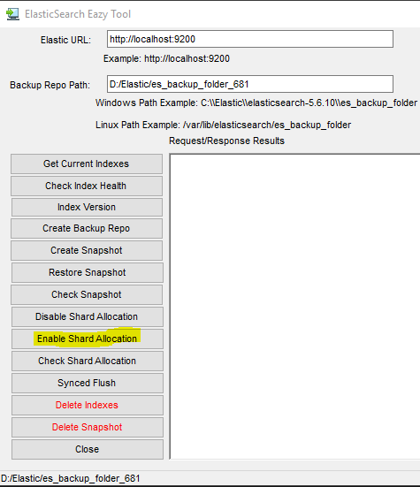
- Back up ELS indexes – Use ES Snapshot Tool

Take a snapshot backup of the Elasticsearch 6.x server indexes after upgrading.
Move existing snapshot repository contents before creating a new snapshot

- Wait for green (when you have more than one node) or wait for yellow (when you have one node)
All primary and replica shards are successfully allocated.
curl -XGET '{hostname}:9200/_cat/health?pretty'


