How to use the "Import from DB" / "Import from Database" adapter with a given set of credentials

According to the "hp_man_UCMDB10.20_DiscIntegContent_3rdParty_Integrations_pdf" - page 107:
This job has no trigger queries associated with it. The job tries to get the Instance name and Port using the attributes Name and Application Listening Port Number of the Input Database CI. If these attributes are empty, it uses the Instance Name and Port number defined in Generic DB Protocol (SQL) credentials.

However the documentation doesn’t not explain how the credentials are bound to the CI (sqlserver in this case).

The requirement is as follows:
- CIs of type sqlserver are imported from a different system (so not discovered) – eg. from System A imported to System B
- These CIs are bound to the credentials set used in the initial discovery (System A).
- Since System A has different set of credentials than System B when Import from Database job is ran the connection fails because it uses the credentials bound to the trigger CI for this job – sqlserver – originated from System A.

But this attribute - to be visible - you need to mark it Visible all the way at the InfrastructureElement parent CI.

Solution:
The following picture highlights how the credentials are actually bound to the trigger CI – sqlserver.
There is a hidden attribute called “credentials_id” which holds the credential set used in the initial discovery (in our case’s example – from System A) - "MsSql Connection By SQL" job.
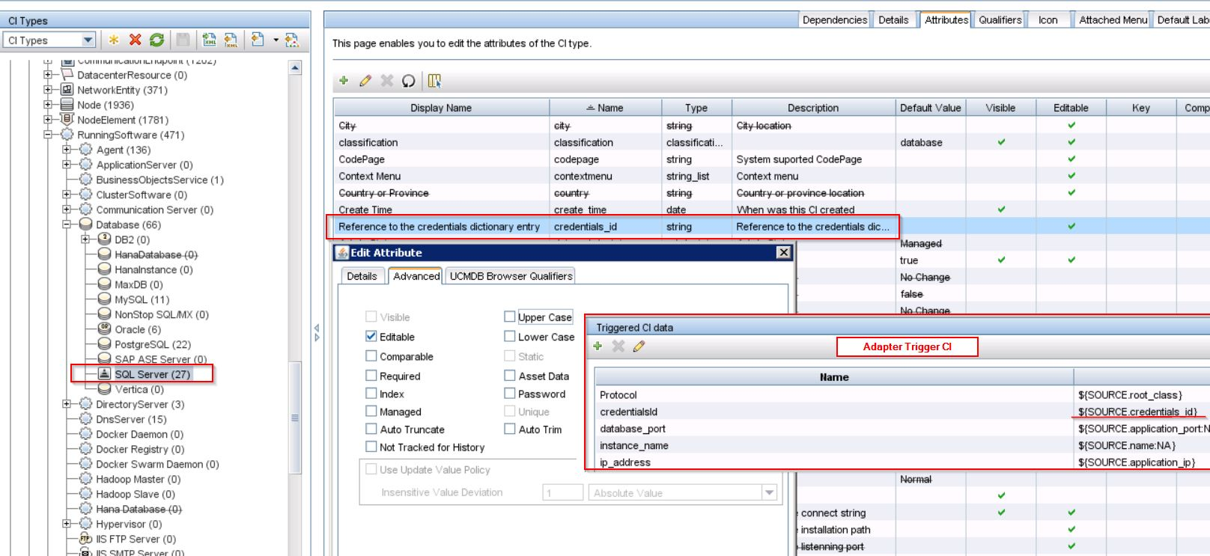

These credentials are used for connection for the trigger CI (sqlserver) in the "Import from Database” adapter.
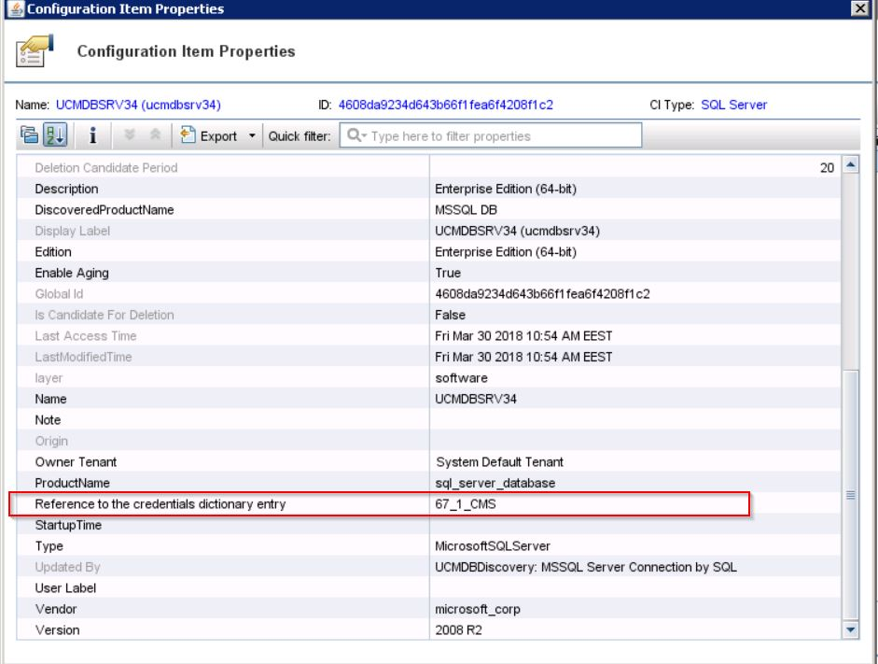

Comparing System A with System B, even if the same set of credentials are defined manually in the DataFlowProbe Setup -> Credentials, the number itself (ref. to example above eg. 67_1_CMS) won’t be the same (these numbers are incrementally generated once a new set of credentials is added), thus the integration job ran on System B will fail (because the "Reference to the credentials dictionary entry" / credentials_id for the CI imported from System A won't match the credentials defined in System B).

So the requirement is to have control of the credentials for the trigger CIs used in the "Import from Database" adapter.

For this we need to add in the adapter’s code a Credentials parameter so that the user can pick up the SQL credentials to be used for the specific Database Server CI (sqlserver) which is in the trigger.

Important Note: Before you begin, you must remove previously saved Integration Points which are using the Import from DB adapter.
Step1:
Go to Adapter Management -> Packages -> External_source_import -> Adapter -> right click and open the Import_DB adapter code. Add the following line in between <parameter></parameter> section and then save the file:

<parameter name="credentialsId" description="Special type of property, handled by UCMDB for credentials menu" type="string" display-name="Credentials ID" mandatory="true" order-index="12" />
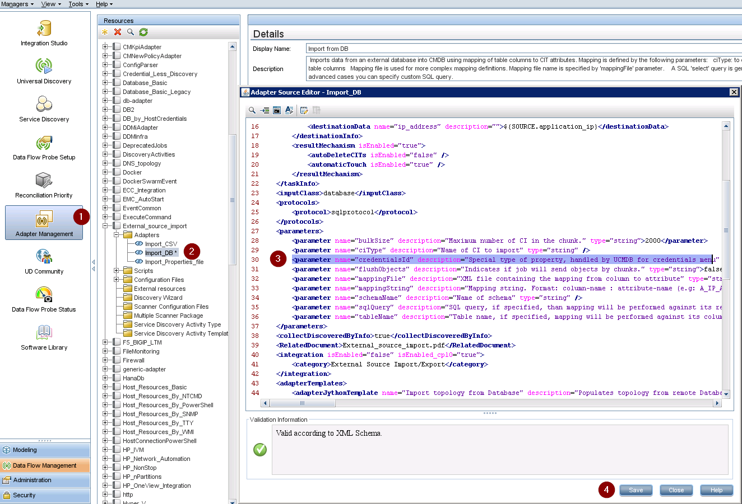

Step2:
In the same section Adapter Management -> Packages -> External_source_import -> Adapter -> Scripts, open db_import.py:

Within the script db_import.py replace this:
client = Framework.createClient(props)
with this:
credentialsId = Framework.getParameter('credentialsId')
client = Framework.createClient(credentialsId, props)

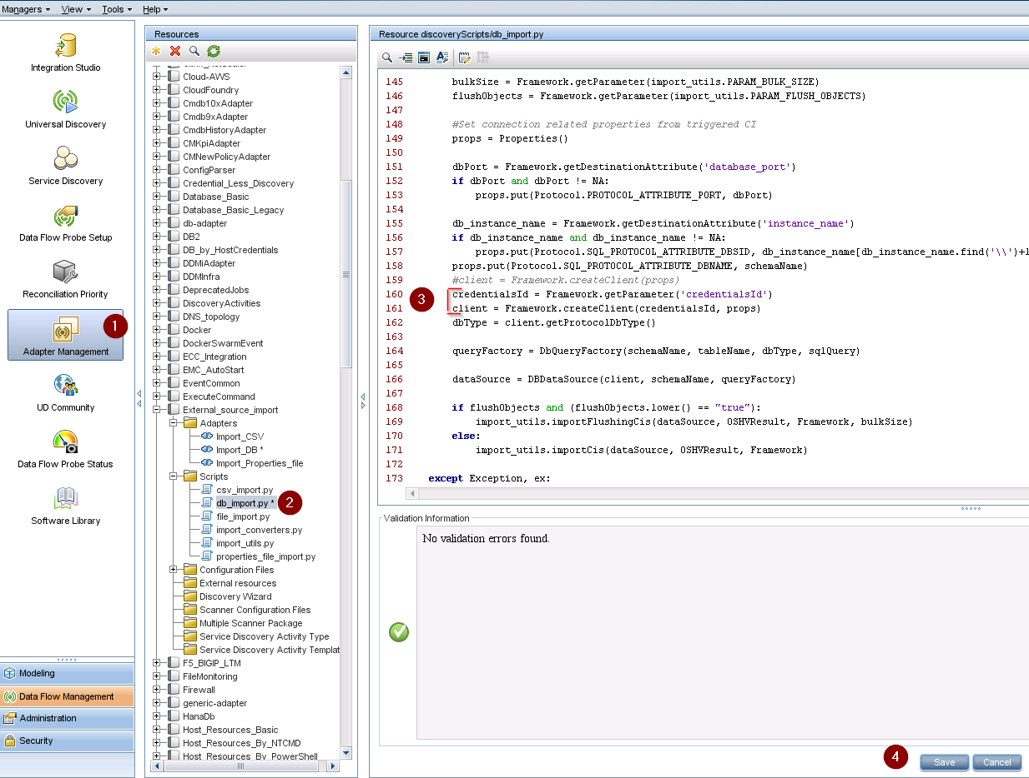
Step3 (optional):
Remove credentialsId from the trigger tql list.

Note: If this step is NOT performed, the comm. log will still list the attribute "Reference to the credentials dictionary entry" / credentials_id as originally discovered for the CI, however the job will attempt the connection with the assigned credentials (as defined in the integration job configuration).

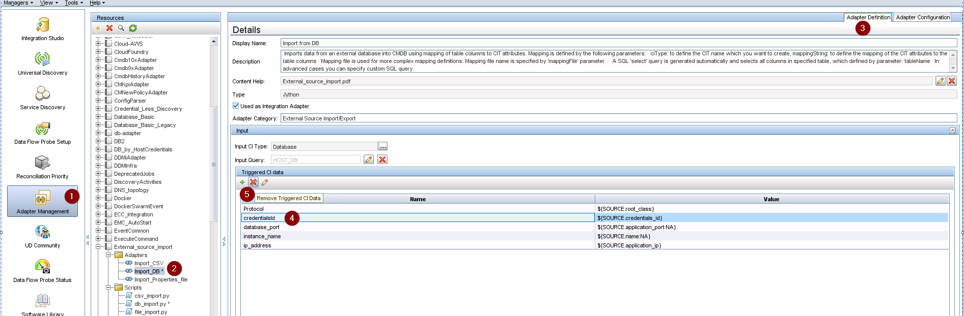

Step4:
Define the integration point. Note that the parameter Credentials ID has now been added to the dialog and it is a mandatory parameter.

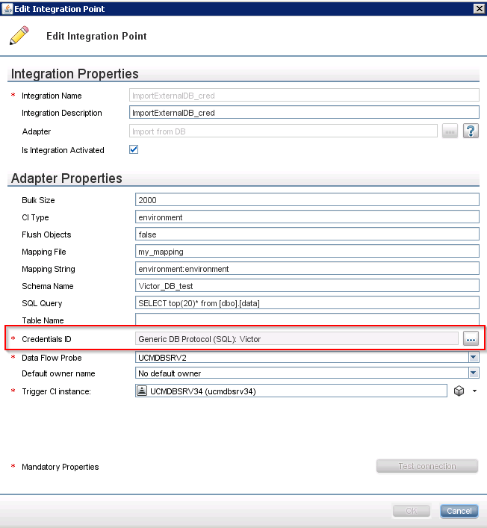

Note: You must recreate the previously saved Integration Points that do not contain this parameter. Also, if you encounter errors removing / changing existing integration points (which are using the Import from DB adapter) after you made the changes mentioned in this article you must redo the changes above, remove the integration points, then add these changes and reconfigure the integration points.

