In order to graph custom OM agent metrics, which are definied in an OM policy, do the following:

Stored metrics data is in:

Datasource MYDS
Oject MYOBJ
Metric MYMET

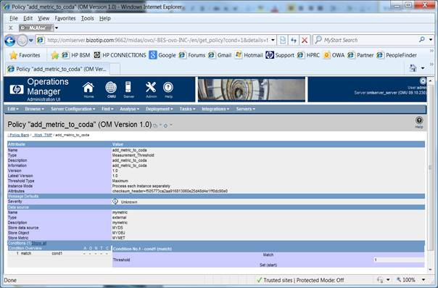

[root@omlserver ~]# ovcodautil -showds
NumDataSources = 4
SCOPE
CODA
SISPI
MYDS

[root@omlserver ~]# ovcodautil -dumpds MYDS
===
01/01/13 10:20:26 AM|_InstanceName | |
01/01/13 10:20:26 AM|MYMET | 146.00|

You need to add the customer metric definition ““MYDS:MYOBJ”
in
Infrastructure settings ➔ Performance Graphing ➔ System Performance Classes

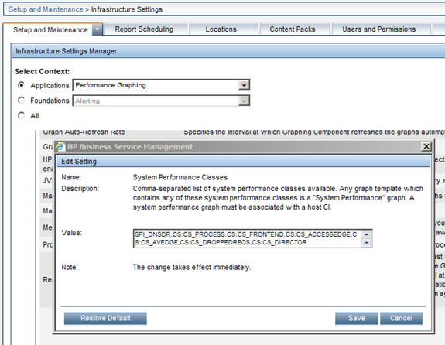

Why is that?

This is done to avoid showing classes that are not relevant and improve usability.
For example, when there are lots of classes, we will filter out and show only classes whose instance name match with instance selected in the Model explorer.

All the Sys Perf classes under infra settings will NOT be filtered.

Then it will be visible in PMI.



