
Note: Changes and actions highlighted in this document do not apply to:
- HPE Software: HPE Software customers will continue to use the current Software Support Online portal.
- HPE Actionable Customer Intelligence – Subscriber Data Management Applications (ACI-SDM). HPE ACI-SDM products will be migrated in phase two of the migration and will be communicated later this year. See the list of HPE ACI-SDM products not included in the initial migration (*).
- For our NonStop customers: Support tools and processes related to NonStop hardware and software are not within the scope of this project phase. There will be no change in the tools and processes currently used to access support in phase 1 of this project.

Dear Customer,

HPE Solution Support Services for Communications Service Providers (CSPs) is announcing the change to your HPE Support Web Portal.

With this message, we would like to provide simple actions required from you only once, to be able to use the Hewlett Packard Enterprise Support Center (HPE SC) Web Portal.
Effective 2 May 2017, online support for your HPE Communication Solutions will move to the HPE Support Center Web Portal www.hpe.com/support/hpesc
The new Portal will replace the previous HPE Software Support portal softwaresupport.hpe.com
In the period up to 1 May 2017, you may carry on using the existing HPE Software Support Portal at softwaresupport.hpe.com (except for HPE ACI-SDM (*)).
The new HPE Support Center Web Portal, allows you to:
- Submit and manage support cases: using the HPE SC Portal to log your issues is our recommended and the most efficient method.
- Download patches
- Get software updates and licensing
- Access technical product information
- Manage your contracts and warranties
Actions required to use the HPE Support Center Web Portal for the first time:

- Login to www.hpe.com/support/hpesc
- Go to «Manage my contracts & warranties»
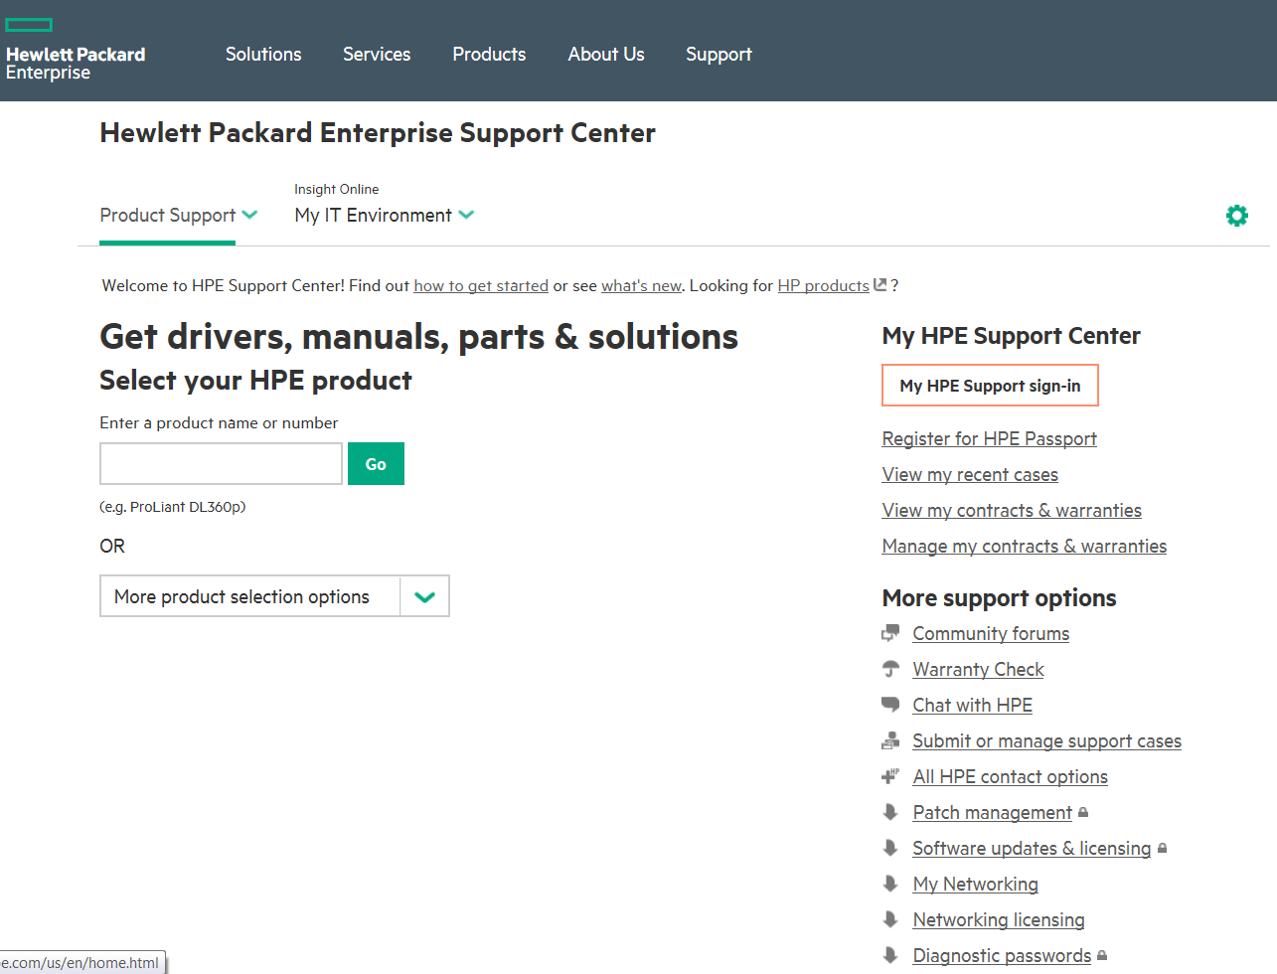

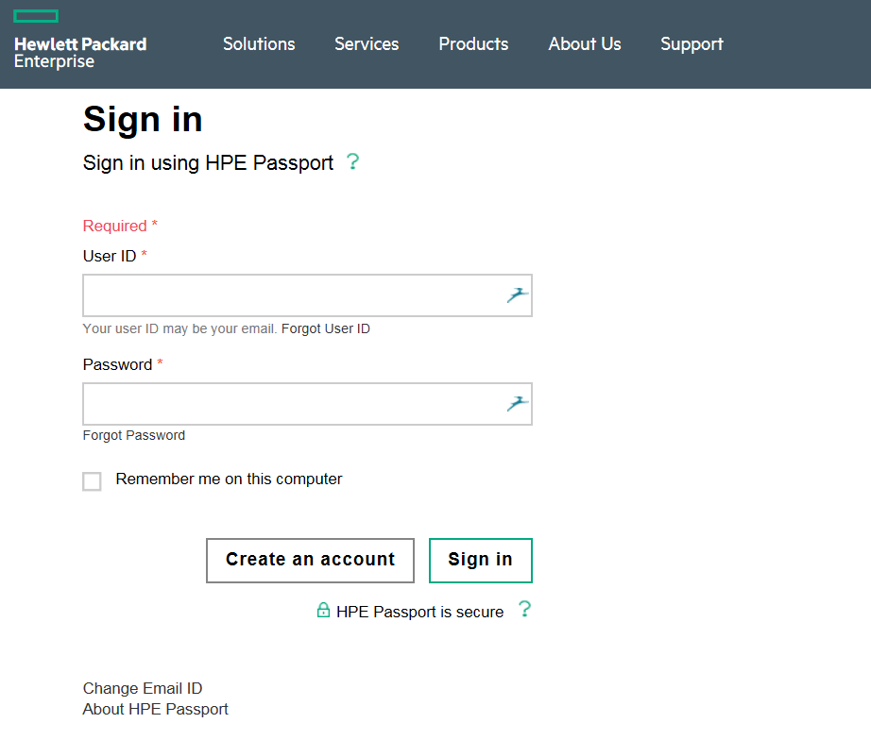
- Create an HPE Passport account, or sign in if you already have one
If you don’t already have an HPE Passport please create your account (required once only).
Otherwise, sign in.

- Click on « Link Support Agreements»
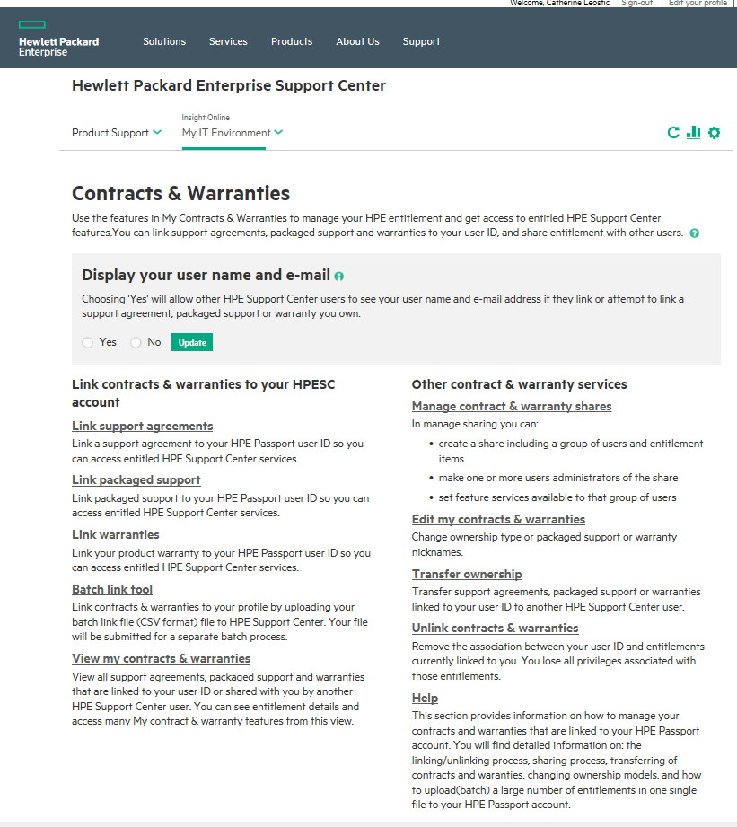
Click on Link Support Agreements

- Within the “Link HPE Support Agreements” page, fill in the required fields, and enter your Service Agreement ID(s) (SAID) and Service Account Reference (SAR) (see item 6) in the required fields, then press Submit.
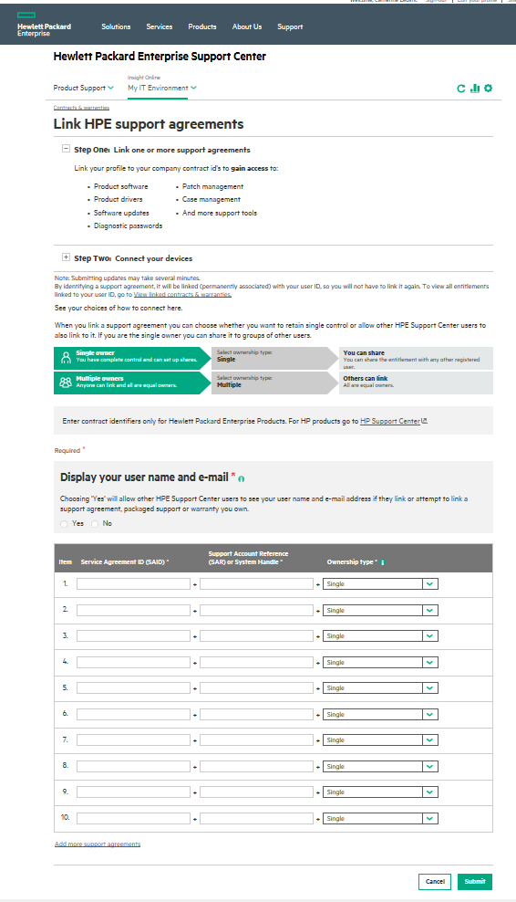
Retrieve and enter your Service Agreement ID (SAID) and Support Account Reference (SAR) (also referred as to System ID or System Handle or Function Location) located on your Support Agreement (item 6)
Ownership type: Multiple is the preferred choice.
If Single is selected, the HPE SC user will either retain unique control or will have to allow the next HPE SC requester to also access his SAID and SAR. The next requester will be prompted to contact the initial requester to request entitlement sharing.

6. Your Service Agreement ID(s) (SAID) and Service Account Reference (SAR, also referred as to System ID or System Handle or Function Location), are located on your HPE Support Agreement (Support Account Overview).

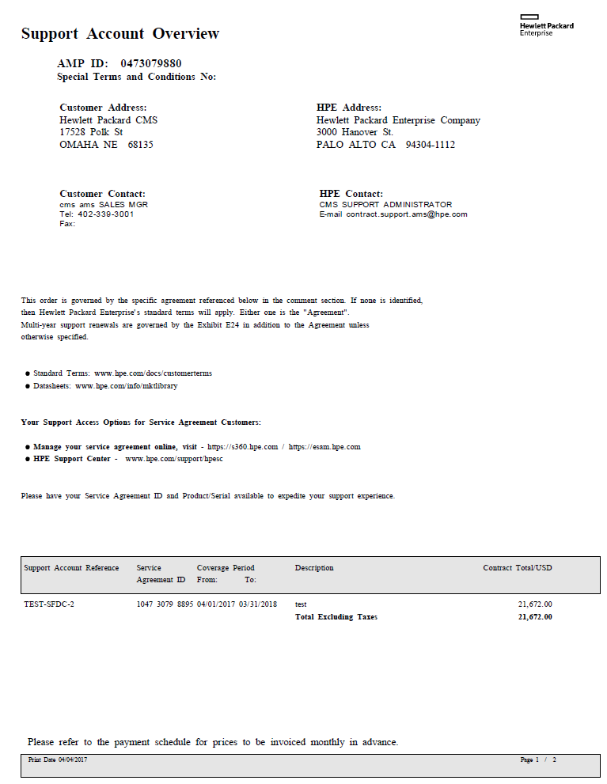
Service Agreement ID (SAID)
Support Account Reference (SAR) (also referred as to System ID or System Handle or Function Location)

Additional web sites to bookmark
We would also take this opportunity to tell you about some key web sites that we recommend you bookmark as the links have been updated.

- To manage your HPE License Entitlements and get your License Keys:
My License Portal MyEnterpriseLicense.hpe.com

replacing HPE Software Licenses and Downloads www.hpe.com/software/entitlements

- To access your HPE Software Updates and Upgrades:
Software Update & Licensing www.hpe.com/downloads/software

replacing HPE Software Licenses and Downloads www.hpe.com/software/entitlements

We thank you for your understanding through this transition and we look forward to providing you with the same world class HPE Support and Services you are accustomed to today.

For any further assistance, please contact your HPE Representative for HPE Solution Support Services for CSPs.
Sincerely,

Hewlett Packard Enterprise Account Representative

(*) HPE Actionable Customer Intelligence – Subscriber Data Management (HPE ACI-SDM) Applications for Communications Service Providers (CSPs)
• Integrated Home Subscriber Server (I-HSS)
• Universal Identity Repository (UIR)
• Intelligent Network Server (INS)
• Position Determination Entity (PDE)
• Real time Management Server (RTMS)
• INS SIP Services Framework (ISSF)
• Short Message Point to Point Gateway (SMPP)
• Simple Network Time Protocol (SNTP)
• Service Creation Environment (SCE)

