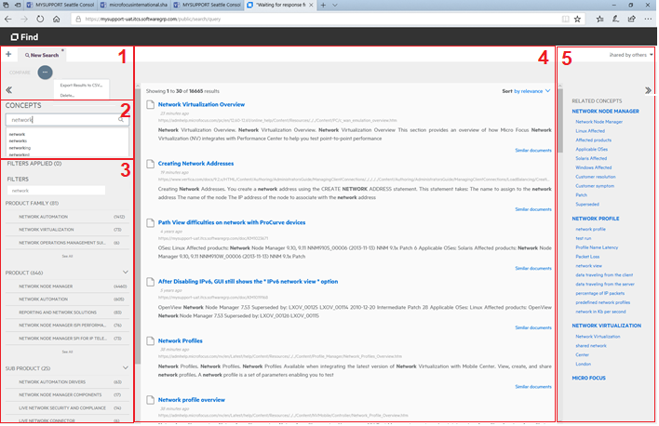
- + – creates additional search tabs
COMPARE – allows compare of results from 2 tabs
… – export results from a tab or deletes a tab

- CONCEPTS – type sought terms
auto-suggest terms will list as you type
includes related word forms by default
use “quotes” to limit to an exact match
you may use Boolean logic (CAPITALIZED)
(term1 OR term2) AND NOT term3
hit enter to execute the search
matching documents list in area 4
to narrow results, type new concepts
to undo, use X by any selected concept

- FILTERS – type or click names of desired filters the filtering options list below such as:
PRODUCT, SUB PRODUCT, PRODUCT FAMILY,
VERSION, STATUS, LANGUAGE, DOCUMENT TYPE
As you type, matching options will list
Click any you wish to use to filter results
Click See All beneath any filter category to alphabetically list all available options
Click X beneath FILTERS APPLIED to remove

- SORT – default is a relevance sort, which will list the ‘best’ search matches first. You may instead click to change this to Sort by Date.
LINK – Click on the blue title link in area 4, to open a search result document in a new window.
SIMILAR – When you find a document that looks promising, you may click the Similar documents link on the far right, to display other documents that are similar.
DOCUMENTS
BOLD TEXT – terms from each matching document which ‘match’ or are related to the terms you provide in area 2 (CONCEPTS) will present in BOLD FACE.

- RELATED – on the far right you will see popular concepts related to your concept(s) entered in area 2. These may help you fine tune your results to specific related concepts.
CONCEPTS click on any you wish to add it as an additional concept for your search, it will appear beneath your typed concept in Area 2, where you may also decide to delete it.

