Select the connector for which you need to create the dtd file->Go to Document type tab and select the Document type, as highlighted below:
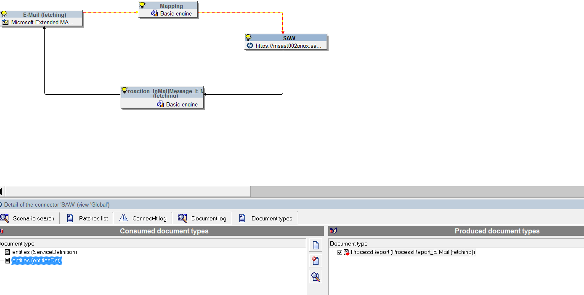

After you have opened the document type, right click on the document type-> select option "Copy this XML DTD"

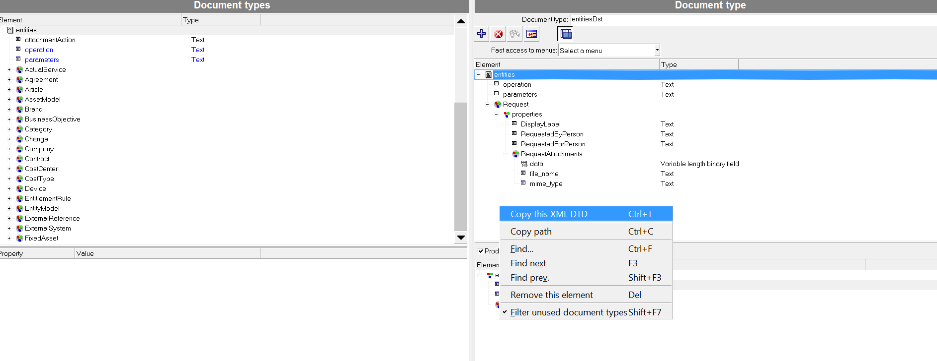
Open any text editor such as notepad or notepad++ and right click in the text editor and click on "paste".
The following content is pasted to the text file:

<?xml version="1.0" encoding="UTF-8"?>
<!ELEMENT entities (operation?,Request*,parameters?)>
<!ELEMENT operation (#PCDATA)>
<!ELEMENT Request (properties?)>
<!ELEMENT properties (DisplayLabel?,RequestedByPerson?,RequestedForPerson?,RequestAttachments*,AssignedToGroup?,Description?,CreateTime?,Name?)>
<!ELEMENT DisplayLabel (#PCDATA)>
<!ELEMENT RequestedByPerson (#PCDATA)>
<!ELEMENT RequestedForPerson (#PCDATA)>
<!ELEMENT RequestAttachments (data?,file_name?,mime_type?)>
<!ELEMENT data (#PCDATA)>
<!ELEMENT file_name (#PCDATA)>
<!ELEMENT mime_type (#PCDATA)>
<!ELEMENT AssignedToGroup (#PCDATA)>
<!ELEMENT Description (#PCDATA)>
<!ELEMENT CreateTime (#PCDATA)>
<!ELEMENT Name (#PCDATA)>
<!ELEMENT parameters (#PCDATA)>

Save this DTD file.

Now create a xml request format that can be used as a template to create emails, which will be processed to create a ticket in SAW.

In the above DTD
<!ELEMENT entities (operation?,Request*,parameters?)>
Means the entities is the root node while its child nodes are Operation, Request, parameters.

So the xml request would look like:
<entities>
<operation>?<\operation>
<Request>?<\Request>
<parameters>?<\parameters>
<\entities>

<! ELEMENT properties(DisplayLabel?,RequestedByPerson?,RequestedForPerson?,RequestAttachments*,AssignedToGroup?,
Description?,CreateTime?,Name?)>

Means the properties is the root node while its child nodes are
DisplayLabel,RequestedByPerson,RequestedForPerson,RequestAttachments,AssignedToGroup,
Description,CreateTime,Name

Note :RequestAttachments*---> it is inturn a multistructured element
<!ELEMENT RequestAttachments (data?,file_name?,mime_type?)>

So the xml request would look like:
<properties>
<DisplayLabel>?<\DisplayLabel>
<RequestedByPerson>?<\RequestedByPerson>
<RequestedForPerson>?<\RequestedForPerson>
<RequestAttachments>
<data>?</data>
<file_name>?<\file_name>
<mime_type>?<\mime_type>
</RequestAttachments>
<AssignedToGroup>?<\AssignedToGroup>
<Description>?</Description>
<CreateTime>?</CreateTime>
<Name>?</Name>
<\properties>

Note:
  - "?"--- indicates a placeholder for a value, ie "?" should be replaced with the value that is required to pass to the field.
  - It is not mandatory to pass all the fields mentioned in the DTD file in the email XML structure.
  - The XML structure should be correct even if some fields are skipped. If the XML Structure is incorrect there would an error on the "Email Connector".
Eg: in the above structure if data and mime type has to be skipped in RequestedAttachments, the XML structure will look like this:
<properties>
<DisplayLabel>?<\DisplayLabel>
<RequestedByPerson>?<\RequestedByPerson>
<RequestedForPerson>?<\RequestedForPerson>
<RequestAttachments>
<file_name>?<\file_name>
</RequestAttachments>
<AssignedToGroup>?<\AssignedToGroup>
<Description>?</Description>
<CreateTime>?</CreateTime>
<Name>?</Name>
<\properties>

The Final XML Structure which can be used as a template for the above DTD would look like this:

<entities>
<operation>?<\operation>
<Request>?<\Request>
<parameters>?<\parameters>
<properties>
<DisplayLabel>?<\DisplayLabel>
<RequestedByPerson>?<\RequestedByPerson>
<RequestedForPerson>?<\RequestedForPerson>
<RequestAttachments>
<data>?</data>
<file_name>?<\file_name>
<mime_type>?<\mime_type>
</RequestAttachments>
<AssignedToGroup>?<\AssignedToGroup>
<Description>?</Description>
<CreateTime>?</CreateTime>
<Name>?</Name>
<\properties>
<\entities>

Following is the Sample Email used for Creating Ticket in SAW:
<?xml version="1.0"?>
<entities>
<operation>create</operation>
<Request>
<properties>
<DisplayLabel>Testing dtd</DisplayLabel>
<RequestedByPerson>14825</RequestedByPerson>
<RequestedForPerson>14825</RequestedForPerson>
<Description><![CDATA[
TEST EMAIL FOR DTD]]> </Description>
</properties>
</Request>
</entities>

Note:
  - "14825" in the above email refers to the ID of the requestor.
  - In SAW the users are recognized by the unique id.
  - The ID of the user mentioned in the email should be a valid user who exists in SAW. If "ID" value passed does not exist in SAW then ticket will not be created.

Source Connector:
Email Fetching connector

Destination Connector:
Maas Connector

Information required to Configure MAAS Connector.
  - Get the Certificate from SAW
  - In Service Anywhere, select the padlock icon in the address bar next to the URL. In the pop-up dialog select the Connections tab. Select the “Certificate information” link.
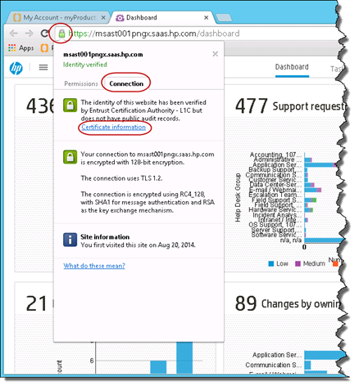

  - In the Certificate dialog, select the Details tab and select the “Copy to File” button.

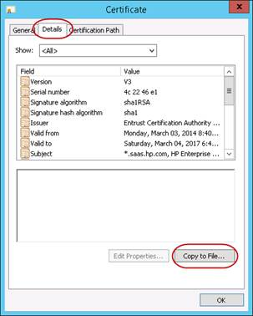

  - In the Certificate Export Wizard select Next button
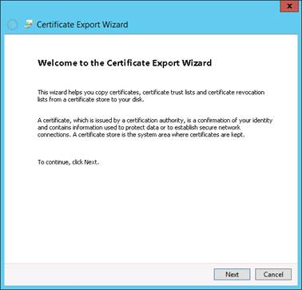

  - Select the “DER encoded binary X.509 (.CER) radio button and select Next button.
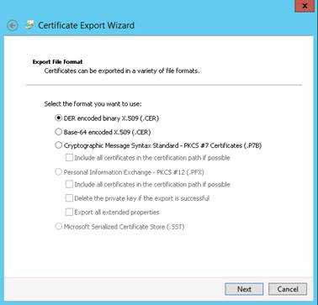

  - Specify a file location e.g. C:\maas.cer and select the Next button
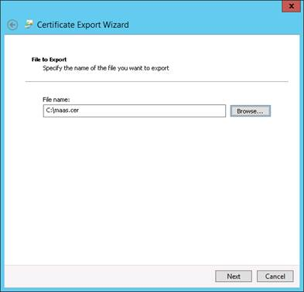

  - Select the Finish button.
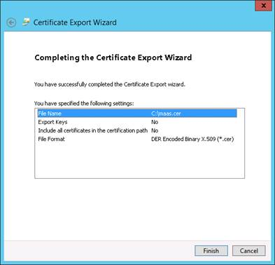

  - Add the certificate to a keystore
  - Start a Command Prompt
  - Change directory to your Java bin directory
cd C:\Program Files (x86)\Java\jre7\bin

  - Add the certificate to a keystore using this command:
keytool -importcert -file c:\maas.cer -keystore c:\maas.jks -alias "maas”

You will be prompted for a password.
You can any password, but remember the password as you need it later while configuring the MaaS connector

  - Configuration the Connect-It Scenario
    - Create the Basic Scenario using the Wizard
  - Start the “Connect-It Scenario Builder”.

You must run 9.53 as it contains a hotfix required for the HP MaaS connector. The initial splash screen shows which version you are running. Alternatively select Help > About.

  - Select File > New to start the Wizard to create a new scenario.
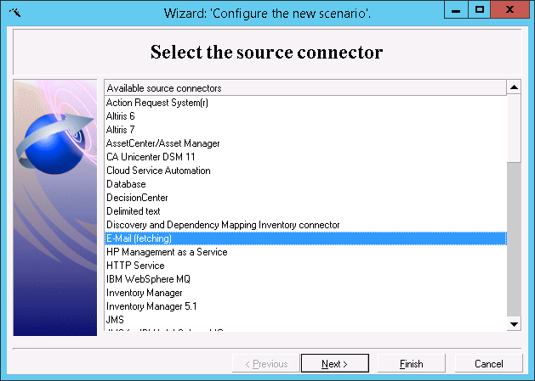

  - In the Wizard, select E-Mail (fetching) source connector and select Next button

  - Select the “HP Management as a Service” destination connector and select Next button
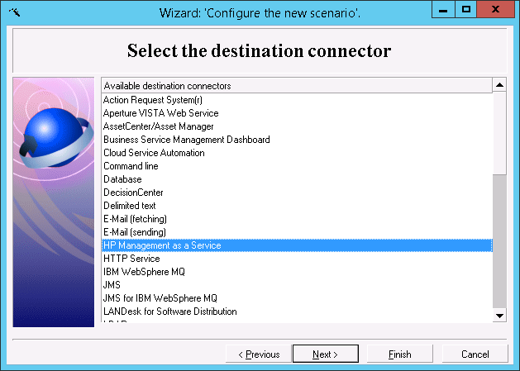

  - Select the Finish button

  - Name the source connector and select Next button
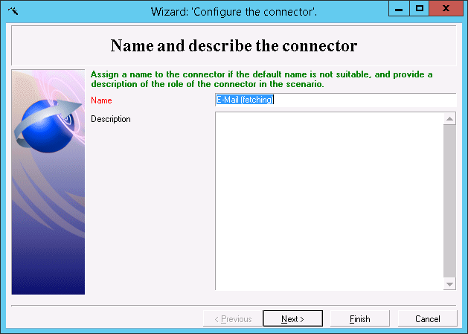

  - Enter the details for POP3 server, Login and Password and select the Test button
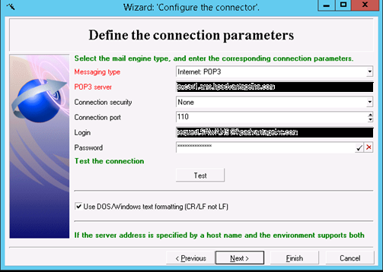

  - If the Test is successful, then select the Close button and then the Next button.

If the Test is unsuccessful within Connect-It you can use the telnet test at the command prompt to help diagnose the problem.
telnet <pop3 server fqdn>110
+OK The Microsoft Exchange POP3 service is ready.
USER request. <pop3 server fqdn>
+OK
PASS your.password.here
+OK User successfully logged on.
LIST
+OK 0 0
.
quit
+OK Microsoft Exchange Server 2013 POP3 server signing off.

  - Select the option "Process contents of email body" and specify the path to the DTD file created above.
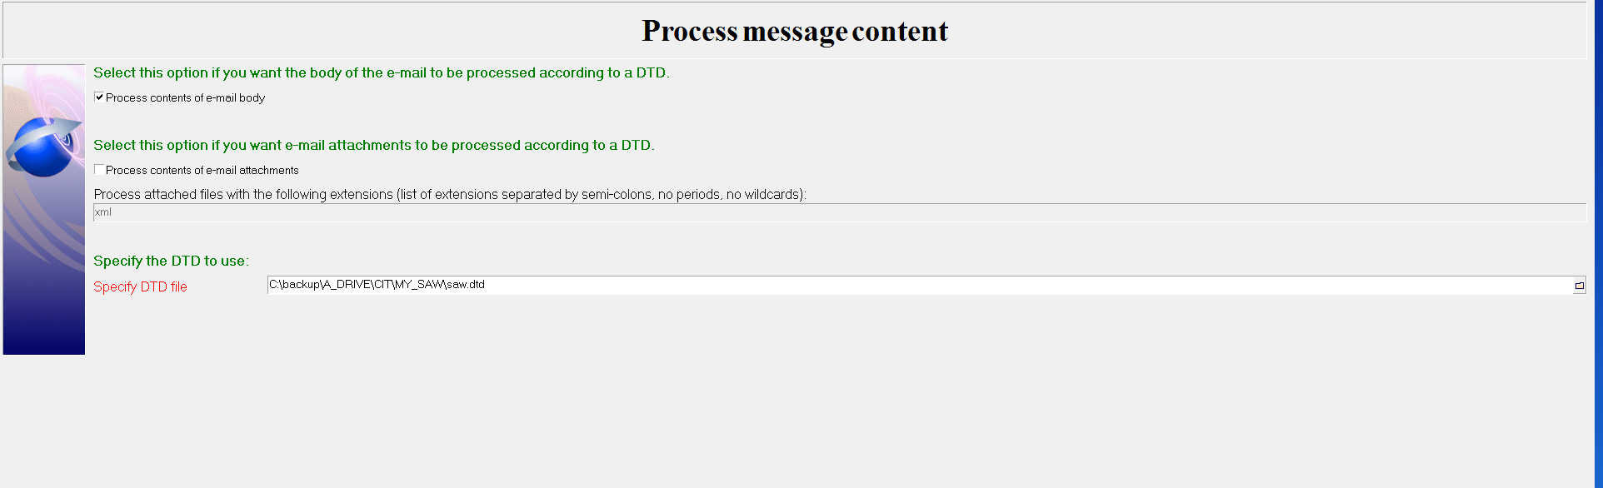

  - In the “Define post-processing actions” dialog, accept the defaults whilst you’re testing the scenario.

Once you’re happy you’re scenario is working:
  - select the “Apply actions just after fetching messages” checkbox
  - select the “Delete e-mail messages from server” checkbox.
  - Select the Next button.

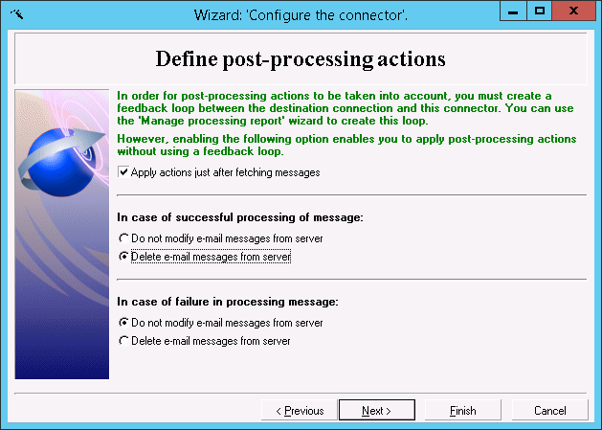

  - Accept the defaults and select the Finish button
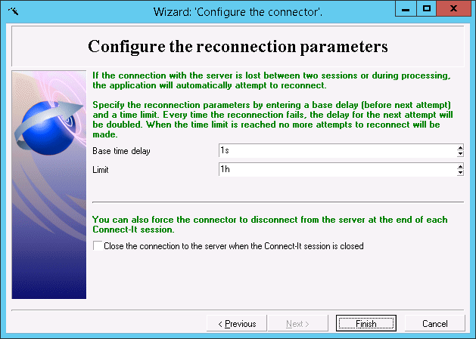

  - Now we’re configuring the destination connector. Name the connector “Query HP Management as a Service” and select the Next button.

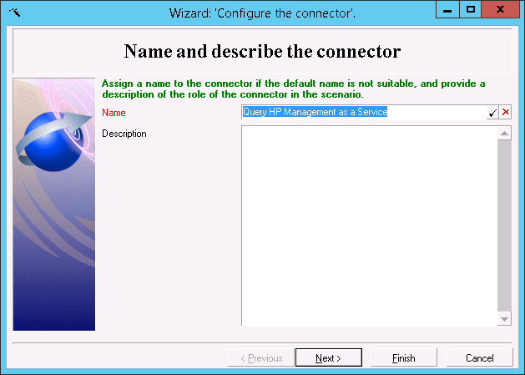

  - Specify the MaaS server and credential information:
  - Construct the Server string using the URL and Tenant ID you found earlier like this: msast001pngx.saas.hp.com/?TENANTID=239117699
Enter the username and password for SAW account.

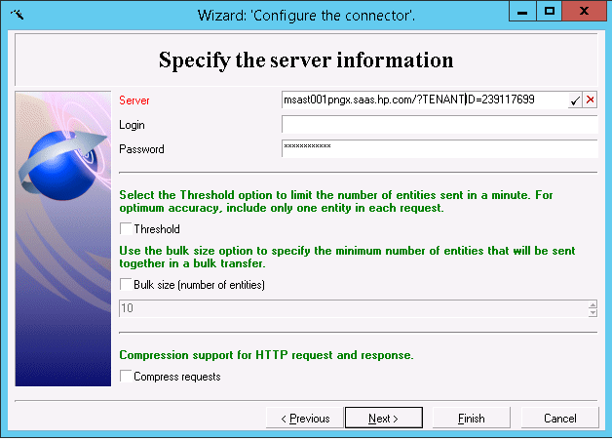

  - On the “SSL configuration” page:
  - select the “Use an SSL connection” checkbox
  - enter the “CA certificates file (truststore)” e.g. C:\maas.jks
  - enter the “Truststore password”
  - Truststore type: JKS
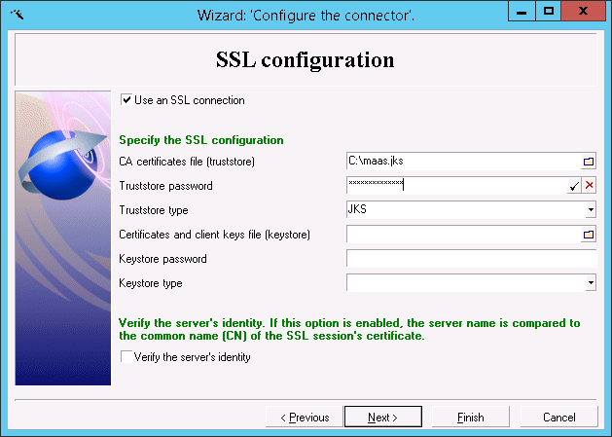

  - Select the Next button

  - On the “Configure the JVM” page:
  - JVM options: -Dcit.maas.exposehidden=true
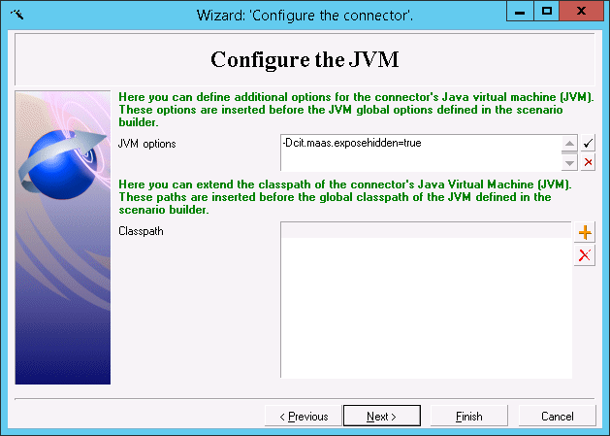

  - Select the Finish button
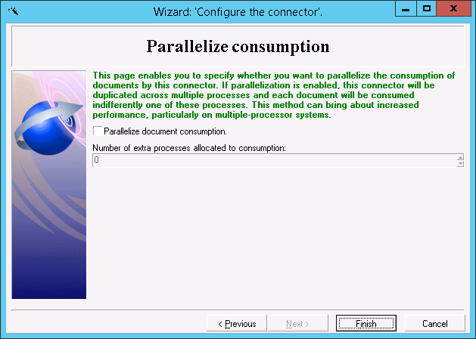

Now you’ve created a basic scenario comprising two adapters and a Mapping that looks like this:
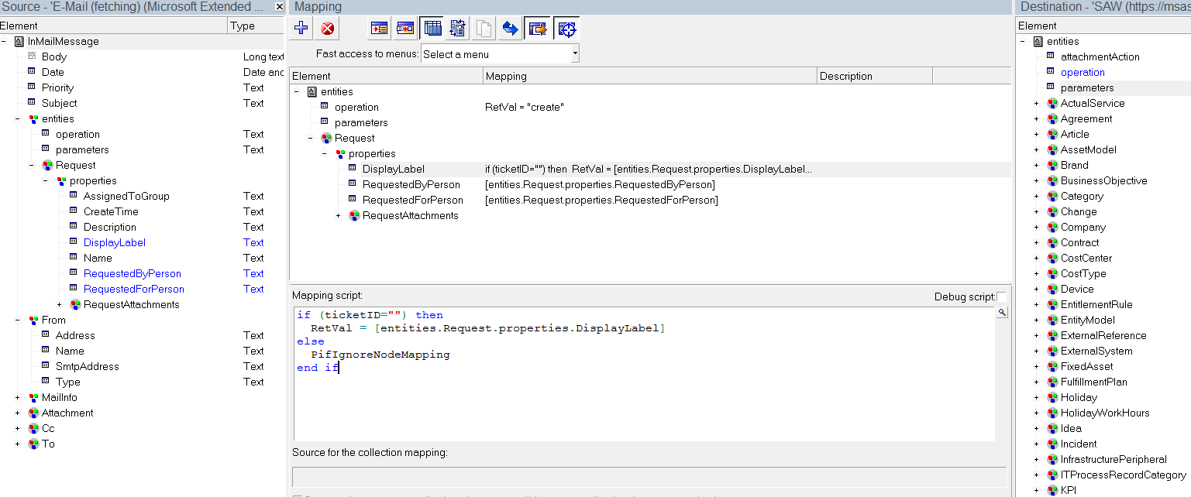

DisplayLabel:

if (ticketID="") then
RetVal = [entities.Request.properties.DisplayLabel]
else
PifIgnoreNodeMapping
end if
Running the scenario
To run the scenario, select the Email connector and select the Produce now
button.

Check if ticket is created in SAW.

