Software Support Online Menus (HPE pre-rebranding) |  |  |  |  |  |  | MySupport Menus (Micro Focus post re-branding)
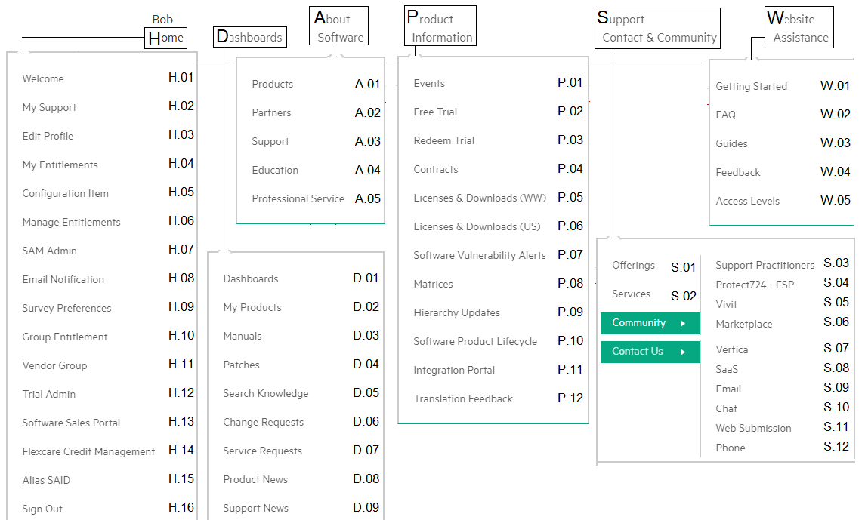 |  |  |  |  |  |  | 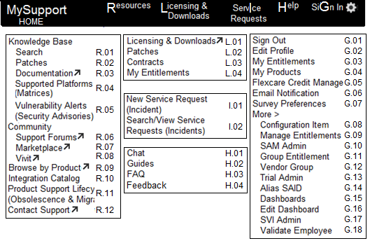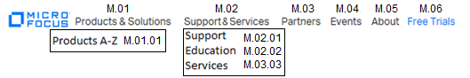
H.01 is now HOME  H.02 is now HOME  H.03 is now G.02  H.04 is now G.03  H.05 is now G.08  H.06 is now G.09  H.07 is now G.10  H.08 is now G.06 | H.09 is now G.07  H.10 is now G.11  H.11 is now G.12  H.12 is now M.06  H.13 is now M.01  H.14 is now G.05  H.15 is now G.14  H.16 is now G.01 | D.01 is now G.15  D.02 is now G.04  D.03 is now R.03  D.04 is now R.02  D.05 is now R.01  D.06 is now R.01¹  D.07 is now I.02  D.08 retired M.01  D.09 retired M.02 | A.01 is now M.01.01  A.02 is now M.03  A.03 is now M.02.01  A.04 is now M.02.02  A.05 is now M.02.03 | P.01 is now M.04  P.02 is now M.06  P.03 is now M.06  P.04 is now L.03  P.05 is now L.01  P.06 is now L.01  P.07 is now R.05  P.08 is now R.04  P.09 retired M.01  P.10 is now R.11²  P.11 is now R.10  P.12 retired | S.01 is now M.02.01  S.02 is now M.02.03  S.03 is now R.06  S.04 retired R.06  S.05 is now R.08  S.06 is now R.07  S.07 retired  S.08 retired  S.09 is now R.12  S.10 is now H.01  S.11 is now R.12  S.12 is now R.12 | W.01 is now H.02  W.02 is now H.03  W.03 is now H.02  W.04 is now R.10  W.05 is now H.02 | ¹D.06 search for CRs requires manual selection of KP & ER in R.01  ²P.10 is also beneath M.02.03 Support Plans & Policies

Software Support Online Icons (HPE pre-rebranding) |  |  |  | MySupport Icons (Micro Focus post re-branding)
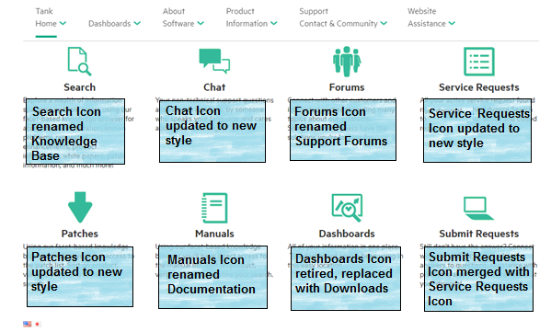 |  |  |  | 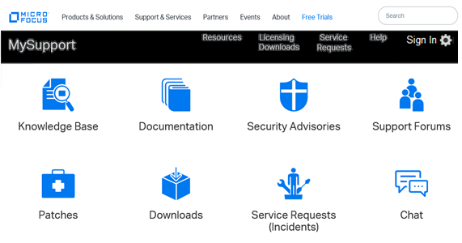
The Search function is unchanged. Its icon style is updated and name changed to Knowledge Base to align with Micro Focus standards. | The Chat function is unchanged. Its icon style is updated to align with Micro Focus standards. | The Forums function in unchanged. Its icon style is updated to align with Micro Focus standards. | The Service Requests function is unchanged. It has been also labelled Incidents to align with Micro Focus standards. | The Knowledge Base icon provides access to the unchanged Search functionality. | The Documentation icon replaces the Manuals icon and will ask you to indicate your product and then direct you to the best website for that product’s documentation. | The Security Advisories icon is new, and provides access to content referred to previously as Software Vulnerability Alerts. The icon name aligns with Micro Focus standards. | The Support Forums icon replaces the Forums icon, but provides unchanged functionality, only renamed to align with Micro Focus standards.
The Patches function is unchanged. Its icon style is updated to align with Micro Focus standards. | The Manuals function has changed to prompt for a product first and then direct you to the best website for that product’s documentation. | The Dashboards function is unchanged but due to low usage, is no longer available via an icon. Use Settings / More / Dashboard menus if needed. | The Submit Requests Icon was converged with the Service Requests Icon due to duplicate functionality, making room for the Downloads Icon. | The Patches icon provides unchanged access to patches within our knowledge base. | The Download icon is new. It will ask you if your entity is government-related or not and provides access to software downloads from the appropriate source. | The Service Requests icon is also labelled (Incidents) to incorporate Micro Focus standard vocabulary, but provides unchanged functionality. | The Chat icon provides unchanged access to our Chat capability.

